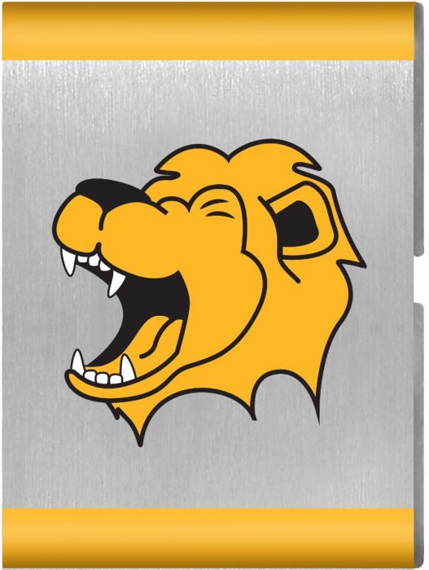
Rumble in the Jungle
Materials

Parent and Leader Guidebook: pages 79-82
Lion Adventure Book: page 17
- Play a game with rules; indicate an understanding of the rules and why it is important to follow the rules while playing the game.
- Choose a jungle animal that you would like to be; describe the animal and why you chose it. Participate in a parade with the other animals in your den. Communicate with other animals using your animal’s sounds, both as loudly as you can and as softly as you can.

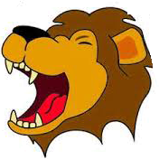
Materials
- Copies of Rumble in the Jungle handout, one per adult
- Copy of Den Meeting Plan, one for leader(s)
- Name tags and Sharpie
- Cub Scouts Poster Set with Scout Law, Scout Oath and Den Code of Conduct (#621086 from Scout Shop)
- Blue tape or something to hang posters on wall

Optional
- Snack and water
- Activities for siblings (e.g., coloring books)

Activity 1: Individual or Team Game
Options:
- Kickball
- Foursquare
- Sock baseball (rolled-up socks as ball and arm as bat)
- Soccer obstacle course (dribble around cones and kick ball into a container or through hula hoop)
- Ring toss with hula hoops

Activity 2: Animal Noises and Animal Parade
- Animal masks or face paint (craft stores, patterns)
- Markers, colored pencils, glitter for masks
- Elastic string for masks
- Music for parade

Activity Wrap Up
- Song: https://www.youtube.com/watch?v=GHdkZ3Pvh40&feature=related
- Colored pencils, crayons or markers
- Few extra copies of Lion Adventure Book page 7 (for those who forget book).

Supplemental
- Copies of Animal Pattern. Lions match the animal pattern to the animal. Can be used as a gathering activity or sent home.

Den Meeting Plan
Rumble in the Jungle
Parent and Leader Guidebook: pages 79-82
Lion Adventure Book: page 17
- Play a game with rules; indicate an understanding of the rules and why it is important to follow the rules while playing the game.
- Choose a jungle animal that you would like to be; describe the animal and why you chose it. Participate in a parade with the other animals in your den. Communicate with other animals using your animal’s sounds, both as loudly as you can and as softly as you can.

Gathering
- Red Light, Green Light
Opening
- Good conduct candle
- Pledge, Scout Oath, Scout Law
Talk Time
- Den business
- Discussion: Importance of Rules and how they carry over into life.
- Sportsmanship
- Need to lead by example
- How do games help us work together?
- What happens when people don’t follow the rules in a game?
- Discussion: Importance of being physically active
- Discussion: Think about what animal you would like to be.
  - Think about sounds that animal makes
  - Do different animals make different sounds?
  - Do you think animals understand each other?
  - What if we all spoke different languages, like these animals?
  - Being able to communicate with each other (through words or actions) and be understood is important.
Activities
- Activity 1: Individual or Team Game
- Activity 2: Animal Noises and Animal Parade
- Activity Wrap-up: Lion Adventure Book, page 17
Closing
- Sing “Elephants Have Wrinkles”
- Lions stand in a circle and recite Scout Law

Rumble in the Jungle Adventure

“Elephants Have Wrinkles” by April Kassirer
This is a movement song where you stomp around with heavy feet, swinging your elephant trunk (your arms) and swaying back and forth.
Elephants have wrinkles, wrinkles,wrinkles
Elephants have wrinkles, wrinkles everywhere
On their toes (on their toes)
No one knows (no one knows) why -y-y-y-
Elephants have wrinkles, wrinkles, wrinkles
Elephants have wrinkles, wrinkles everywhere
On their knees (on their knees) On their toes (on their toes) no one knows (no one knows) why -y-y-y-
Elephants have wrinkles, wrinkles,wrinkles
Elephants have wrinkles, wrinkles everywhere
Scout Law
A Scout is trustworthy, loyal, helpful, friendly, courteous, kind, obedient, cheerful, thrifty, brave, clean, reverent.
Scout Oath
On my honor, I will do my best to do my duty to God and my country and to obey the Scout Law; to help other people at all times; to keep myself physically strong, mentally awake, and morally straight.
On their hips (on their hips) ….. knees, toes
On their ears (on their ears) ….. hips, knees, toes
On their trunks (on their trunks) ears, hips, knees, toes
On their teeth
Spoken: On their teeth? That’s ridiculous!
Elephants have wrinkles, wrinkles,wrinkles
Elephants have wrinkles, wrinkles everywhere.
Upcoming Events

Dec 16 Wreaths Across America, optional
10:00 am at Houston Cemetery

Dec 20 Pack Meeting
(bring donation of first aid supplies)

Jan 10 Den Meeting
TBD Outing

Feb 7 Den Meeting
Feb 24 Pinewood Derby
Feb 28 Pack Meeting
Mar 7 Den Meeting

Pack 72
facebook.com/pack72tomball
pack72tomball.scoutlander.com
Orion District
www.orion.shac.org
facebook.com/orionbsa
Sam Houston Area Council
www.shac.org
facebook.com/shac.bsa

 |  |  |  |  |  | Draw a line to match the animal to the pattern.
1. |  |  | 6. | 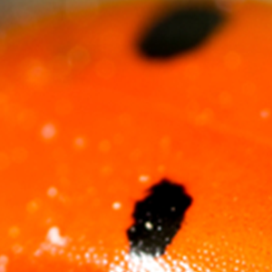
2. | 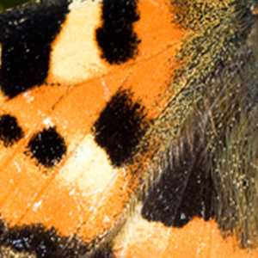 |  | 7. | 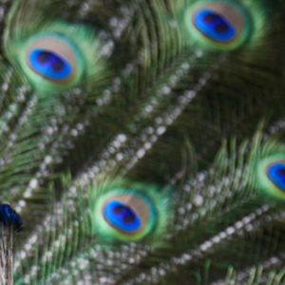
3. |  |  | 8. | 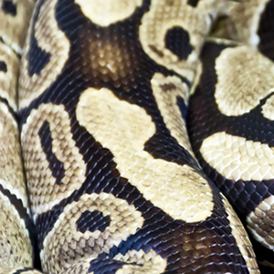
4. | 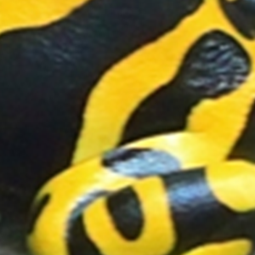 | 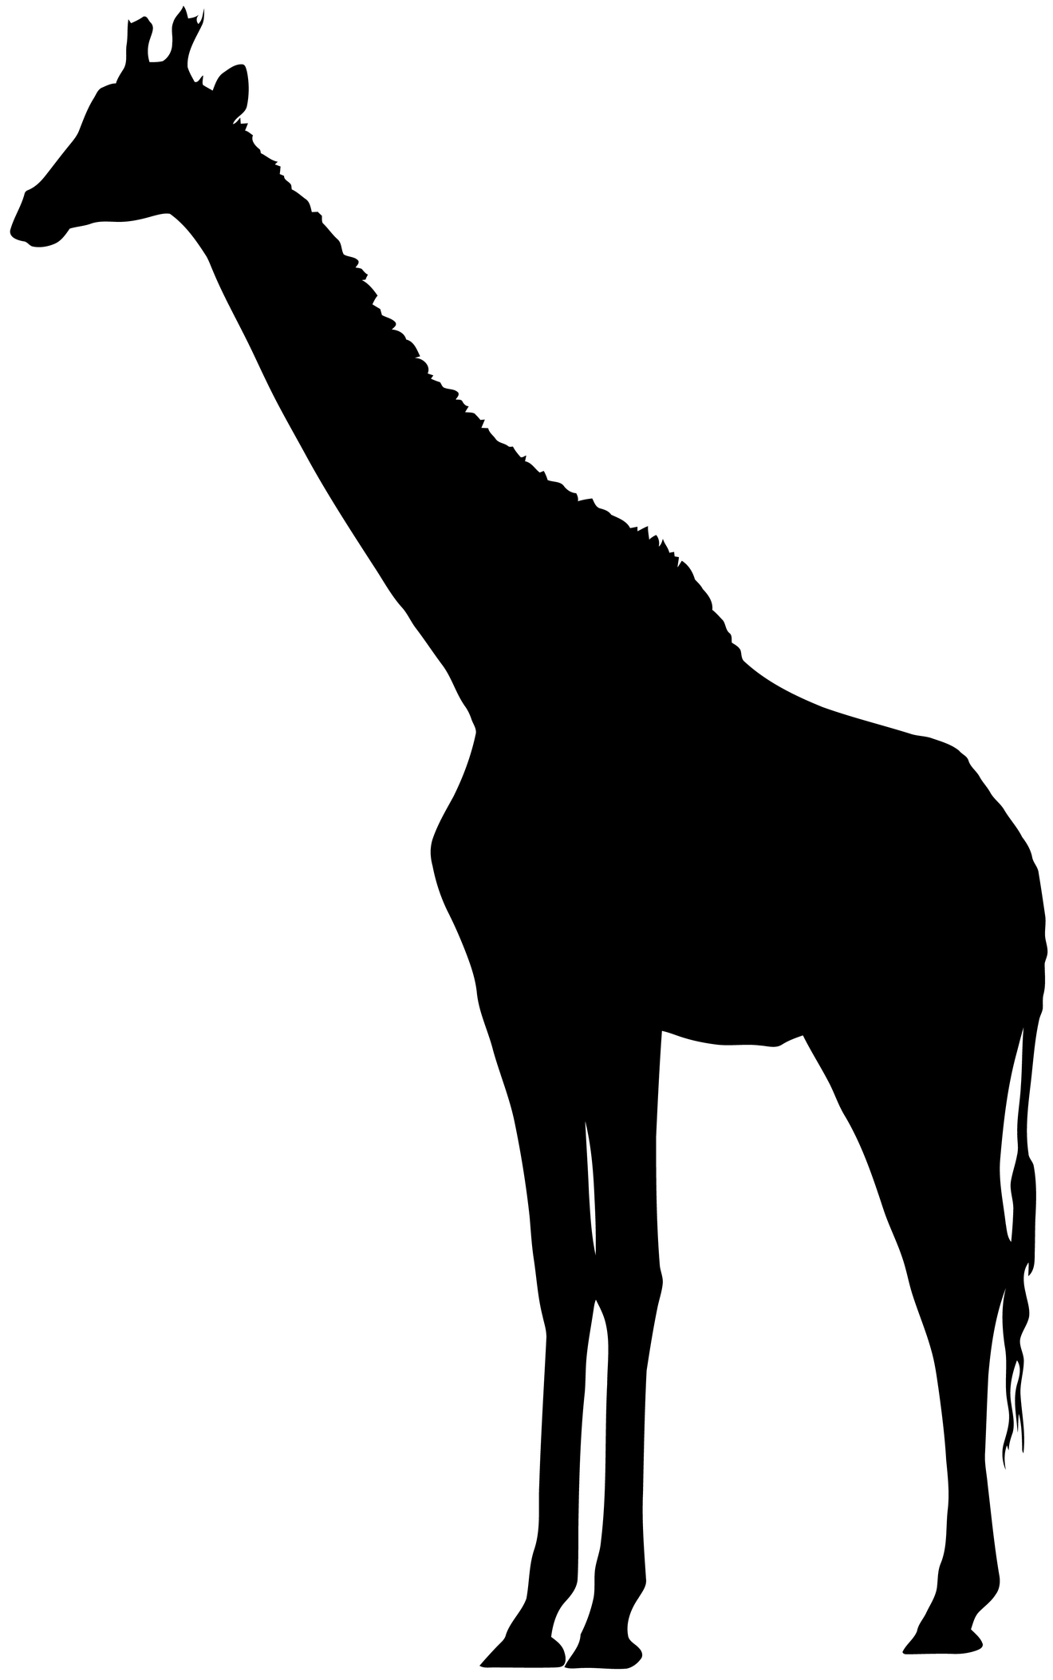 | 9. |  | 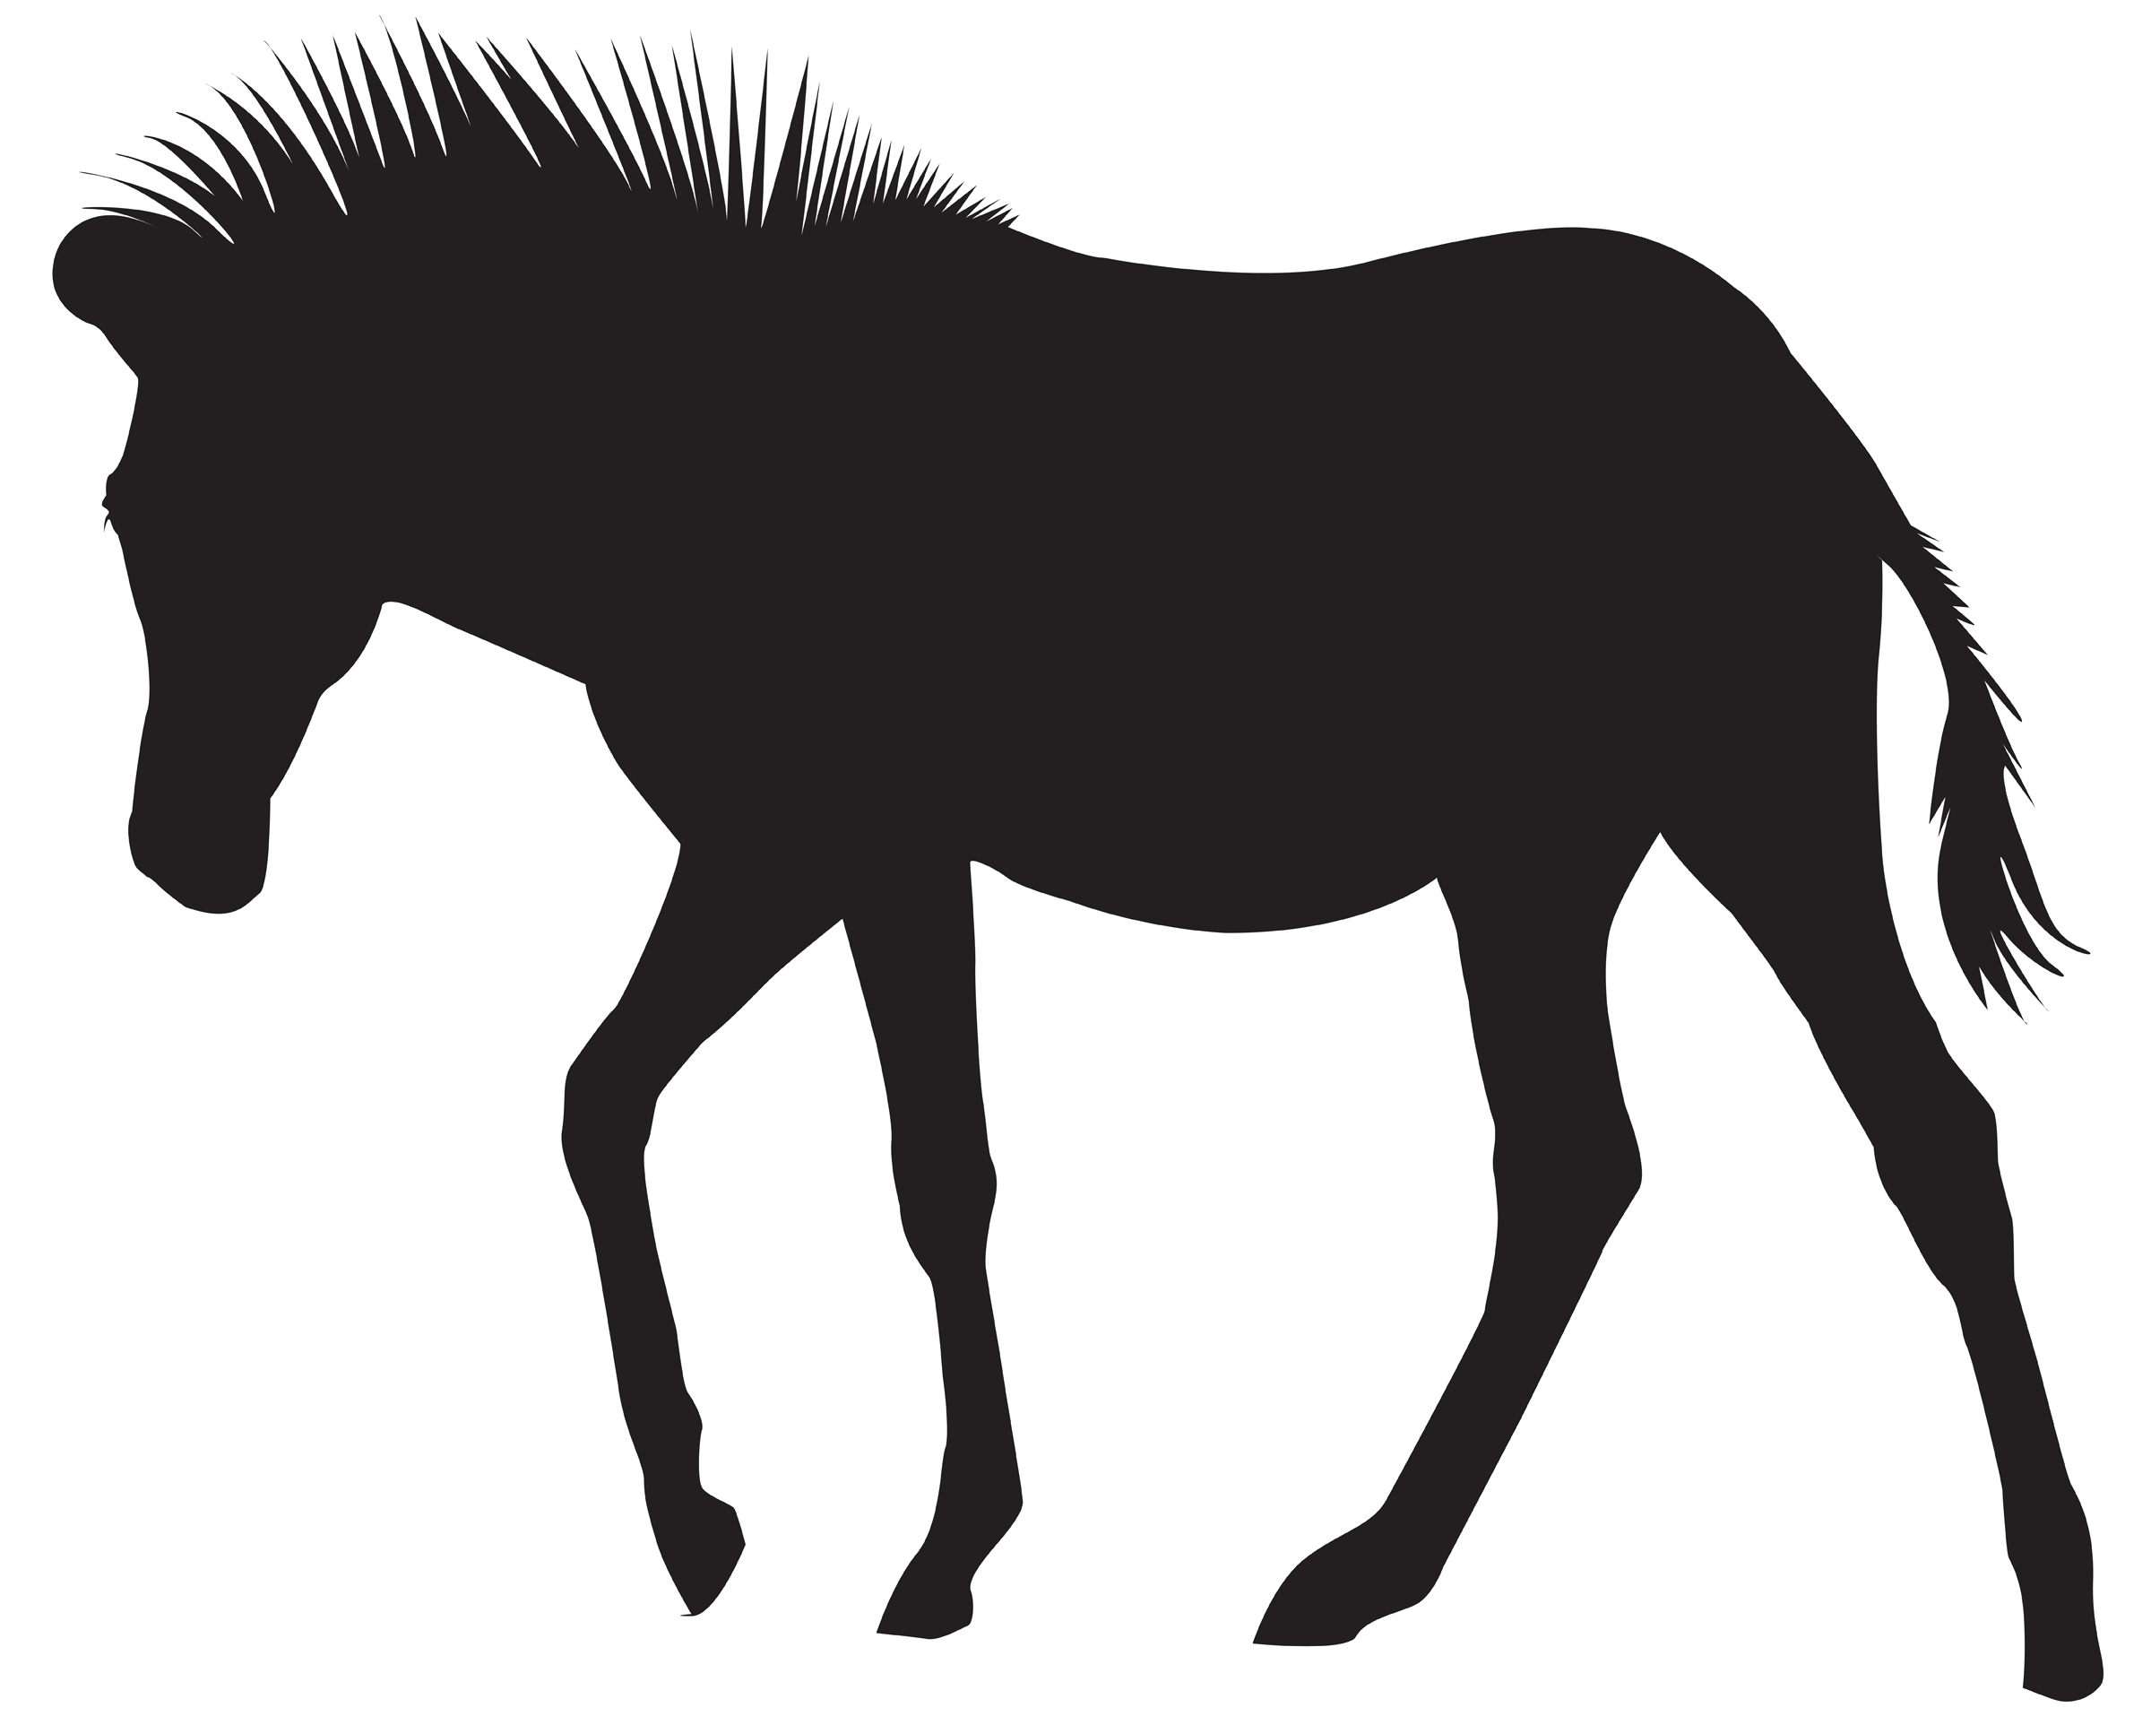
5. | 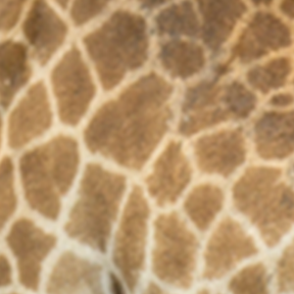 |  | 10.

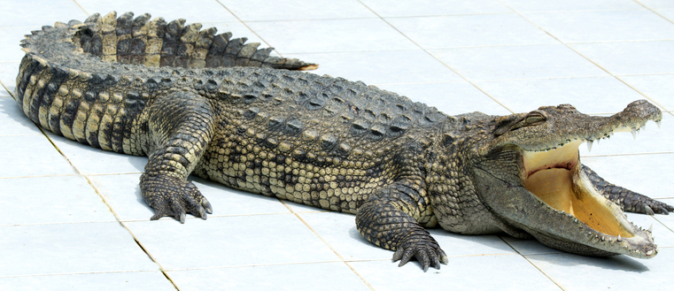 | 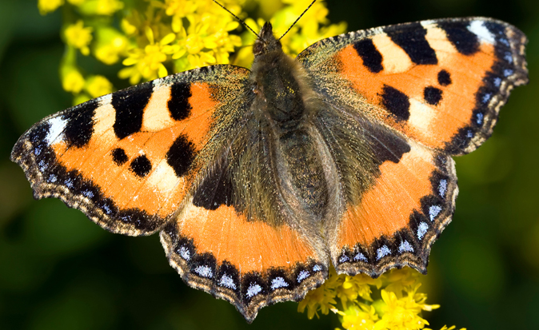 | 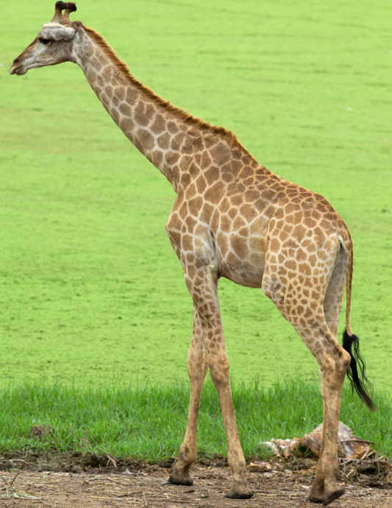
 | 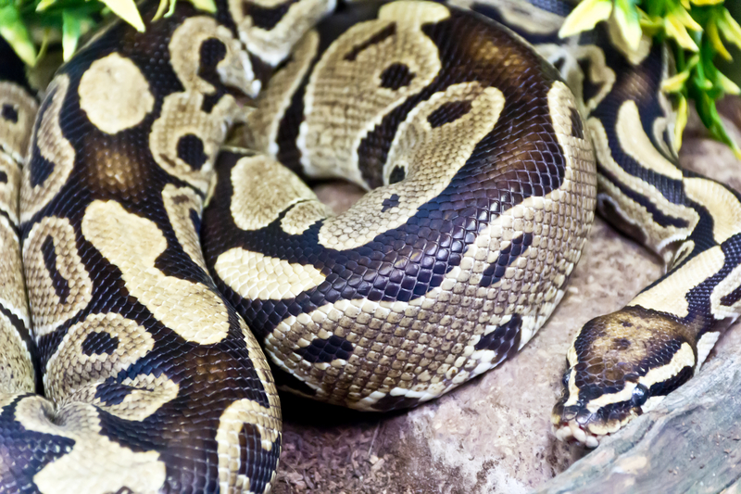
 | 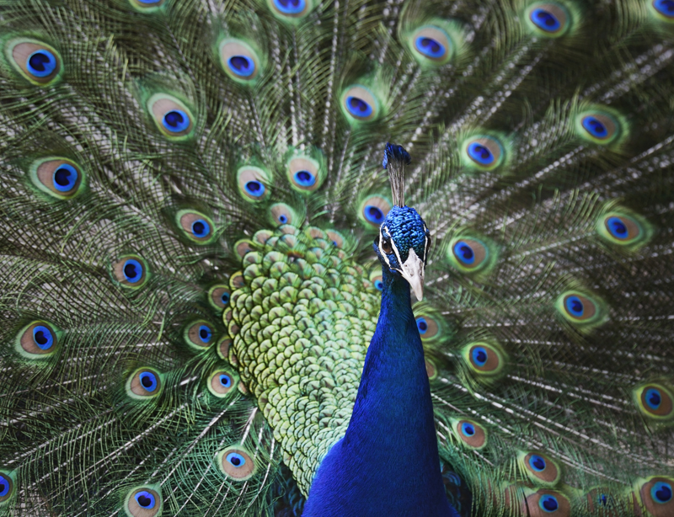
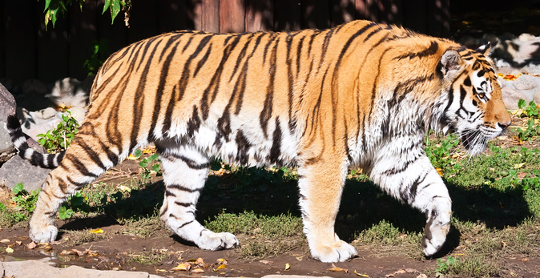 | 