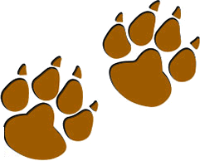
Mountain Lion
Parent and Leader Guidebook: pages 50-54
Lion Adventure Book: page 9

Location: park or outdoors

Materials
- Copies of Mountain Lion Adventure handout, one per adult
- Copy of Den Meeting Plan, one for leader(s)
- Name tags and Sharpie
- Copies of pack calendar
- Cub Scouts Poster Set with Scout Law, Scout Oath and Den Code of Conduct
(#621086 from Scout Shop)
- Blue tape or something to hang posters on wall

Optional
- Snack and water
- Activities for siblings (e.g., coloring books)

Activities
- Pick and Choose Game:
- First-aid kit
- Flashlight
- Water bottle
- Trail food
- Sun protection
- Whistle
- Other non-essential items (e.g., candy, heavy item, flying disc, hand tool, toys, crayons)
- SAW Game:
- Whistle for each Scout

- Optional: Scavenger Hunt, print one copy per Scout

Wrap Up Game
- Colored pencils, crayons or markers
- Few extra copies of Lion Adventure Book page 9 (for those who forget book)
Den Meeting Plan
Mountain Lion

Gathering
- Game: Lion, May I (page 51)

Opening
- Pledge, Scout Oath, Scout Law
- Buddy system - explain

Activities
- Activity 1: Pick and Choose Game (page 52)
- Activity 3: SAW (page 51)
- S = STAY put!
- A = Answer (if you hear your name)
- W = Blow your Whistle.

Wrap Up
- Lion Adventure Book, page 9

Closing
- Scout Law
- Outdoor Code

Mountain Lion Adventure

Happy Lions
Tune: Frere Jacques or Are you Sleeping?
Happy Lions, Happy Lions
Scout Law
A Scout is trustworthy, loyal, helpful, friendly, courteous, kind, obedient, cheerful, thrifty, brave, clean, reverent.
Scout Oath
On my honor, I will do my best to do my duty to God and my country and to obey the Scout Law; to help other people at all times; to keep myself physically strong, mentally awake, and morally straight.
Yes we are, yes we are
Hiking out in nature
Leaving only paw prints.
We’ll go far, we’ll go far.

Actions
- Happy Lions: Give a big grin
- Yes we are: Two thumbs up
- Hiking out in nature: March in place
- Leaving only paw prints: Hold both hands up in front, palms out
- We’ll go far: Hold a hand over, eyebrows, searching.

Outdoor Code
As an American, I will do my best to –
Be clean in my outdoor manners,
Be careful with fire,
Be considerate in the outdoors, and
Be conservation minded.
Upcoming Events

April 14 Scout Fair, NRG Arena
shac.org/scout-fair
10:00 am – 3:00 pm

May 2 Den Meeting

May 19 Banquet / Pack Meeting

June 12-15 Day Camp
orion.shac.org/day-camp

July Resident Camp
shac.org/resident-camp
Pack 72
facebook.com/pack72tomball
pack72tomball.scoutlander.com
Orion District
www.orion.shac.org
facebook.com/orionbsa
Sam Houston Area Council
www.shac.org
facebook.com/shac.bsa
Scavenger Hunt
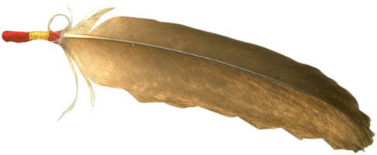  feather | 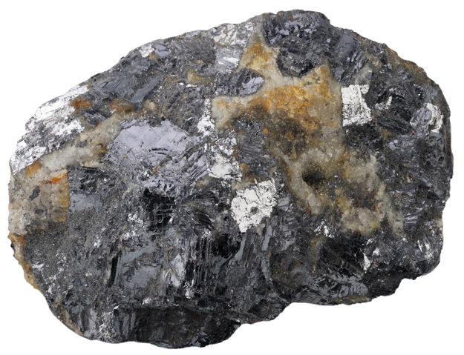  rough rock | smooth rock
dry leaf | 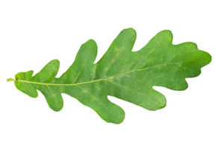  Oak leaf | 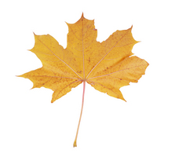  maple leaf
butterfly | 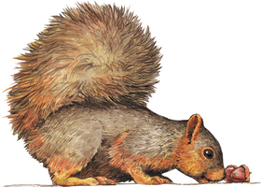  squirrels | 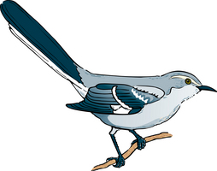  bird
pine needles | 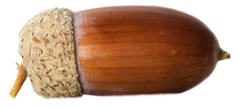  acorn | 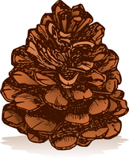  pinecone
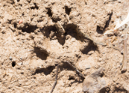  animal tracks | sticks | tree bark

Look for the state bird (Mockingbird), state tree (pecan), state mammal (armadillo), state insect (Monarch butterfly), state nut (pecan), state plant (prickly pear cactus), state shrub (crape myrtle and Texas sage)
Extra: Find 3 shapes of leaves and draw them. Find leaves of different colors. Find an animal home above your head. Find an animal home under the ground. Find a rock with more than 3 colors.

