CONSTRUCTION MEETING IDEAS

www.shac.org/construction-theme

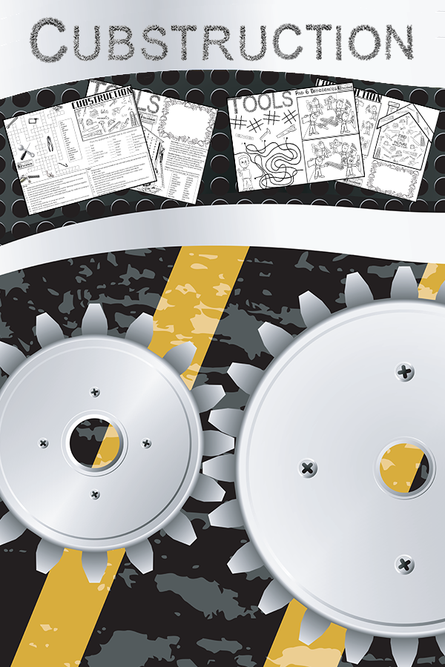
Put on your construction hats and dig in! Cub Scouts love to build things and work with tools and wood. Learn about different kinds of wood and where it comes from. Make gifts for your family or bird or bat houses for the community. Build a pinewood derby car. Cub Scouts can work with their family to make repairs around their home. Visit the local hardware store or home- improvement store and see all the different tools. Get permission to visit a local construction site. Since the best gifts are often homemade, make handcrafted awards to present at the pack meeting. Work on advancements focusing on art and tools. Construction makes a great theme for pack meetings or banquets.

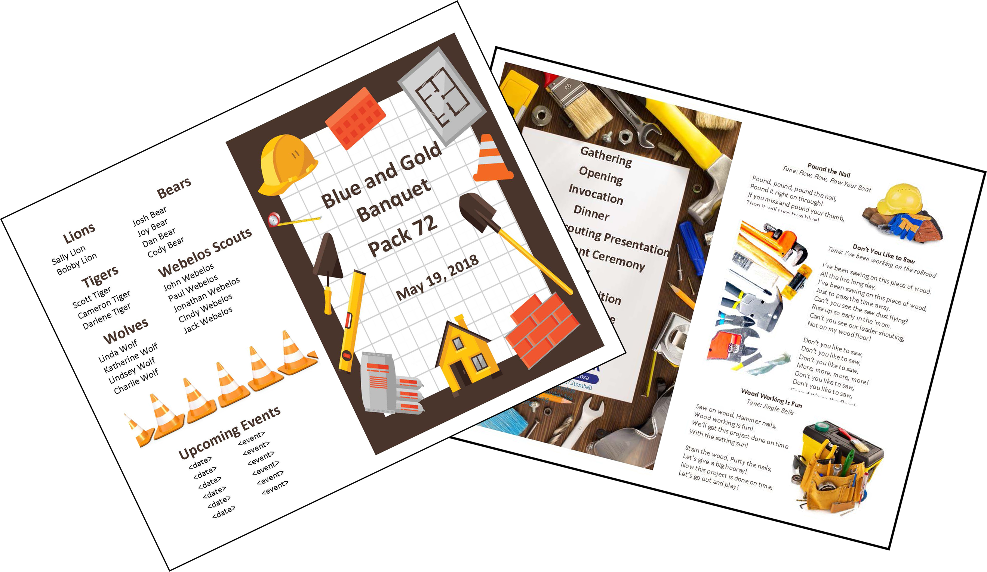
- Pack Meetings: The pack meeting brings all the dens in the pack together for the purposes of recognizing the achievements of the Cub Scouts, communicating information about upcoming events, and providing a program that enriches the Cub Scouting experience. It helps the Cub Scouts realize their den is part of a larger organization. A good pack meeting should be well planned and well organized. Packs meet several times during the year – there is no required number.
- Banquets: Most packs celebrate Scouting Anniversary Week in February with a birthday party called the blue and gold banquet; some packs do end of the year banquets.

Content  Sources: Baloo’s Bugle: Cubstruction (Mar 2006) and Cubstruction (Mar 2016), BSA: Cubstruction (Mar 2016).  Sample Meeting  Program Agenda Page 4  Podium Script Page 7  Cheers Page 38  Pack Meeting or Banquet Handout Page 40  Additional ideas  Advancement Ceremonies Page 46  Audience Participation Page 48  Cubmaster Minute Page 49  Closing Ceremonies Page 50  Den and Pack Activities Page 51  Games Page 56  Gathering Activities Page 59  Leader Recognition Page 61  Opening Ceremonies Page 61  Run-ons, Stunts & Jokes Page 63  Skits Page 64  Songs Page 66  Activity Pages Coming Soon  Placemats shac.org/construction-theme | Placemats  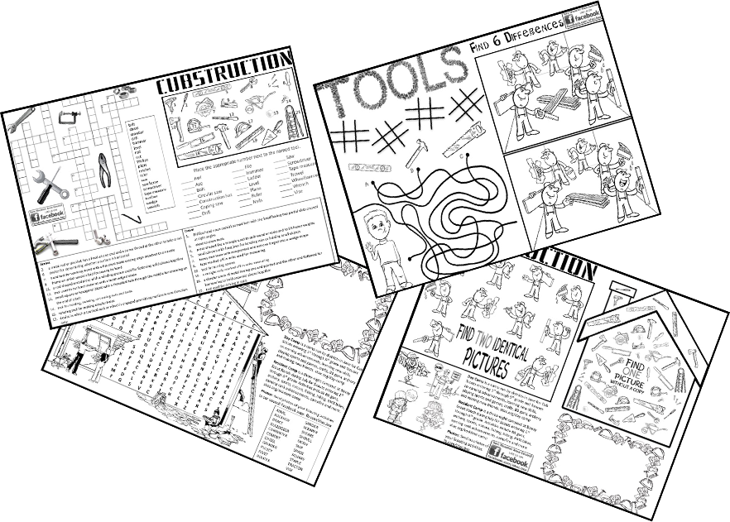  Free, customizable placemats are available for packs to use at banquets or den meetings to help promote day camp.  Placemats: www.shac.org/bug-theme.
Pinterest
Find additional ideas on the SHAC Pinterest page: www.pinterest.com/samhoustonbsa

ABOUT PACK MEETINGS

1. Before the Meeting prepare all materials and notify each person responsible for a part of the program. Plan to arrange the room (e.g., doors unlocked, room set up: chairs, tables, sound system, flag displayed properly) and set up equipment and materials (e.g., advancements and awards, props, agenda, script) with plenty of time to spare so the meeting can start on time.

2. Gathering (optional) activities give participants something to do while waiting for meeting for start. Elements can include:

Greeters to make people feel welcome and knows where to sit.

Den Exhibits and demonstrations set up on tables.

Preopening Activity such as an informal activity (e.g., activity sheet, placemat) or game often conducted by the den chief to keep everyone interested and active until the entire group has arrived. The gathering activity must be done prior to the formal start of the meeting as it encourages everyone to arrive on time so the meeting can start on time. Find gathering activities here and in the Den Chief Handbook, No. 647787, Cub Scout Leader How-To Book, No. 33832 and Group Meeting Sparkers, No. 33122.

3. Opening: While brief and energetic, the opening should include several elements:

Opening ceremony is the official start to the meeting and sets the stage. It can reinforce the purpose of Scouting and help make the Scouting ideals meaningful through the words and pictures of the ceremony. The Cubmaster, other pack leader or dens can lead the opening ceremony which should include a flag ceremony, and reciting the Scout Oath and Law. Pre-select a den to lead the pledge and have the den leader practice flag etiquette with the Scouts for several meetings prior. The pocket guide can assist the Scouts: https://shac.org/Data/Sites/1/media/instep/flag-ceremony.pdf. One of the points of the Scout Law can be highlighted each month or the pack meeting theme can be creatively introduced. Be aware of physical and/or mental disability challenges. Be sensitive that not all youth may be able to read or talk in front of a group. Adapt ceremonies in a sensitive way to involve everyone at the level they will feel comfortably involved. Dens pre-selected to lead the opening ceremony should practice for several den meetings prior to the pack meeting. If posters or props are used, have a picture on one side and the script printed with large letters on the back. Den leaders should teach the Scouts how to talk with their head up and project their voice to the people in the back of the room. Find opening ceremonies here and in the Cub Scout Ceremonies for Dens and Packs, No. 33212.

Invocation. A brief prayer may be included, but be sensitive to the diverse religious beleifs that may be repsresented in your pack. Find invocations here and in the Cub Scout Ceremonies for Dens and Packs, No. 33212.

Welcome and Introductions. The Cubmaster introduces and recognized visitors.

4. Program is the most fun and energetic part of the meeting. It can include these elements:

Audience Participation involve the entire audience and will help get the meeting into high gear and to add variety and fun. It can be led by the Cubmaster or another leader. Some include motions. Some require the audience to be dived into groups that respond to a key word in a story read by a a leader. It’s a good idea to let groups practice their motions or phrases first. Find participation skits here and the Cub Scout Leader How-To Book, No. 33832.

Skits appeal to Cub Scouts. Acting comes naturally to many Cub Scouts, and help channel youth imagination. Skits give a chance for creative expression, gaining self-cofidence, and teamwork and coopration. Some shy kids many not want to take part in skits and might be give responsibilities for handling props or “directing.” Have a den leader select a skit and practice for several meetings prior. Skits can also be found in the Cub Scout Leader How-To Book, No. 33832. The Cub Scouts should be taught how to talk clearly, slowly, loudly and to the back row of the audience (or speaking into the microphone correctly).

Run-ons are similar to skits but are much shorter and require only one or two people. Run-ons are good for a change of pace during pack meetings and campfires – something to make everyone laugh and relax. They come in handy as fill-ins between acts to fill dead time or to enliven the program.

Webelos Den Demonstrate things they learned during the month.

Games provide most of the action in the meeting and are part of the fun of Scouting. Games (e.g., relay races between dens, parent-child competitions, or skills competitions) can help youth develop self-confidence, independence and the ability to get a long with others. Games teach youth to follow rules, take turns, responsibt the rights of others, to give and take and to play fair. Games can be effective during pack meetings as long as the meeting doesn’t run too long. Consider the physical aspect, age of the youth, space requirements, time requirements, equipment, skills and abilities, number of players needed, equipment and purpose (physical, mental, educational). Games can be found a here and in the Cub Scout Leader How-To Book, No. 33832 has a whole section on cooperative games.

Songs. Singing builds pack spirit and enthusiasm. Singing gives Cub Scouts a chance to let off steam. Singing is fun! Use a song or two to set the mood for meetings, to get the audience moving and get rid of those wiggles or to quiet and calm the group when it’s time to go. Have a few songs ready to use as fillers during transition times. If not using “repeat after me” songs, make sure attendees have a printed copy. Pre-select a den to lead a song in the meeting handout. Songs can be found here and in the Cub Scout Leader How-To Book, No. 33832 and Cub Scout Songbook, No. 33222.
For blue and gold banquets, the pack committee may decide to bring in an entertainer such as a scientist or magician and have a video or slide show of what the pack did over the past year. Each unit is requested to hold a Friends of Scouting (FOS) presentation typically at the blue and gold banquet. The presentation, which takes approximately seven minutes to conduct, informs parents and leaders of all council services, its financial needs and extends an opportunity to help fulfill the need. The FOS campaign is a vital component to the programs and services of the council. The money offsets cost of training leaders, operating camps, and the service center, as well as providing other resources to units in the council.

5. Recognition
Advancement Ceremony. Recognition is important to Cub Scouts. Each one represents a great amount of time and effort on the part of the Cub Scout, family, and leaders and should be presented in a special ceremony. The presentation should be worthy of the award and the work that went into it. When Cub Scouts are recognized for their accomplishments, they are motivated to achieve more. Memories of meaningful, impressive ceremonies will last years. Depending on the advancements that you have for each month’s pack meeting, you’ll need to adapt ceremonies. Delete sections that relates to a badge that you are not presenting or change that section to a narrative form in place of the badge presentation. Use your imagination to make the ceremonies work for you. A variety of leaders can be involved in the advancement ceremony (e.g., advancement chair, Cubmaster, assistant Cubmasters, den leaders, den chiefs). Use simple props and costumes to enhance ceremonies. Some ceremonies will be simple (monthly awards) while others are more involved (e.g., rank ceremonies, crossover ceremonies, Arrow of Light ceremonies). When ranks are presented, a family member can be called forward with the Cub Scout and receive the recognition to then give to the youth; otherwise, it is acceptable to present awards to the Cub Scout directly. Find advancement ceremonies here and in the Cub Scout Den and Pack Ceremonies, No. 33212.

Leader Recognition (for banquets and other meetings as appropriate). When working with volunteers, thanks is the only payment we can really give them. Public recognition is the most valued form of payback for volunteers – so remember to recognize parents, leaders and others who help the program! Consider a hand written thank you note, homemade award, certificate of appreciation, or gift from the Scout Shop. Consider submitting pack leaders for adult awards and recognitions (e.g., training awards) or district awards that they qualify for and presenting them at the blue and gold banquet. Also recognize volunteers who have made significant contributions. Find leader recognition ceremonies here.

6. Closing

Announcements. Announcements should be kept bried, to the point, and written out, if possible. Announcement details (e.g., date, time, address, description of event, who can attend, what to bring, web page to find more information) should be provided in pack meeting handout. The Cubmaster should take only about one minute to enthusiastically highlight the exciting upcoming activities and the date of the next pack meeting.

Cubmater Minute. At the end of a pack meeting filled with learning, fun, and fellowship comes the grand finale, the Cubmaster Minute. Consider it a closing argument to your Scouts — one last chance to inspire before they head home. Find a message that’s relevant, powerful, and memorable that can be crammed into 60 seconds. It’s an opportunity to quiet the Cub Scouts and put them in a reflective mood before departing. Find Cubmaster Minutes here.

The Closing Ceremony draws the meeting to an end. It’s usually serious and quiet and provides an opportunity to present a brief character lesson, a simple thought. Keep it simple.

7. After the Meeting.
Refreshments (optional). Packs can serve refreshments which can be furnished by a special committee or brought by assigned dens.
It is important that sufficient help be recruited to put the meeting room back in order. The leaders review the events of the meeting, finalize plans for the next pack meeting, and review their progress toward the upcoming pack meeting.

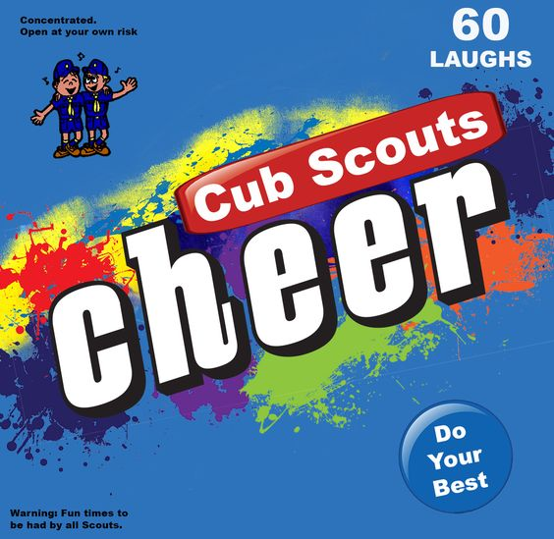
Cheers and applauses add fun to meetings and campfire programs and are a great way to recognize Scouts and Scouters during den or pack meetings or campfires for accomplishments and performances. Be sure everyone knows and understands the cheers or applause and how to do it. Cheers and applauses serve more than one purpose -- they not only provide recognition but also help liven up a meeting. Strive for quality of performance. Another important side effect is they provide” wiggle time” for all the Scouts and siblings during the ceremonies so they sit still during the serious moments. It is a lot easier and a lot less stressful to lead a cheer and have fun than to be constantly reminding the Scouts to sit quietly. Assign a leader (e.g., assistant Cubmaster) to enthusiastically lead the cheers at every opportunity throughout the meeting (e.g., after a skit or advancement ceremony). Stuff the cheer box with themed cheers before the meeting. Find cheers here and www.shac.org/cheers. Make a cheer box or bag by attaching the graphic (www.shac.org/Data/Sites/1/media/resources/leader-guides/Cheer-Box-1200x1170.jpg) to a blue bag or box.

Resources:
- Pack Meeting Resources: www.shac.org/pack-meetings
- BSA Pack Meeting Resources: www.scouting.org/programs/cub-scouts/pack-meeting-resources
- Pack Meeting Tips: https://blog.scoutingmagazine.org/2018/12/10/8-essential-tips-for-controlling-chaos-at-cub-scout-pack-or-den-meetings

PACK MEETING PLANNING SHEET

Pack Meeting Date: |  | Theme: | Cubstruction

Time | Activity | Materials | Responsible
6:30 pm | Before the meeting  Meeting props: construction hats, traffic cones, safety vests, tool belt | - set up chairs  - sound system  - flags  - advancement table  - props (e.g., construction hats, traffic cones, safety vests, tool belt)
6:45 pm | Gathering | - activity sheet  - pencils  - pack meeting handouts | - ___ Den  (greeters)
7:01 pm | Opening Ceremony: Purposeful Building Opening Ceremony  Decorate ten identical boxes to look like bricks, boards or some other construction material. Put one purpose of Cub Scouting on each box.*  Character Development  Spiritual Growth  Good Citizenship  Sportsmanship and Fitness  Family Understanding  Respectful Relationships  Personal Achievement  Friendly Service  Fun and Adventure  Preparation for Scouts BSA  Recruit Cub Scouts to each carry in a block. Have the script printed on the back of the block (The side the Cub Scout sees but the audience does not).  #1 and #12 do not get blocks. Leaders may perform these parts. Cub Scouts can perform more than one part, if needed. Have each Cub Scout place their block on the stack after reading. Start with 4 on the bottom level, three on the next row, then two and one on top.  # 1: Let us begin our meeting by thinking about the ways we help Cubstruct our Scouts.  # 2: Character Development - Cub Scouting influences the development of positive character traits (Places block for first level of pyramid)  # 3: Spiritual growth – Cub Scouting encourages spiritual growth by all members (Places block for first level of pyramid)  # 4: Good Citizenship – Cub Scouts develop habits of good citizenship (Places block for first level of pyramid)  # 5: Sportsmanship and Fitness – Cub Scouting encourages good sportsmanship and pride in growing strong in mind and body(Places block for first level of pyramid)  # 6: Family Understanding – Cub Scouting improves understanding within the family (Places block for second level of pyramid)  # 7: Respectful Relationships – Cub Scouting strengthens the ability to get along with other Cub Scouts and respect other people (Places block for second level of pyramid)  # 8: Personal Achievement – Cub Scouting fosters a sense of personal achievement by developing new skills and interests (Places block for second level of pyramid)  # 9: Friendly Service – Cub Scouts learn how to be helpful and do their best (Places block for third level of pyramid)  # 10: Fun and Adventure – Cub Scouting provides fun and exciting new things to do (Places block for third level of pyramid)  # 11: Preparation for Scouts BSA – Cub Scouting prepares us to become a Scout in a troop (Places block for top level of pyramid)  # 12: Let us now think about how our nation of fifty states was constructed from 13 original colonies as we take the Pledge of Allegiance. | - 12 Cub Scouts (or Scouts can do more than one part)  - 10 boxes with words printed on one side and script on the back  - table to place boxes, optional  - flags  - pocket guide  - cheer box  - printed cheers | - ___ Den  - den leader  - assistant Cubmaster (leads cheer)
7:06 | Invocation We give thanks for this world we live in. We commit to be thrifty when building by recycling and reusing our resources wisely to construct our world and keep it clean and beautiful. | - script
7:00 pm | Welcome | - props to wear: construction hat, tool belt | - Cubmaster
7:08 | Program |  | - ___ Den  - den leader
 | Audience Participation (optional) | - script | - Cubmaster  - assistant Cubmaster (leads cheer)
7:15 | Song  List on pack meeting handout | - pack meeting handout | - ___ Den  - den leader
7:17 | Skit (optional) |  | - ___ Den  - den leader  - assistant Cubmaster (leads cheer)
 | Game (optional, if time permits) |  | - Cubmaster  - assistant Cubmaster (leads cheer)
7:20 | Advancement Ceremony: Working with Wood  Props: Pocket knife, saw, screw driver, sandpaper and varnish.  Narrator: Before you are a variety of tools used by  carpenters and wood workers to transform plain wood into objects of beauty and usefulness. There are many steps between beginning to work with a piece of wood and completing a project. So, it is with Cub Scouting. Tonight, we are recognizing significant steps of progress along the Cub Scout trail.  Lion (pocket knife) Of course, a carpenter has to start with a plan. Once they have a plan in mind, the first tool they use begins to shape the wood. We have young carpenters who have completed the initial step and are here to receive their awards. [Call Lions forward, present awards, lead cheer.]  Tiger (saw) Once started on the project, a carpenter has to focus on the major task of shaping this project- whether the finished product is a chair or a bowl. Many, many steps are required to complete this stage of the task. We have several Cub Scouts who have completed the Tiger adventures. [Call Tigers forward, present awards, lead cheer.]  Wolf (screw driver) Once the wood is shaped, it is ready for the assembly process. This stage requires many different types of tools and fasteners and precision in assembly. Much patience is needed. Our Wolf Cub Scouts are learning more and have a tougher set of requirements to fulfill. We have several Cub Scouts who have completed Wolf adventures. [Call Wolves forward, present awards, lead cheer.]  Bear (sandpaper) After the pieces are assembled, the rough edges must be smoothed out. Sandpaper will smooth out the edges and roughness. Our Bear Cubs are maturing and becoming smoother in their actions and learning more about how to be a leader. We have several Cub Scouts who have completed Bear adventures. [Call Bears forward, present awards, lead cheer.]  Webelos Scouts – 4th grade (varnish) The crowning touch to finishing a fine piece of furniture is what truly makes a piece of wood a masterpiece. Many coats of glass and sanding in between are needed to make wood glow. Drawers and doors without proper hardware are useless. Webelos are learning how to put on the finishing touches. We have several Cub Scouts who have completed several Webelos adventures. [Call 4th grade Webelos Scouts forward, present awards, lead cheer.]  Webelos Scouts – 5th grade – Our 5th grade have demonstrated a commitment to becoming master craftsmen and are preparing to finish their goal by earning the Arrow of Light rank and joining Scouts BSA. [Call 5th grade Webelos Scouts forward, present awards, lead cheer.] | - awards  - script  - props: Pocket knife, saw, screw driver, sandpaper and varnish.  - cheer box  - printed cheers | - advancement chair  - Cubmaster  - assistant Cubmaster (assists; leads cheer)
 | Leader Recognition (if applicable) | - printed script  - recognition items | - committee chair  - Cubmaster (assists)
7:50 | Song  List on pack meeting handout | - pack meeting handout | - ___ Den  - den leader
7:53 | Announcements | - script  - pack meeting handout | - Cubmaster
7:55 | Cubmaster Minute: Block of Wood II  Prop: Hold up a nicely finished wooden item.  A wood carver does not learn carve overnight. It takes patience and hard work to learn how to carve well and make something beautiful. As the wood is shaped, assembled, sanded, finished, and adorned with the final details of a fine finished piece of furniture, so our Cub Scouts grow through experiencing the many trails Cub Scouting has to offer. And soon, almost before we know it, the Cub Scout has grown and developed until they are ready to advance into the Scouts BSA program. Before our eyes, a Cub Scout has turned into a well-adjusted young adult. But a Cub Scout doesn’t become a finished product all by himself. They need challenge and direction. Our den leaders, assistants, and other pack leaders provide this help for our Cub Scouts. They help to carve and shape the future of young men. Parents provide vital support to help put the finishing touches on their sons. Thanks so much to all of you who have reached out to help the Cub Scouts in our pack along the way to become all they can be. | - script  - nicely carved piece of wood | - Cubmaster
7:56 | Closing: : Tools That Build a Better World Arrangement  Each Cub Scout holds a tool as they speak - saw, hammer, wrench, ruler, plunger, drill, and pliers. You will need seven Cub Scouts. Maybe hang tags on the tools with their parts in LARGE print  # 1: We are the future builders of America and the world. And this is how we will shape tomorrow.  # 2: (Hammer) I will hammer out injustice.  # 3: (Saw) I will help cut out crime.  # 4: (Drill) I will drill love into every heart.  # 5: (Wrench) I will wrench out discrimination.  # 6: (Plunger) I will plunge out hatred.  # 7: (Pliers) I will pinch out poverty. | - script  - 7 tools (hammer, saw, rill, wrench, plunger, pliers) with script attached  or  - Seven pictures of tools with script printed on back | - ___ Den  - den leader
7:59 | Closing Flag Ceremony | - flags  - pocket guide | - ___ Den  - dean leader
 | After the Meeting |  | - (clean up)

Podium Script: Invocation

Would the audience please rise (pause)?

“We give thanks for this world we live in. We commit to be thrifty when building by recycling and reusing our resources wisely to construct our world and keep it clean and beautiful.”

Opening Ceremony: Print for back of posters
Purposeful Building Opening Ceremony
Ten identical boxes (can be decorated to look like bricks, boards or some other construction material).
Put one purpose of Cub Scouting on each box.* Ten Cub Scouts to each carry in a block and say something about the purpose listed on their block. Having the script printed on the back of the block (The side the Cub Scout sees but the audience does not). Cub Scouts can do more than one part.
#1 and #12 do not get blocks. Leaders may perform these parts.
Have each Cub Scout place their block on the stack after reading. Start with 4 on the bottom level, three on the next row, then two and one on top.

No Block

# 1: Let us begin our meeting by thinking about the ways we help Cubstruct our Scouts.

Character
Development

# 2: Character Development - Cub Scouting influences the development of positive character traits (Places block for first level of pyramid)

Spiritual
Growth

# 3: Spiritual growth – Cub Scouting encourages spiritual growth by all members (Places block for first level of pyramid)

Good
Citizenship

# 4: Good Citizenship – Cub Scouts develop habits of good citizenship (Places block for first level of pyramid)

Sportsmanship
and Fitness

# 5: Sportsmanship and Fitness – Cub Scouting encourages good sportsmanship and pride in growing strong in mind and body(Places block for first level of pyramid)

Family
Understanding

# 6: Family Understanding – Cub Scouting improves understanding within the family (Places block for second level of pyramid)

Respectful
Relationships

# 7: Respectful Relationships – Cub Scouting strengthens the ability to get along with other Cub Scouts and respect other people (Places block for second level of pyramid)

Personal
Achievement

# 8: Personal Achievement – Cub Scouting fosters a sense of personal achievement by developing new skills and interests (Places block for second level of pyramid)

Friendly
Service

# 9: Friendly Service – Cub Scouts learn how to be helpful and do their best (Places block for third level of pyramid)

Fun and
Adventure

# 10: Fun and Adventure – Cub Scouting provides fun and exciting new things to do (Places block for third level of pyramid)

Preparation
for Scouts BSA

# 11: Preparation for Scouts BSA – Cub Scouting prepares us to become a Scout in a troop (Places block for top level of pyramid)

No Block

# 12: Let us now think about how our nation of fifty states was constructed from 13 original colonies as we say the Pledge of Allegiance.

Podium Script: Advancement Ceremony

Working with Wood
Props: Pocket knife, saw, screw driver, sandpaper and varnish.

CM: Before you are a variety of tools used by carpenters and wood workers to transform plain wood into objects of beauty and usefulness. There are many steps between beginning to work with a piece of wood and completing a project. So, it is with Cub Scouting. Tonight, we are recognizing significant steps of progress along the Cub Scout trail.

Lion (pocket knife) Of course, a carpenter has to start with a plan. Once they have a plan in mind, the first tool they use begins to shape the wood. We have young carpenters who have completed the initial step and are here to receive their awards. [Call Lions forward, present awards, lead cheer.]

Tiger (saw) Once started on the project, a carpenter has to focus on the major task of shaping this project- whether the finished product is a chair or a bowl. Many, many steps are required to complete this stage of the task. We have several Cub Scouts who have completed the Tiger adventures. [Call Tigers forward, present awards, lead cheer.]

Wolf (screw driver) Once the wood is shaped, it is ready for the assembly process. This stage requires many different types of tools and fasteners and precision in assembly. Much patience is needed. Our Wolf Cub Scouts are learning more and have a tougher set of requirements to fulfill. We have several Cub Scouts who have completed Wolf adventures. [Call Wolves forward, present awards, lead cheer.]
Bear (sandpaper) After the pieces are assembled, the rough edges must be smoothed out. Sandpaper will smooth out the edges and roughness. Our Bear Cubs are maturing and becoming smoother in their actions and learning more about how to be a leader. We have several Cub Scouts who have completed Bear adventures. [Call Bears forward, present awards, lead cheer.]

Webelos Scouts – 4th grade (varnish) The crowning touch to finishing a fine piece of furniture is what truly makes a piece of wood a masterpiece. Many coats of glass and sanding in between are needed to make wood glow. Drawers and doors without proper hardware are useless. Webelos are learning how to put on the finishing touches. We have several Cub Scouts who have completed several Webelos adventures. [Call 4th grade Webelos Scouts forward, present awards, lead cheer.]

Webelos Scouts – 5th grade – Our 5th grade have demonstrated a commitment to becoming master craftsmen and are preparing to finish their goal by earning the Arrow of Light rank and joining Scouts BSA. [Call 5th grade Webelos Scouts forward, present awards, lead cheer.]

Podium Script: Cubmaster Minute
Block of Wood II
Prop: Hold up a nicely finished wooden item.

A wood carver does not learn carve overnight. It takes patience and hard work to learn how to carve well and make something beautiful.

As the wood is shaped, assembled, sanded, finished, and adorned with the final details of a fine finished piece of furniture, so our Cub Scouts grow through experiencing the many trails Cub Scouting has to offer.

And soon, almost before we know it, the Cub Scout has grown and developed until they are ready to advance into the Scouts BSA program. Before our eyes, a Cub Scout has turned into a well-adjusted young adult.

But a Cub Scout doesn’t become a finished product all by himself. They need challenge and direction. Our den leaders, assistants, and other pack leaders provide this help for our Cub Scouts. They help to carve and shape the future of young men.

Parents provide vital support to help put the finishing touches on their sons.

Thanks so much to all of you who have reached out to help the Cub Scouts in our pack along the way to become all they can be.

Closing Ceremony: Print for back of posters
Tools That Build a Better World Arrangement

You will need seven Cub Scouts.

Each Cub Scout holds a tool as they speak - saw, hammer, wrench, ruler, plunger, drill, and pliers. Tape the script to the back side of the tool or hang tags on the tools with their parts in LARGE print

If actual tools are not available, print the pictures below, one-sided to two-sided.

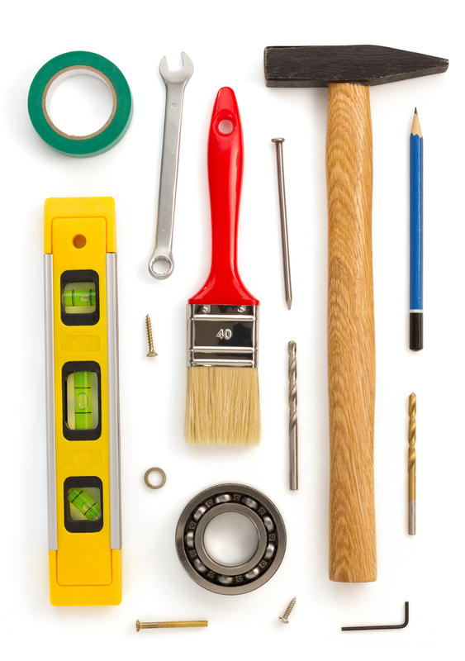

# 1:

We are the future builders of America and the world. And this is how we will shape tomorrow.

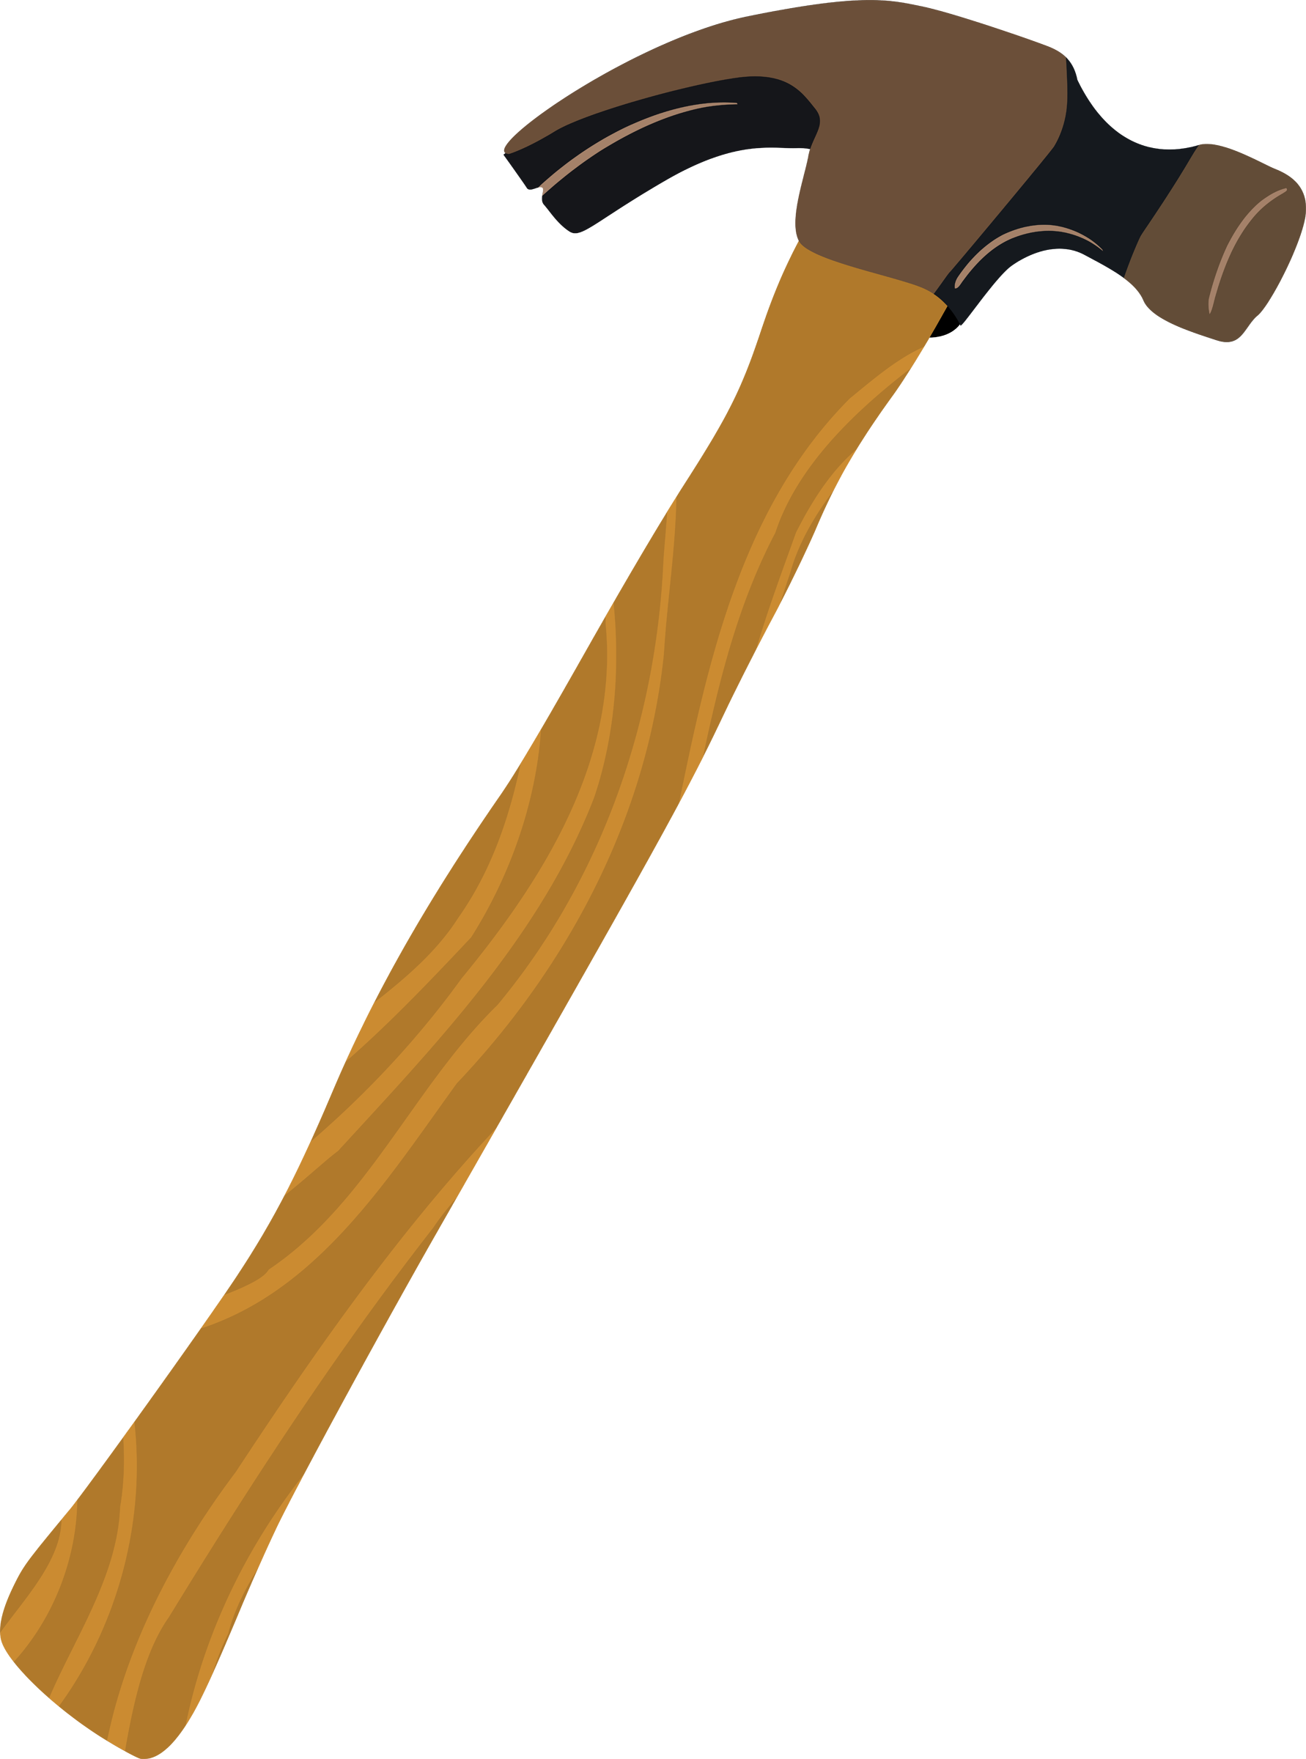
# 2: (Hammer)

I will hammer out injustice.

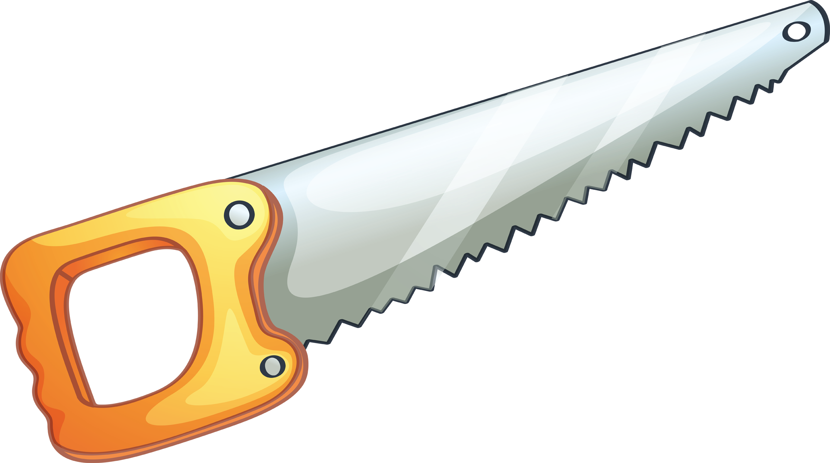
# 3: (Saw)

I will help cut out crime.

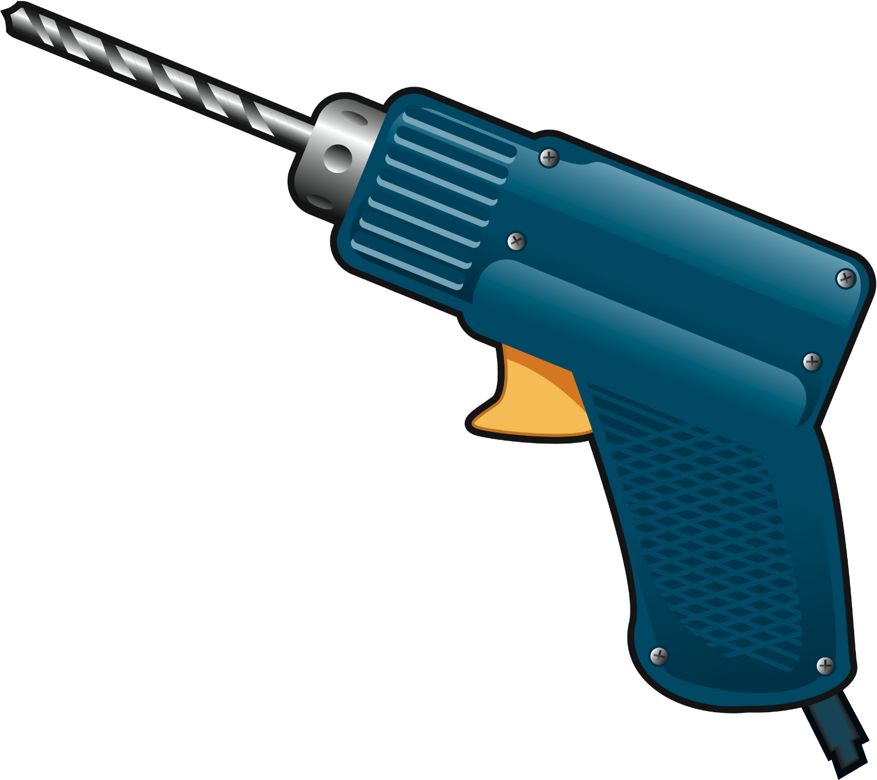
# 4: (Drill)

I will drill love into every heart.

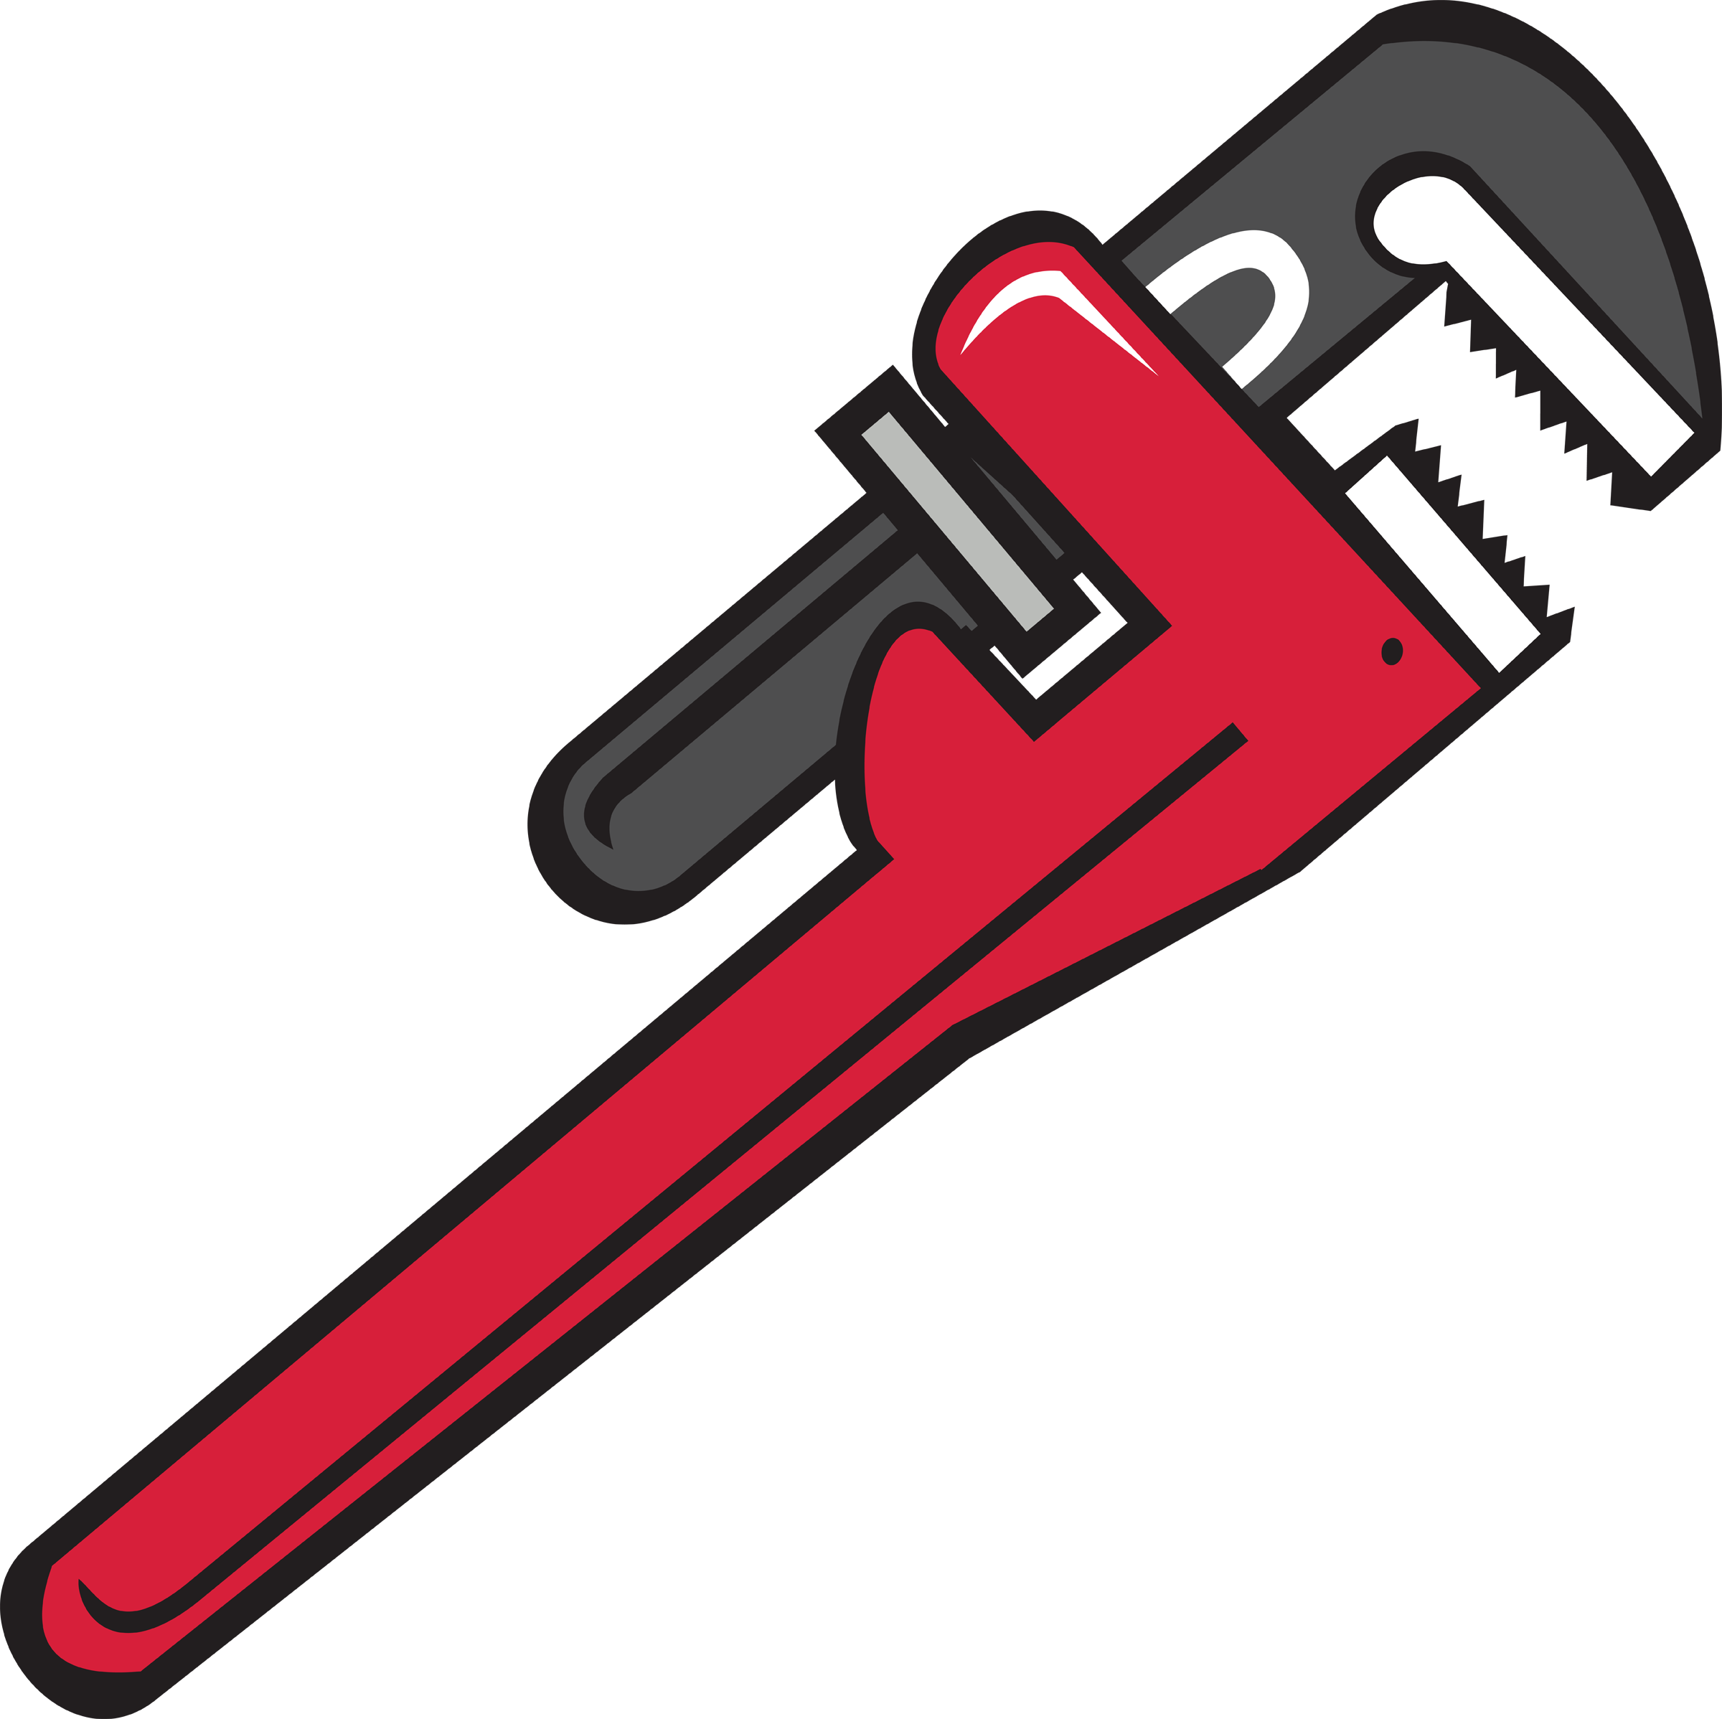
# 5: (Wrench)

I will wrench out discrimination.

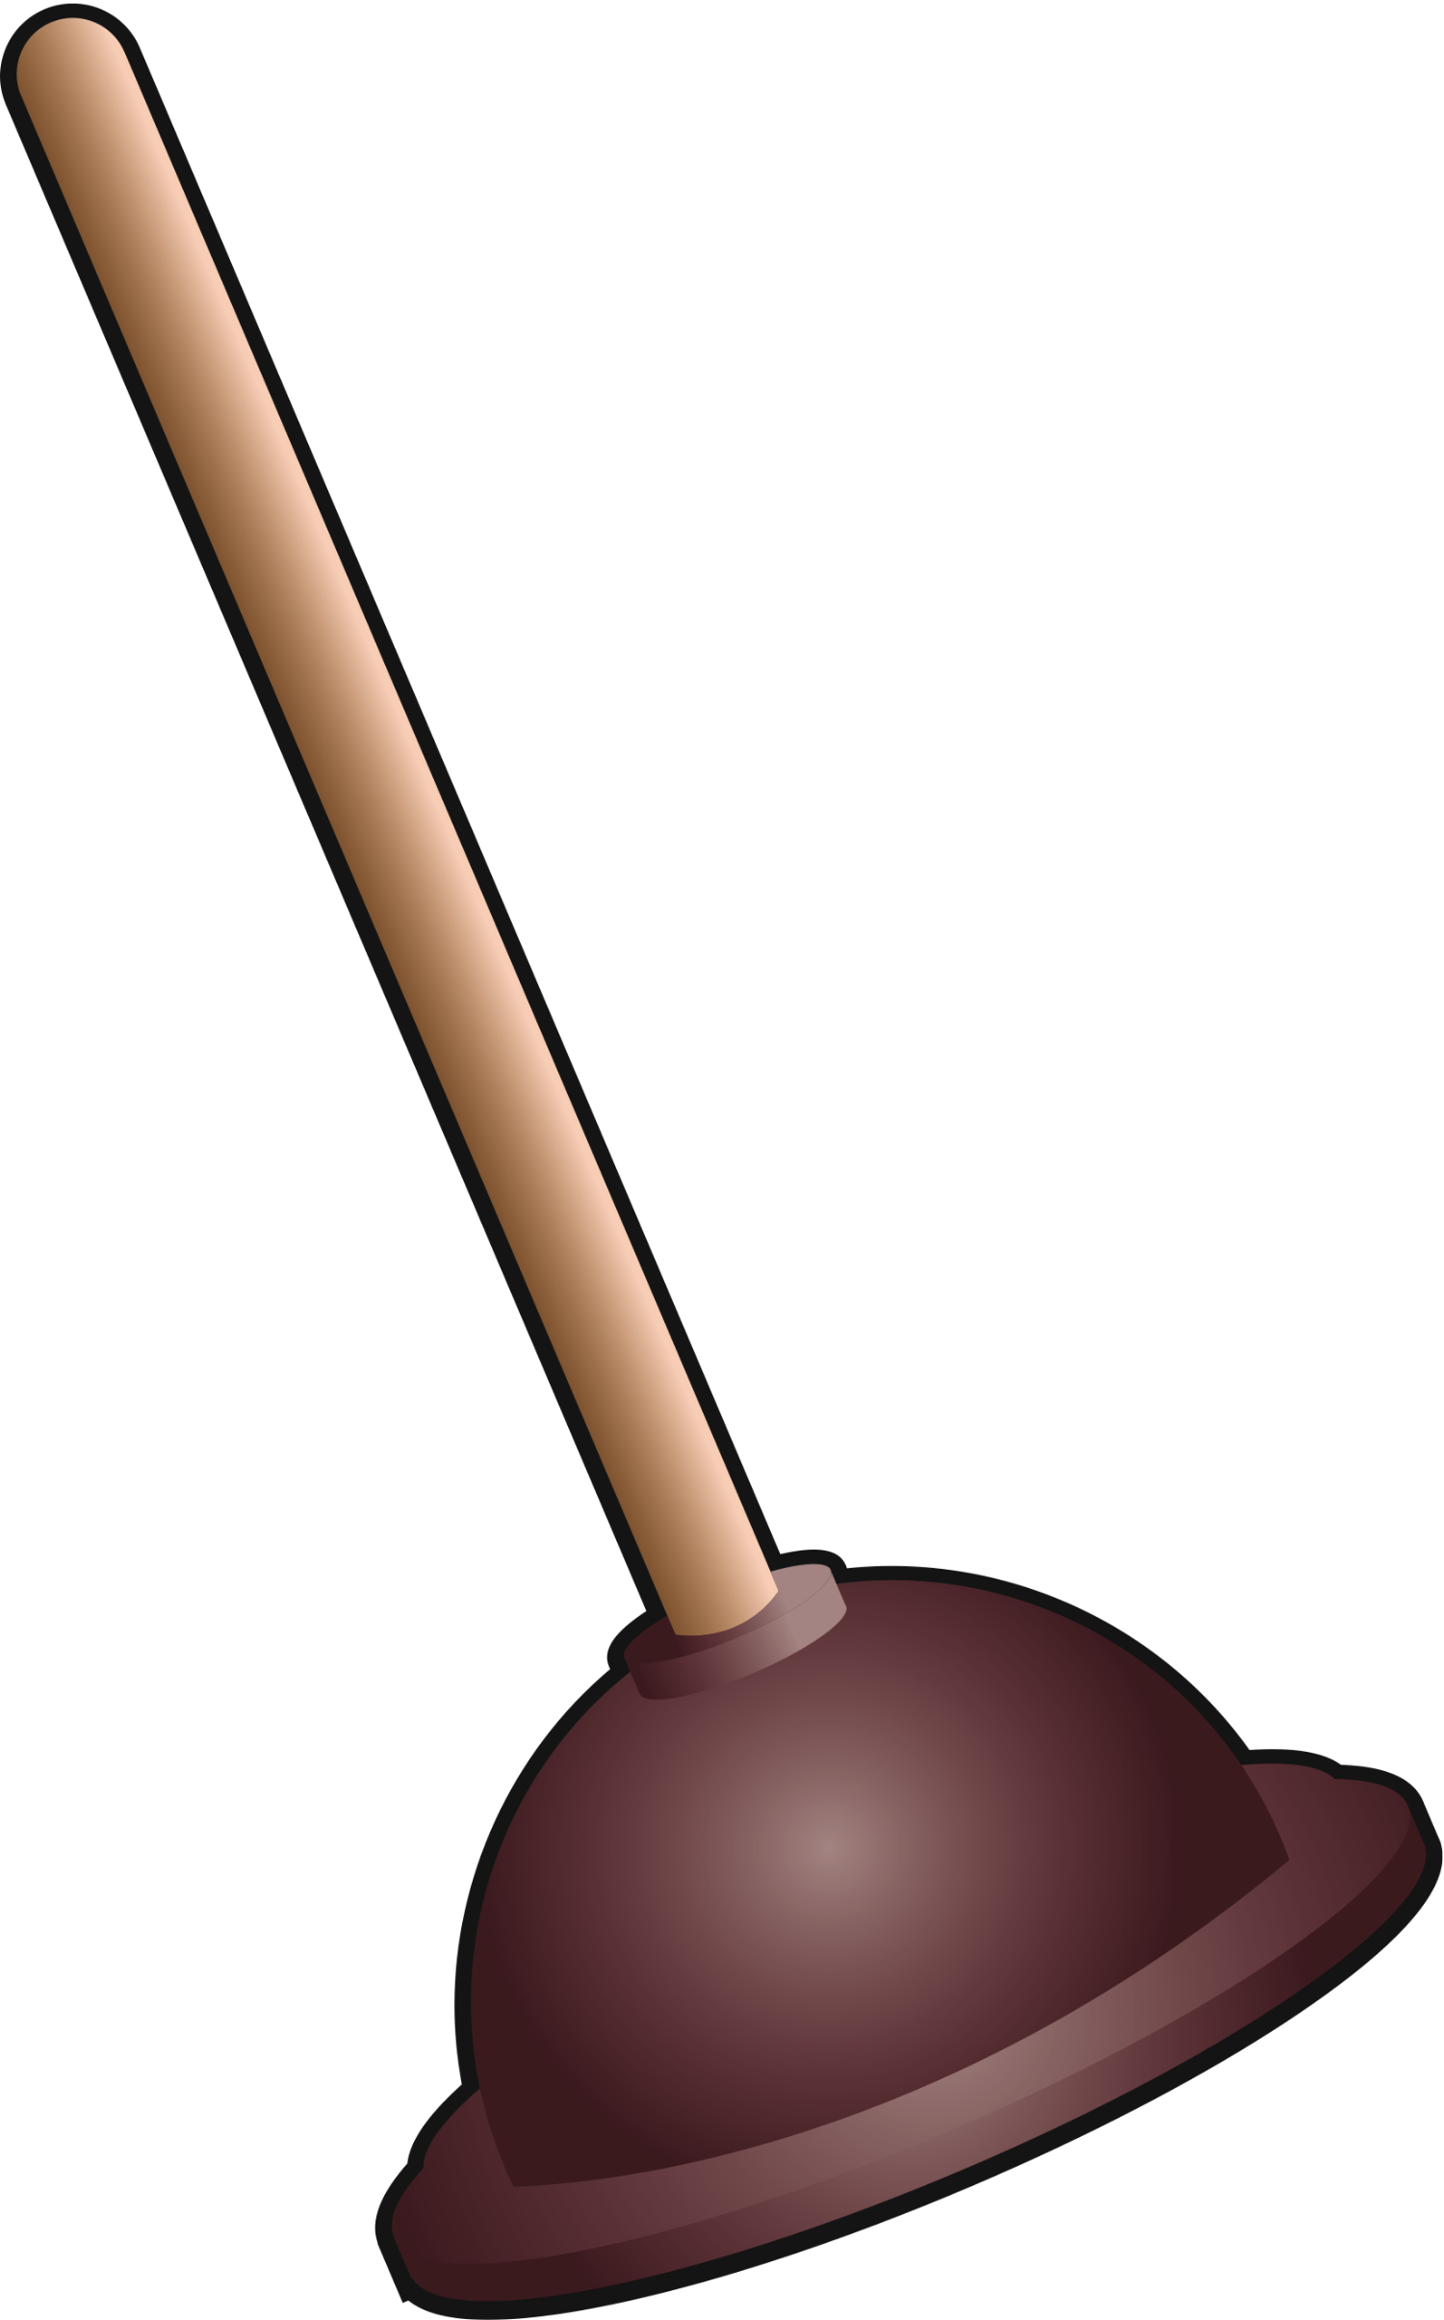
# 6: (Plunger)

I will plunge out hatred.

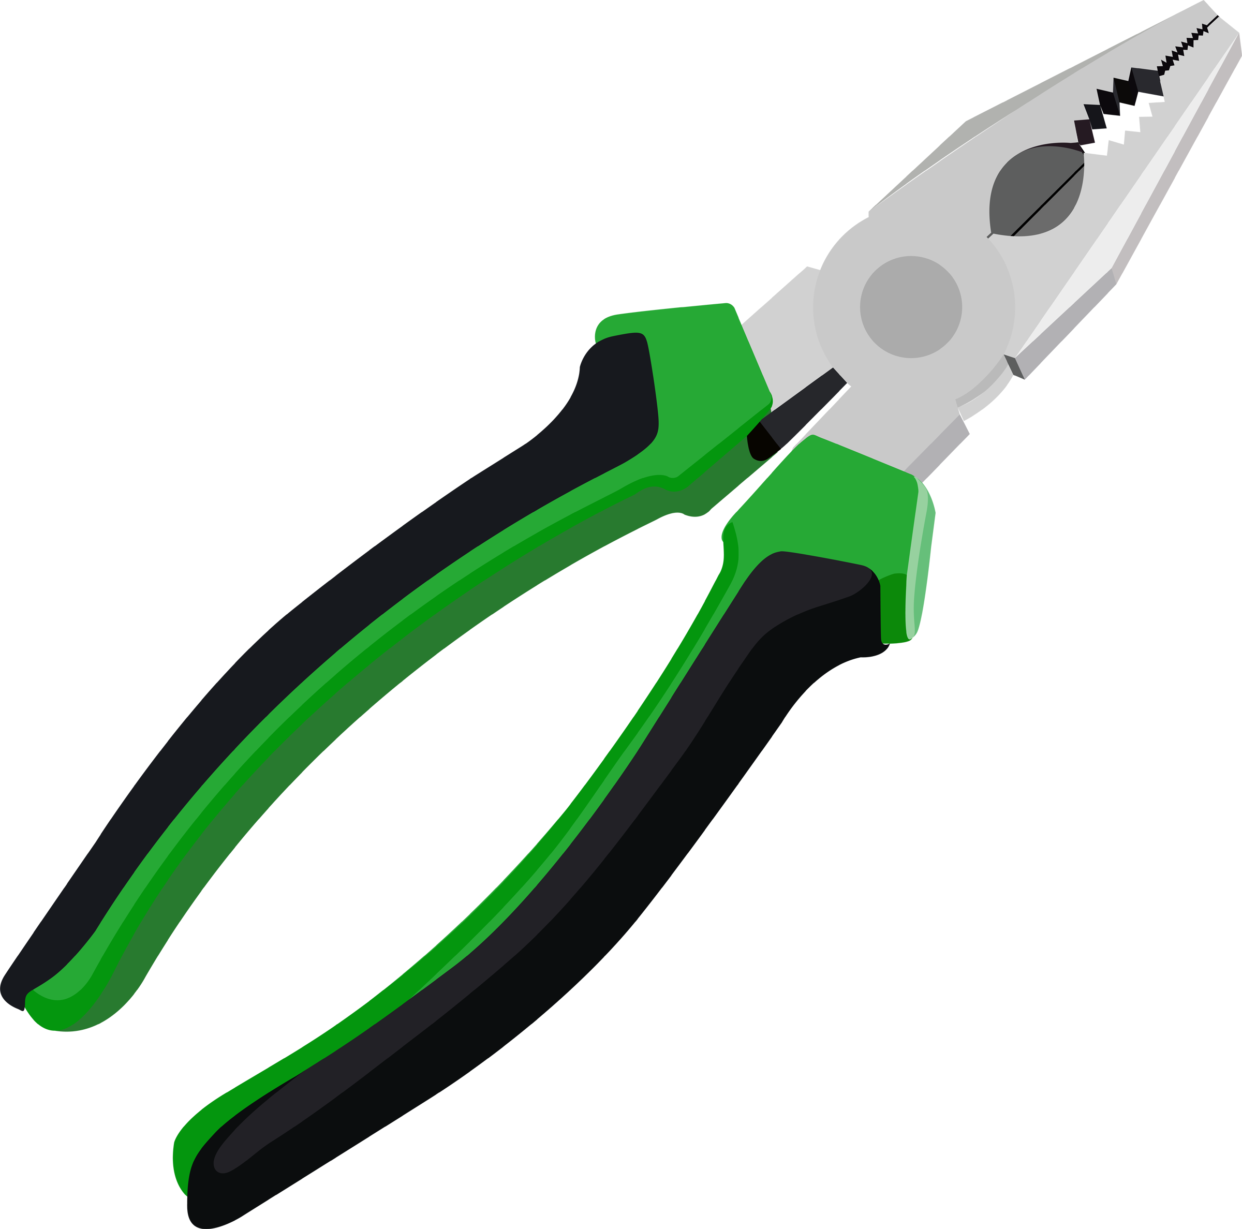
# 7: (Pliers)

I will pinch out poverty.

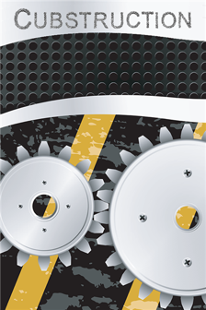  Construction Cheers  shac.org/construction-theme  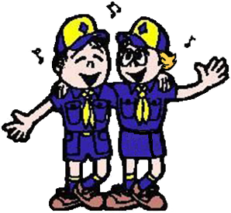  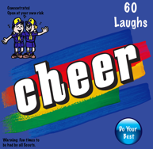 |  |  |  | 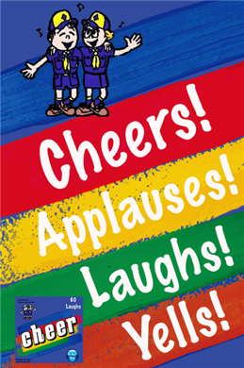  Cut out cheers and put in a cheer box. Find more cheers and instructions to make a cheer box at shac.org/cheers.
Chip, Chop Cheer  Divide audience into two sides. One says “Chip,” the other “Chop.” After a few times, all yell, “Timber.” |  | Chain Saw Cheer  Pretend to hold chain, start the chain with 3 pulls and make GRRZRRZRRZRRZRRZRRZRRZRRZ! sound while pretending to saw a piece of wood! |  | Electric Drill Cheer  Pretend to hold an electric drill and make a Brrrrrr sound for as long as you can.  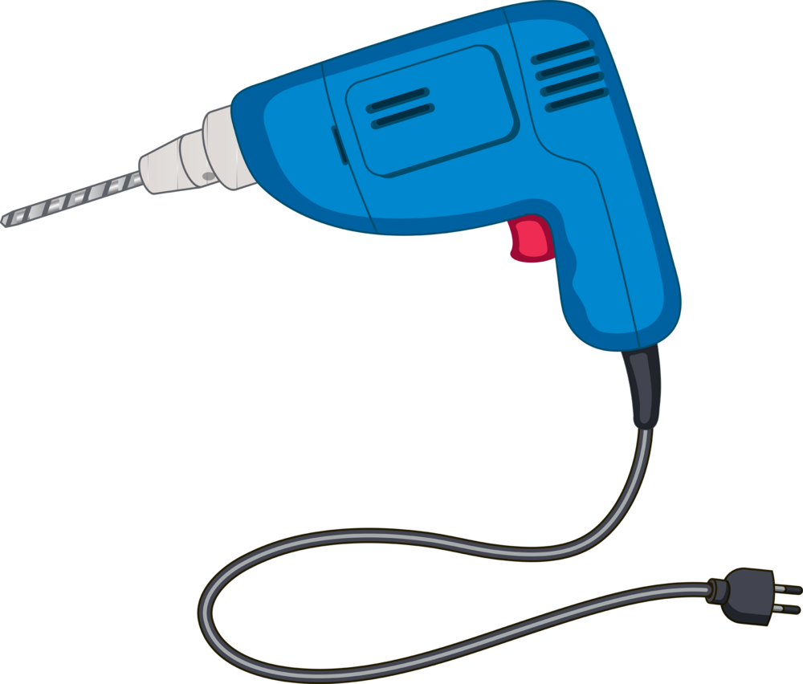
Glue Cheer  Clap hands together and they get stuck, struggle to pull them apart.  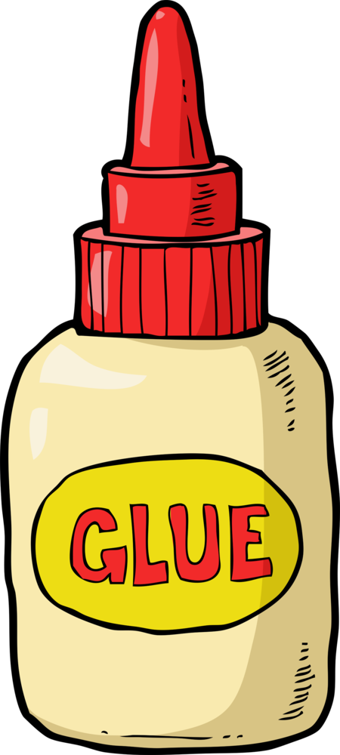 |  | Hammer Applause  Hold nail in one hand and hammer with other hand, saying “Bang, bang, bang, ouch!” (shake hand that got hit).  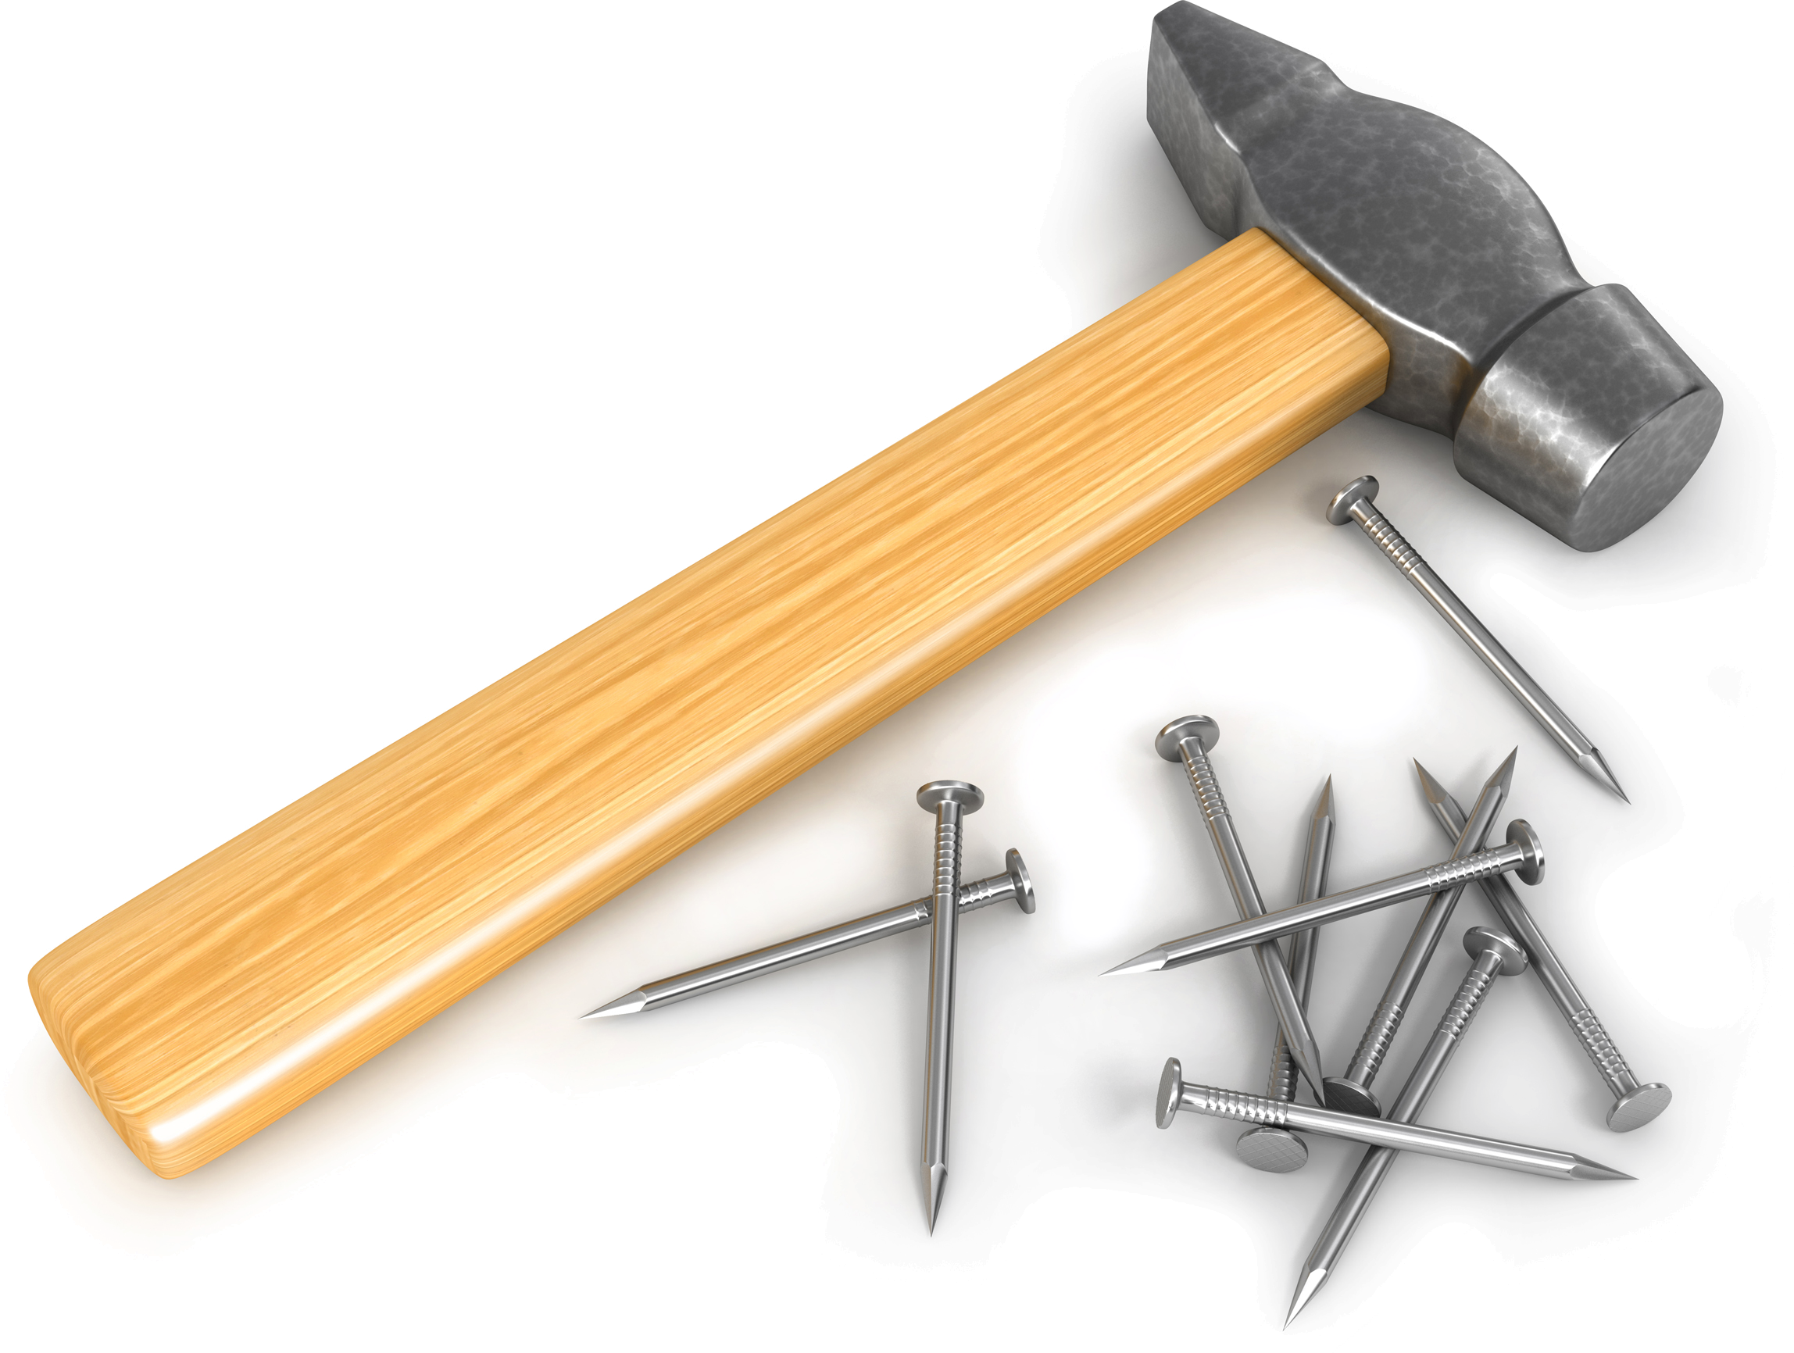 |  | Jackhammer Applause  Hold jackhammer with both hands and begin using it. “Bap-bap-bap-bap-bap!”  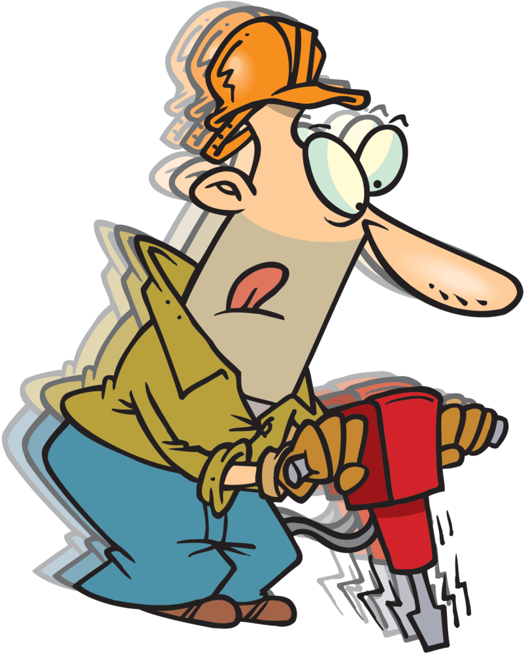
Lumberjack Cheer  With a partner…  - First person makes a fist with thumb up.  - Second person grasp thumb and makes a fist with thumb up  - First person grasps that thumb and makes fist thumb up.  - Second person repeats.  - With all four hands together, make back and forth sawing motion. |  | Sandpaper Applause  Rub hands together as loud and fast as you can.  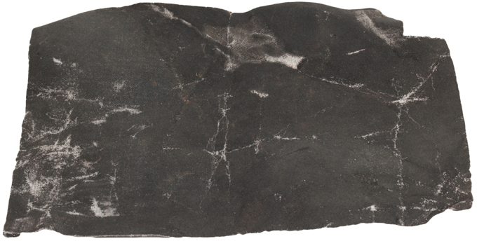 |  | Saw Cheer  Pretend to get a piece of lumber, measure it, draw a line, place pencil behind the ear, pick up saw and begin to saw holding your lumber with one hand and sawing with the other.  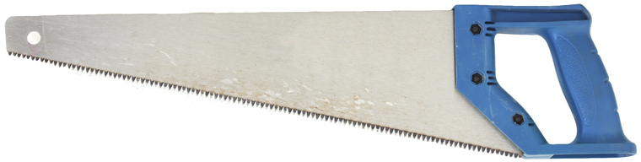

Cubstruction Cheer  Hammer, saw, nail, put to the test. You’ll never fail, when you do your best.  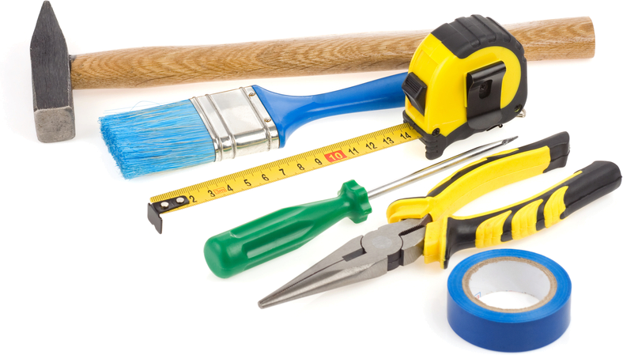 |  | Super Glue Cheer  Hands get stuck on first clap and can’t be pulled apart. Have pack yell something for help (e.g., mom, Home Depot, Lowes, Mr. Fix-It)… be original.  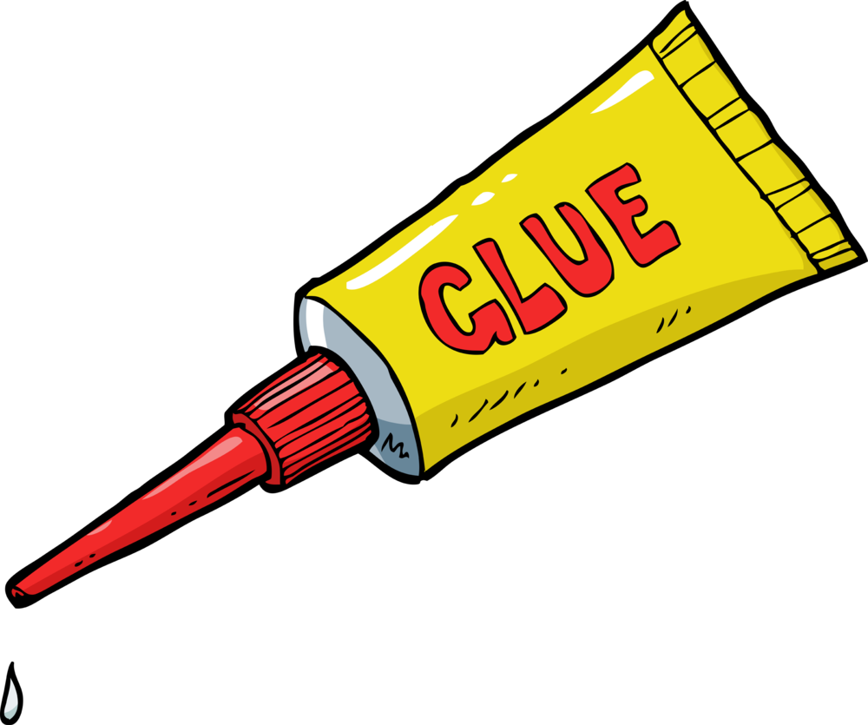 |  | Rubber Tree Cheer  Pretend to hold axe to chop tree. Every time you swing it bounces back. Make bouncing noise - “Boing, Boing.”  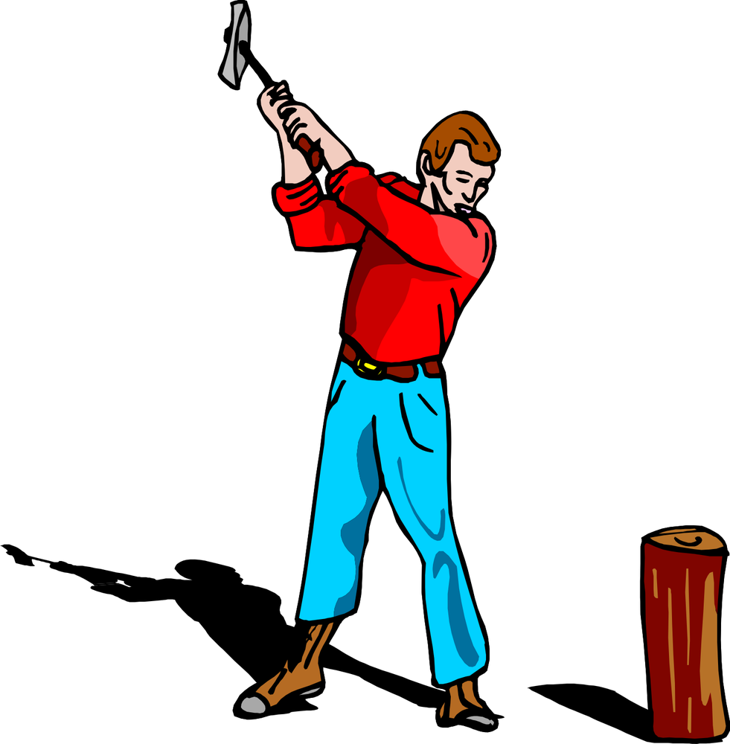
Plane Applause  Hold imaginary plane in hands and plane the wood to the sound of “zzzziiiiiippp!” |  | Pinewood Derby  Hold your right hand over your head and bring it down as if it were a car coming down a track, while saying: “Swoooooosh,” then “Thud” as it hits the bottom of the track. |  | Related cheers can be found at  www.shac.org/pinewood-derby-theme

MEETING HANDOUT

Edit the text boxes on the next two pages. An editable, word version of this document is available at www.shac.org/construction-theme.
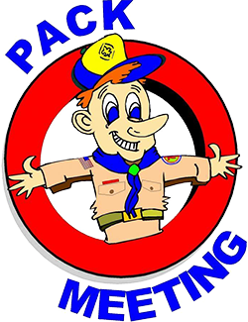
- Page 1: insert pack number and month/year
- Page 2: list detailed announcements, edit upcoming events for next three to six months, customize electronic communications.

Print one copy per person (of next two pages), one-sided to two-sided

Announcements: During meetings, keep announcement very short. Having detailed announcements printed in the handout saves times during meetings and avoids the dreaded long announcements that run on and on (that nobody can hear, nobody pays attention too and Scouts dislike). Parents will get used to getting a handout at each pack meeting.

Songs: have more songs than you think you need. You don’t have to sing them all, but having a back-up in case of a lull in the program is always helpful.

 | Pack <#> |  |  | 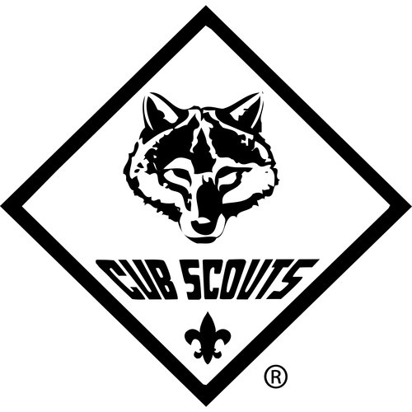 | <Month Year>
Pound the Nail  Tune: Row, Row, Row Your Boat  Pound, pound, pound the nail,  Pound it right on through!  If you miss and pound your thumb,  Then it will turn true blue! |  |  | 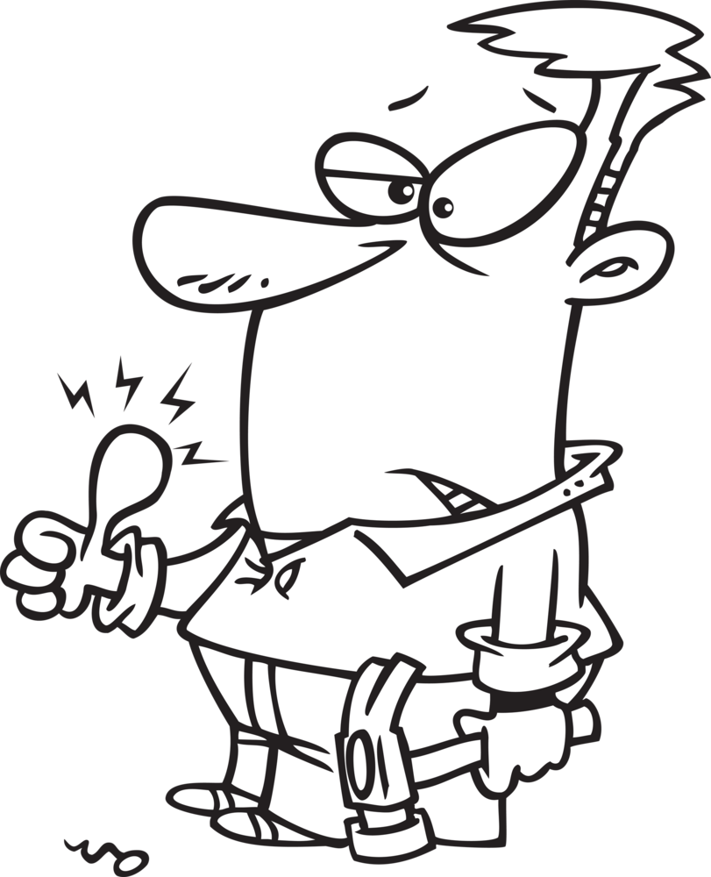 |  |  | 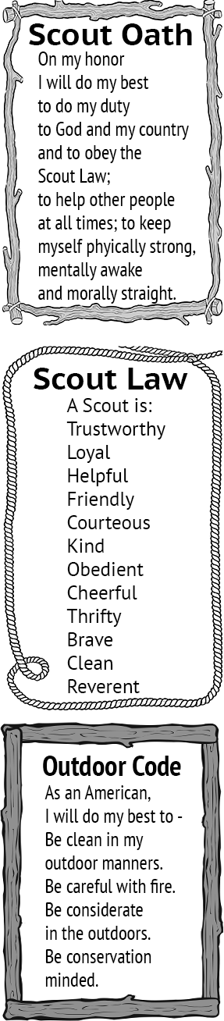
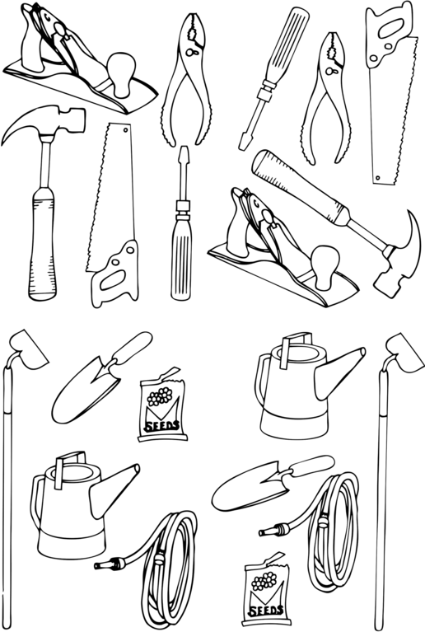 |  |  | Don’t You Like to Saw  Tune: I’ve Been Working on the Railroad  I’ve been sawing on this piece of wood.  All the live long day,  I’ve been sawing on this piece of wood,  Just to pass the time away.  Can’t you see the saw dust flying?  Rise up so early in the ‘mom.  Can’t you see our leader shouting,  Not on my wood floor!  Don’t you like to saw,  Don’t you like to saw,  Don’t you like to saw,  More, more, more, more!  Don’t you like to saw,  Don’t you like to saw,  Even if it’s on the floor!
Wood Working Is Fun  Tune: Jingle Bells  Saw on wood, Hammer nails,  Wood working is fun!  We’ll get this project done on time,  With the setting sun!  Stain the wood, Putty the nails,  Let’s give a big hooray!  Now this project is done on time,  Let’s go out and play! |  | 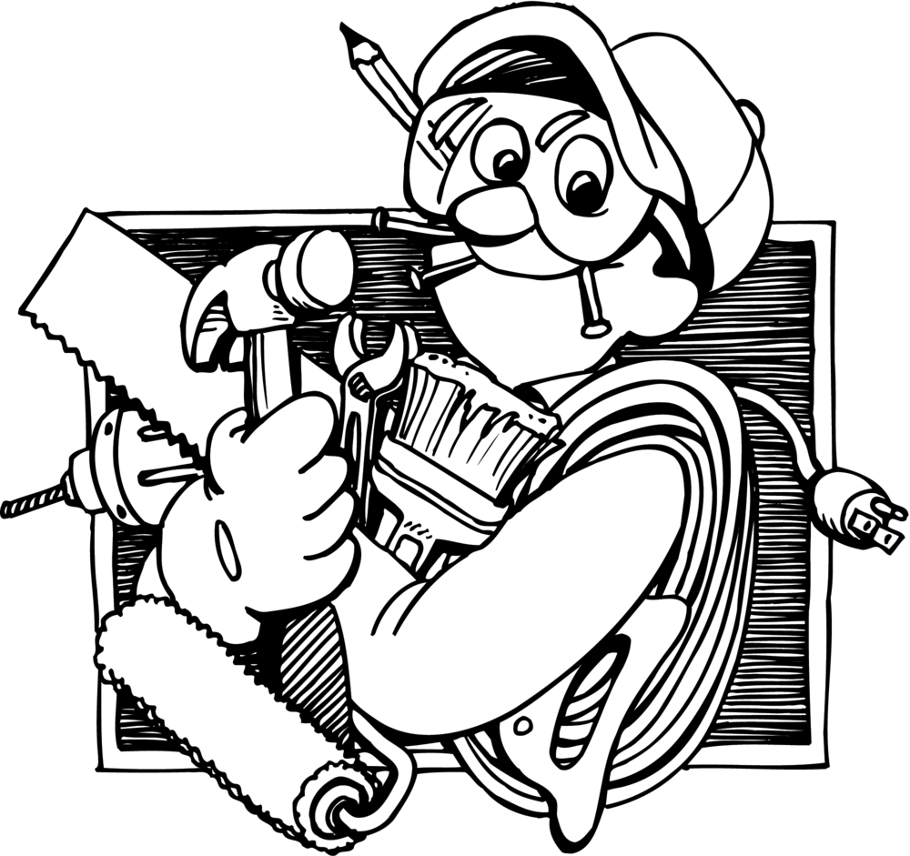

< insert details about upcoming pack, district and council events.  Find district event information on your district website.  Find upcoming council event articles in the Scouting Trail at www.shac.org/toolkit.> |  |  |  | Upcoming Events  <Month Year>  <day> <event>  <day> <Den meeting>  <day> <Pack meeting>  <day> <District event>  <day> <Council event>  <Month Year>  <day> <event>  <day> <Den meeting>  <day> <Pack meeting>  <day> <District event>  <day> <Council event>  <Month Year>  <day> <event>  <day> <Den meeting>  <day> <Pack meeting>  <day> <District event>  <day> <Council event>  <Month Year>  <day> <event>  <day> <Den meeting>  <day> <Pack meeting>  <day> <District event>  <day> <Council event>  <Month Year>  <day> <event>  <day> <Den meeting>  <day> <Pack meeting>  <day> <District event>  <day> <Council event>
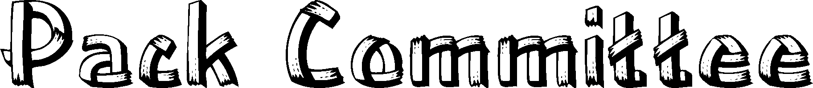  <insert pack committee and contact info>  Name Committee Chair Email  Name Cubmaster Email  Name Secretary Email  Name Treasurer Email  Name Popcorn Chair Email  Name Scout Fair Chair Email  Name Banquet Chair Email |  | 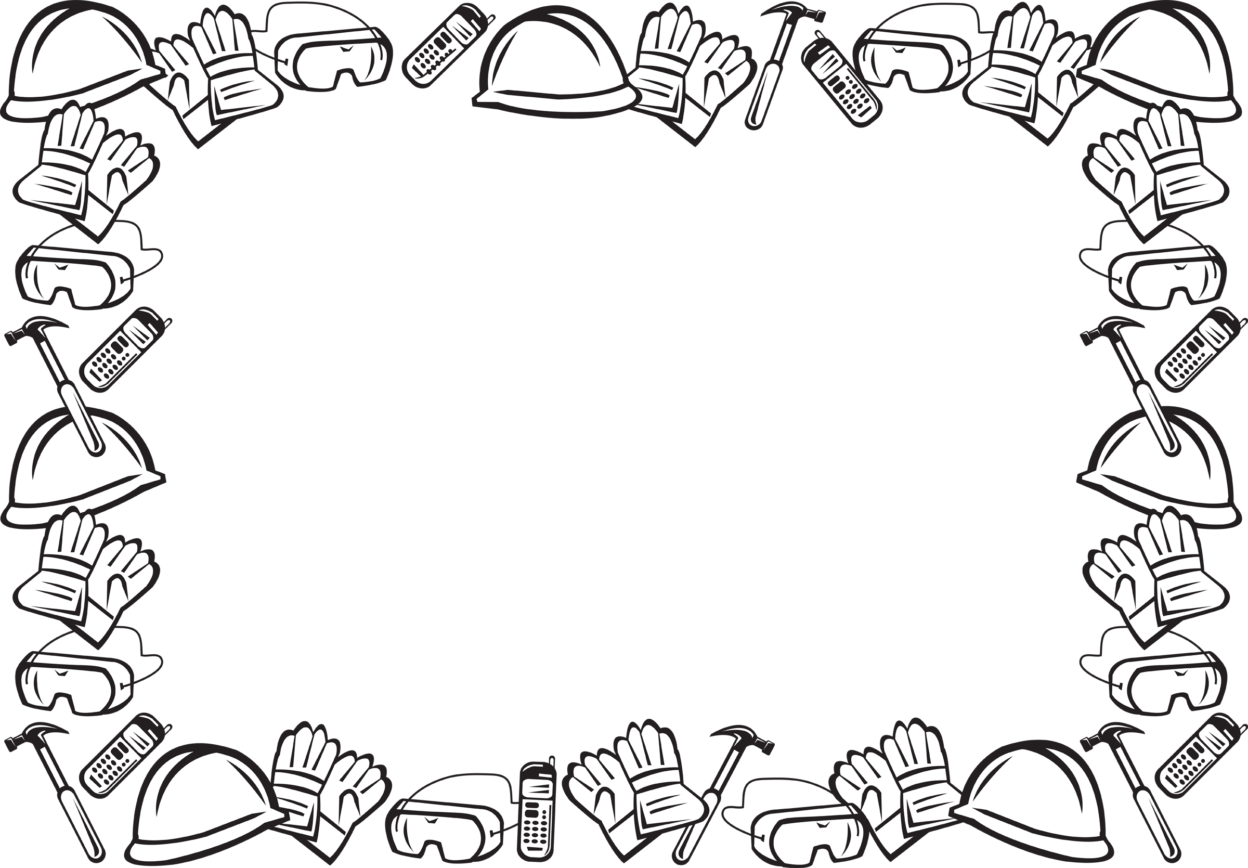  Pack <#>  facebook.com/<insert URL>  <pack website>  <insert> District  <district website>  facebook.com/<insert URL>  Sam Houston Area Council  www.shac.org  facebook.com/shac.bsa

BANQUET HANDOUT

For banquets a more formal handout can be used.
Edit the text boxes in the next two pages (insert Scout’s names, upcoming events, pack number, agenda and date). An editable, word version of this document is available at www.shac.org/construction-theme.

Print one copy per person (of next 2 pages), front to back.

Banquets: Most packs celebrate Scouting Anniversary Week in February with a birthday party called the blue and gold banquet; some packs do end of the year banquets. It brings families together for fun and cheer. The purpose of a banquet is to celebrate the Scouting, thank leaders and volunteers, and inspire the leaders, Scouts, and parents.

The banquet can be like a regular pack meeting with songs, skits, stunts, and awards, or it can be something different and a little more special. The pack committee may decide to bring in an entertainer such as a mad scientist or magician and have a video or slide show of what the pack did over the past year.

A good banquet needs lots of careful planning at least two months in advance to be successful. The pack committee should recruit a banquet chair, who in turn may select others to carry out the responsibilities of the program, such as making physical arrangements, promotions, inviting special guests, decorations, choosing a theme, ordering food, etc.

A detailed plan for banquets, including a planning calendar, sample agenda, and suggested program activities, is available in the Cub Scout Leader How-To Book, No. 621165.

Banquet Planning: www.skcscouts.org/wp-content/uploads/2013/06/Blue-Gold-Planning-Guide.pdf

Banquet Planning: www.ocbsa.org/wp-content/uploads/2011/06/Blue-Golf-Banquet-for-Website.pdf

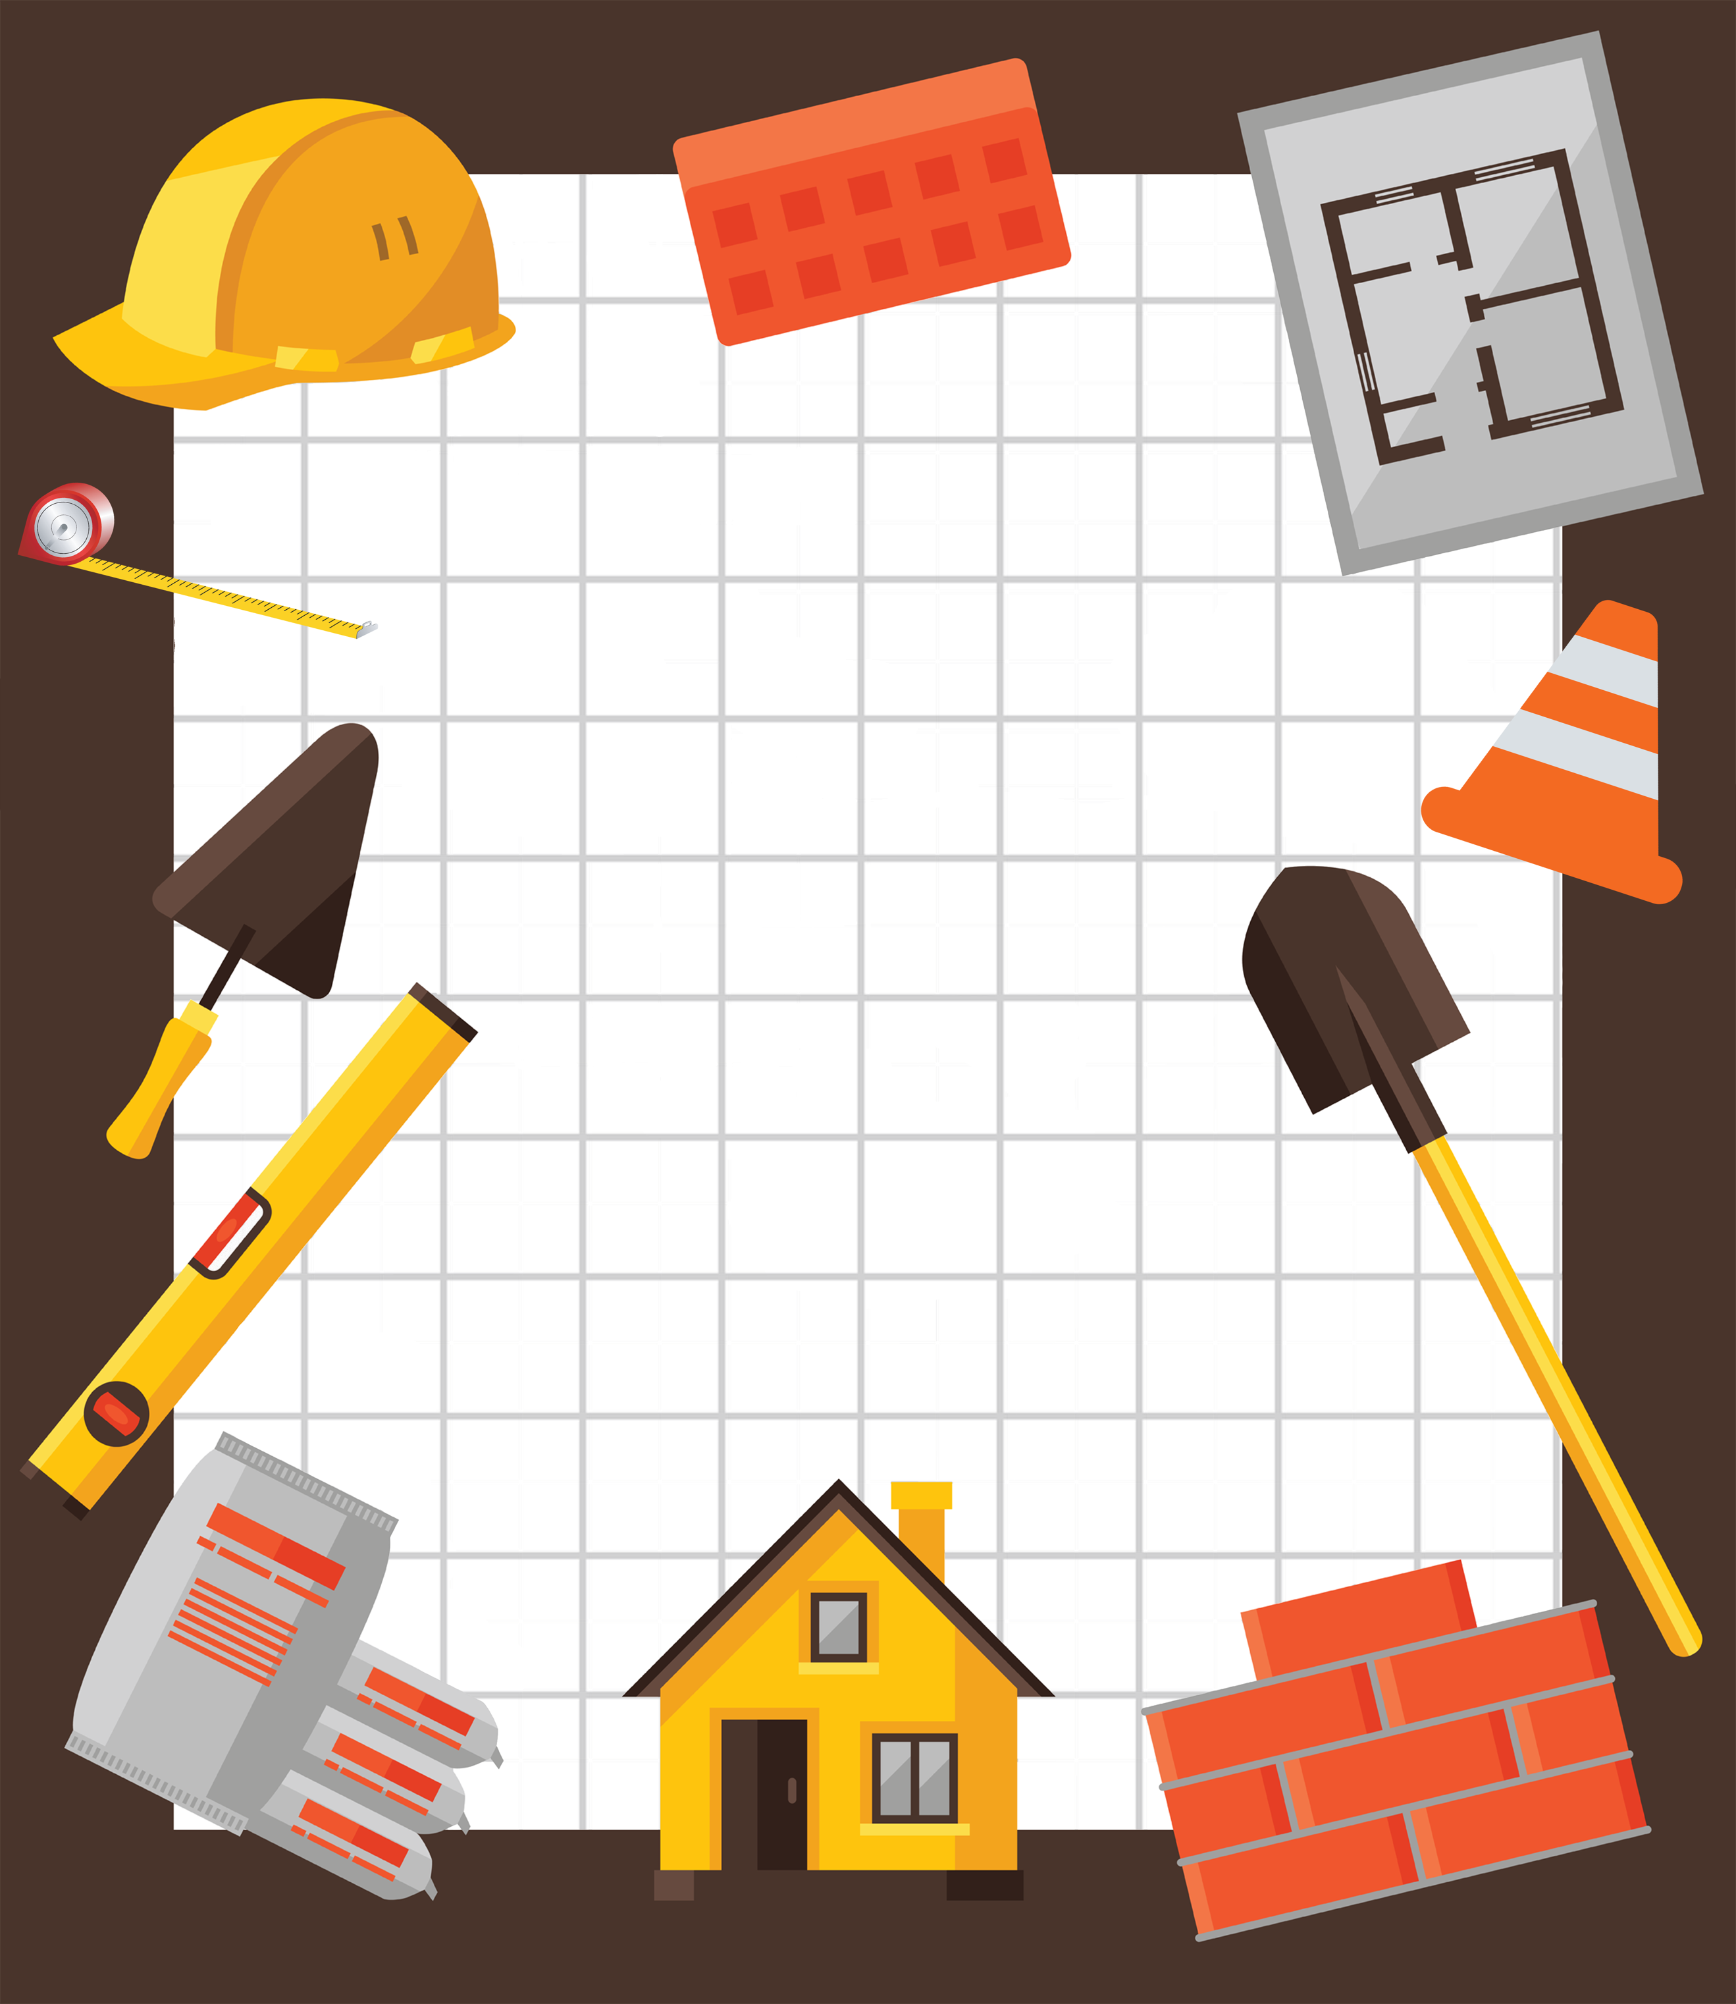
May 19, 2018
Pack 72
Blue and Gold
Banquet
Lions  Sally Lion  Bobby Lion  Tigers  Scott Tiger  Cameron Tiger  Darlene Tiger  Wolves  Linda Wolf  Katherine Wolf  Lindsey Wolf  Charlie Wolf |  | Bears  Josh Bear  Joy Bear  Dan Bear  Cody Bear  Webelos Scouts  John Webelos  Paul Webelos  Jonathan Webelos  Cindy Webelos  Jack Webelos
Upcoming Events
<date> <event>
<date> <event>
<date> <event>
<date> <event>
<date> <event>
<date> <event>
Pound the Nail
Tune: Row, Row, Row Your Boat

Pound, pound, pound the nail,
Pound it right on through!
If you miss and pound your thumb,
Then it will turn true blue!

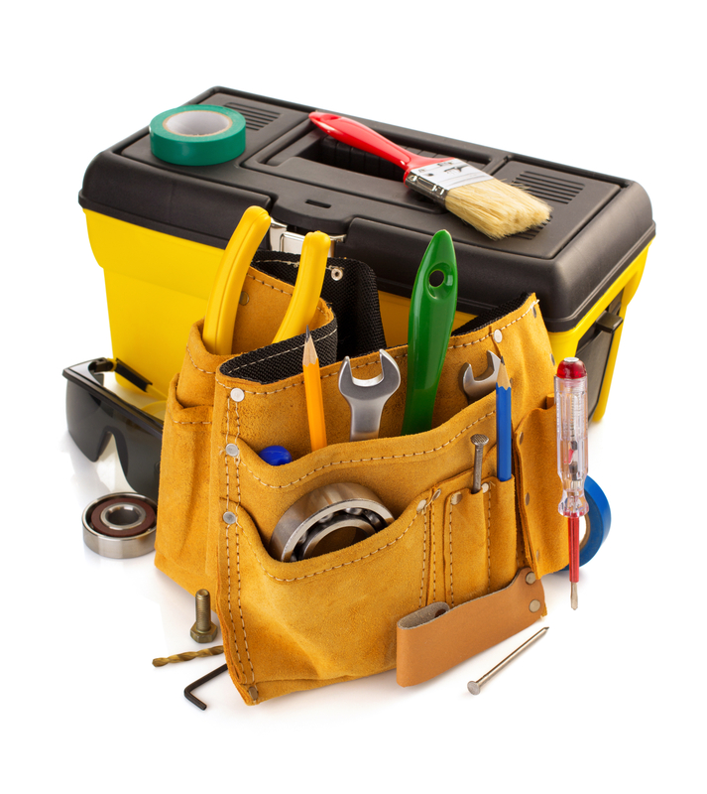
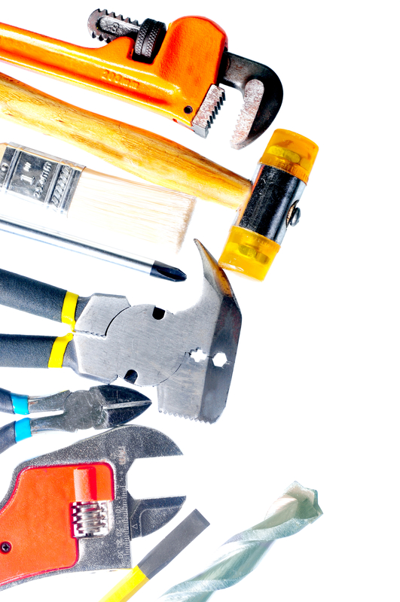
Don’t You Like to Saw
Tune: I’ve been working on the railroad

I’ve been sawing on this piece of wood.
All the live long day,
I’ve been sawing on this piece of wood,
Just to pass the time away.
Can’t you see the saw dust flying?
Rise up so early in the ‘mom.
Can’t you see our leader shouting,
Not on my wood floor!

Don’t you like to saw,
Don’t you like to saw,
Don’t you like to saw,
More, more, more, more!
Don’t you like to saw,
Don’t you like to saw,
Even if it’s on the floor!

Gathering

Opening

Invocation

Dinner

Friends of Scouting Presentation

Advancement Ceremony

Song

Leader Recognition

Cubmaster Minute

Closing
www.facebook.com/pack72tomball
www.facebook.com/orionbsa
www.facebook.com/shac.bsa
www.orion.shac.org
www.shac.org

Wood Working Is Fun
Tune: Jingle Bells

Saw on wood, Hammer nails,
Wood working is fun!
We’ll get this project done on time
With the setting sun!

Stain the wood, Putty the nails,
Let’s give a big hooray!
Now this project is done on time,
Let’s go out and play!

ADVANCEMENT CEREMONIES

Advancement Ceremony
The Cubmaster and assistant Cubmaster or other adult places the award for each Cub Scout in a “repurposed” small jar, such as a baby food jar, and presents it to the parents to give to the Scout at the appropriate time. Cubmaster: “It is now time for our award ceremony. It is my honor to award each of our Scouts with their new rank in a recycled container, which is now filled with best wishes for their next Cub Scouting adventures.” (At the end of the narration for each rank, call forward by name each Cub Scout who has obtained the rank and their parents or guardians.)
Lions: “Our newest Scouts are learning about Cub Scouting. These will be their resources to use wisely as they travel down the path of Cub Scouting.” [call forward Lions, present awards, lead cheer]
Tiger: “The Tigers have tried and learned new things that will help them in every adventure to come.” [call forward Tigers, present awards, lead cheer]
Wolf: “The Wolves have ventured further. They have learned that Cub Scouts are thrifty and make the best use of the skills they have gained.” [call forward Wolves, present awards, lead cheer]
Bear: “Our Bears have used their experience to travel to even greater lengths through their latest adventures.” [call forward Bears, present awards, lead cheer]
Webelos Scouts – 4th grade: “Our Webelos Scouts are working to meet the challenges required to earn the Arrow of Light.” [call forward 4th grade Webelos Scouts, present awards, lead cheer]
Webelos Scouts – 5th grade: “These Webelos Scouts have climbed to the highest peaks in their latest adventure, using all the skills they have mastered along the Cub Scout trail in new ways so they are prepared for Scouts BSA. [call forward 5th grade Webelos Scouts, present awards, lead cheer]
Cubmaster: “Let’s congratulate all of our Scouts with the ‘Re’ Cheer: ‘Recycle, reuse, reinvent!’”
Punny Cubstruction Ceremony
Props: Cubmaster in a work smock with a carpenter's tool belt. Awards taped to wood scraps that are hidden in tool belt. Be sure to emphasize the "puns" though out the ceremony.
Cubmaster: Tonight, we have some Cub Scouts who "saw" the opportunity to "nail down" some advancement. At times these Cub Scouts had to keep "hammering" on some of the tougher requirements, but they kept on "drilling", "carving" and "sanding" and finally "cut" through. We "wood" like to honor them tonight. Will Cub Scout
please come forward with their parents?
Cubmaster: These Scouts have "chiseled" through the requirements. (Cubmaster takes award from their tool belt and holds it up.)
We "wood" like to have their parents present the awards. (Cubmaster hands the award to the parents who present the Cub Scout the award.)
Other "puns" which could be used when presenting awards include: "filed", "planed", "sharpened", "glued", "cut", "painted" or any other tool related name or adjective.

Recognition Ceremony Props
Attach awards to card stock cut in the shape of wood working tools (i.e., saw, hammer, tape measure, etc.) Captions on the awards could match the tool:
- "Way to measure up!"
- "You really hammer down problems!"
- "You saw us through!"

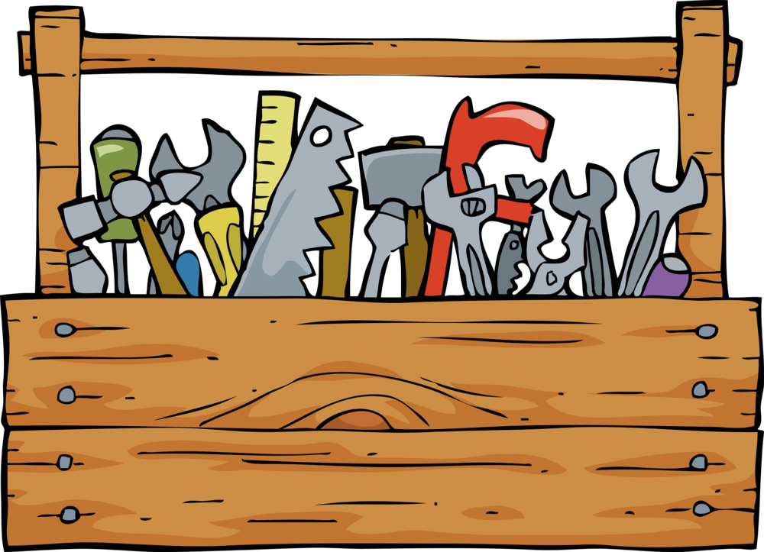

Working with Wood
Props: Pocket knife, saw, screw driver, sandpaper and varnish.
Narrator: Before you are a variety of tools used by
carpenters and wood workers to transform plain wood into objects of beauty and usefulness. There are many steps between beginning to work with a piece of wood and completing a project. So, it is with Cub Scouting. Tonight, we are recognizing significant steps of progress along the Cub Scout trail.
Lion (pocket knife) Of course, a carpenter has to start with a plan. Once they have a plan in mind, the first tool they use begins to shape the wood. We have young carpenters who have completed the initial step and are here to receive their awards. [Call Lions forward, present awards, lead cheer.]
Tiger (saw) Once started on the project, a carpenter has to focus on the major task of shaping this project- whether the finished product is a chair or a bowl. Many, many steps are required to complete this stage of the task. We have several Cub Scouts who have completed the Tiger adventures. [Call Tigers forward, present awards, lead cheer.]
Wolf (screw driver) Once the wood is shaped, it is ready for the assembly process. This stage requires many different types of tools and fasteners and precision in assembly. Much patience is needed. Our Wolf Cub Scouts are learning more and have a tougher set of requirements to fulfill. We have several Cub Scouts who have completed Wolf adventures. [Call Wolves forward, present awards, lead cheer.]
Bear (sandpaper) After the pieces are assembled, the rough edges must be smoothed out. Sandpaper will smooth out the edges and roughness. Our Bear Cubs are maturing and becoming smoother in their actions and learning more about how to be a leader. We have several Cub Scouts who have completed Bear adventures. [Call Bears forward, present awards, lead cheer.]
Webelos Scouts – 4th grade (varnish) The crowning touch to finishing a fine piece of furniture is what truly makes a piece of wood a masterpiece. Many coats of glass and sanding in between are needed to make wood glow. Drawers and doors without proper hardware are useless. Webelos are learning how to put on the finishing touches. We have several Cub Scouts who have completed several Webelos adventures. [Call 4th grade Webelos Scouts forward, present awards, lead cheer.]
Webelos Scouts – 5th grade – Our 5th grade have demonstrated a commitment to becoming master craftsmen and are preparing to finish their goal by earning the Arrow of Light rank and joining Scouts BSA. [Call 5th grade Webelos Scouts forward, present awards, lead cheer.]
Woody the Carpenter
Props:
- A worktable to the side of the awards table.
- Props: hammer, saw, sandpaper, varnish, paintbrush, rough cut board with Lion rank on it, sandpaper, sanded board with Tiger rank on it, clean square sanded board with Wolf rank on it, clean board routed with Bear rank on it, varnished board with Webelos rank on it
- Candles and rank poster on table.
- Large sign "WOODY THE CARPENTER AT WORK" to be set up to hide what is on table.
- The Cubmaster (CM), Committee Chair (CC) (or other Committee Member), and an Assistant Cubmaster (CA) or other adult in work coveralls carrying a tool box.

CM: Hello, who are you?
CA: Hello, I'm Woody the carpenter. I have skills, but no work.
CM: Well, let's see. I think I can use your help. Here, set up your tools on this worktable.
CA: (sets up sign to hide what they are doing) I'm ready, what do I do first?
Lion
CM: I need a Lion plaque.
CA (Starts to hammer, saw, etc. hands a rough cut board with Lion rank on it.) Will this do?
CM: Woody, this is a fine job. That is just like a Lion award; it has been roughly cut but there is no question that it's a board not a tree. A Lion has also just been cut. Their skills and crafts are rough and just starting to develop. But they have just taken the first step in Cub Scouting. We can see the difference in this board and a tree.
CC: Will the following Cub Scout Trade School Students please enter the lumberyard? [Call Lions forward, present awards, lead cheer.]
CM: Let's see, I guess we need a Tiger plaque next.
Tiger
CA: (Starts to saw, hammer, sand etc. hands out a clean square cut board with Tiger rank on it). Will this do?
CM: That certainly will do Woody. A Tiger is very much like this piece of wood. It is clean and square cut, but in need of help just like the Tiger who needs the help of their adult partner.
CC: Will the following Apprentices and their parents please come down to the shop? [Call Wolves forward, present awards, lead cheer.]
CM: Let's see, I guess we need a Wolf plaque next.
Wolf
CA: (Starts to saw, hammer, sand etc. hands out a clean square sanded board with Wolf rank on it). Will this do?
CM: That certainly will do Woody. A Wolf is very much like this piece of wood. They are smooth and clean but still pretty basic with a long way to go.
CC: Will the following Apprentices and their parents please come down to the shop? [Call Wolves forward, present awards, lead cheer.]
CM: What next (pause) I know, Woody, I need a Bear Plaque.
Bear
CA: (saws, hammers, etc. hands a board with routed edges and the Bear rank on it) How is this?
CM: Woody, you have done it again! This is just like the Bear Cub Scout, a lot of effort and accomplishment has gone into this, but, it's not quite completed yet. A Bear has accomplished many things on the trail of Cub Scouting, yet they are not at the end and their training is not complete.
CC: Will the following Cub Scout Journeymen and their foremen join us on the job? [Call Bears forward, present awards, lead cheer.]
CM: Woody, I know what I need now, the Webelos plaque.
Webelos Scouts
CA: (Saws, Hammers, drills, paints, etc. ) Hands out a finished plaque with Webelos rank on it.
CM: Woody, you certainly have done a fine job. This plaque is just like a Webelos Scout. Their skills and crafts are almost completed. The Cub Scout trail has but a few steps left.
CC: Will the following Master Craftsman Cub Scouts and their parents join us? [Call Webelos Scout forward, present awards, lead cheer.]
CM: Just as a skill and accomplishments were shown on these pieces of wood tonight, the skills and accomplishments were shown on these wooden squares tonight, the accomplishments and skills of these Cub Scouts were evident as they progress along the Cub Scout tr ail.

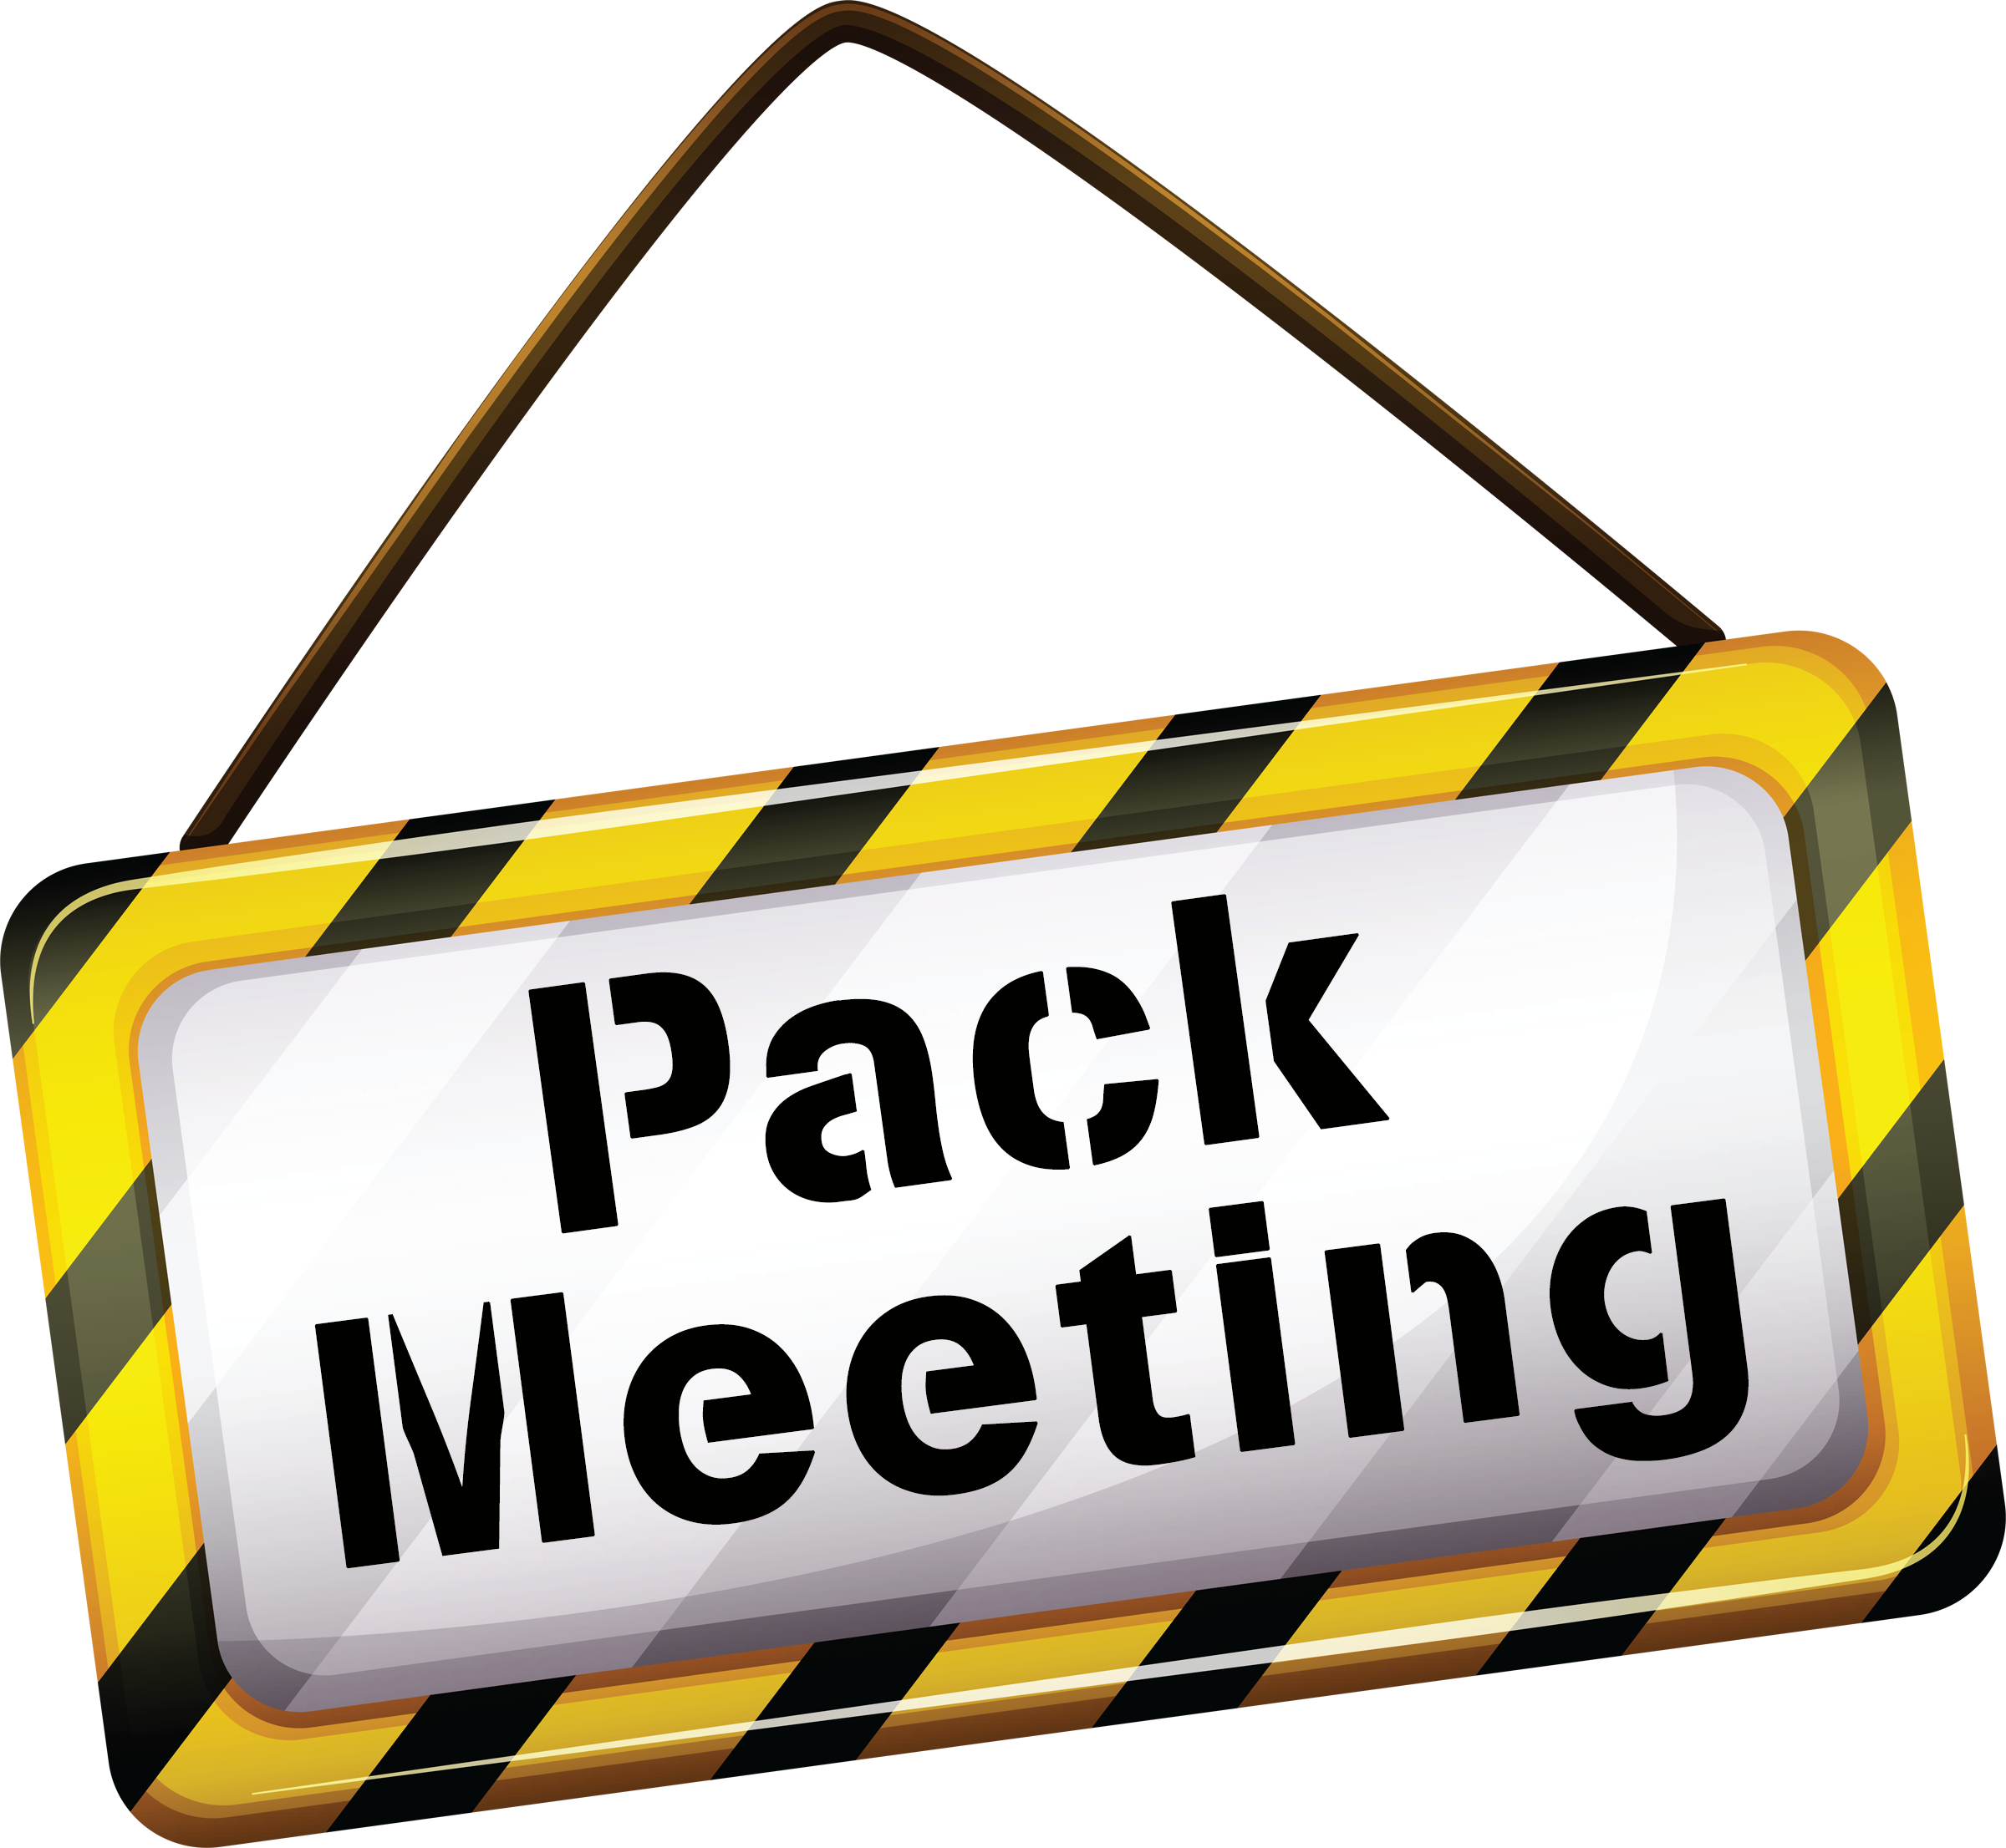

AUDIENCE PARTICIPATION

This Is the House that I Built
Have audience repeat the words and actions along with you.

This is the house (Make a roof with arms, touching fingertips together)
That I built. (Point to self)
This is the saw that cut the boards (Make sawing motion)
That went into the house (Make roof with arms)
That I built. (Point to self)
This is the hammer (Make fist with right hand)
That nailed the boards (Pound right fist into left palm)
That I cut with the saw (Sawing motion)
That went into the house (Make roof with arms)
That I built. (Point to self)
These are my hands (Hold out hands and look at them)
That held the hammer (Make fist)
That nailed the boards (Pound right fist in left palm)
That I cut with the saw (Sawing motion)
That went into the house (Make roof with hands)
That I built. (Point to self)

Hi My Name Is Joe
Audience repeats after the leader and does what the song says Joe does
Hi, my name is Joe
And I work in a button factory I have a wife and a fam-i-ly.
One day my boss ... he said Joe "Are you busy?" I said NO.
He says, “Can you press this button with your RIGHT HAND?”
(You start repeatedly pressing a button with your right hand and saying doot, doot, doot. Keep the movement with your body parts while you sing the next verse)
Hi, my name is Joe
And I work in a button factory I have a wife and a fam-i-ly.
One day my boss ... he said Joe "Are you busy?" I said NO.
He says, “Can you press this button with your LEFT HAND? “
(Continue previous movements, but start repeatedly pressing a button with your left hand and saying doot, doot, doot.
Keep the movement with your body parts while you sing the next verse)
Continue with: Right Leg, Left Leg, Your Head, Hips, Tongue,
Last Verse – done while doing all previously named motions –
Hi, my name is Joe
And I work in a button factory. I have a wife and a fam-i-ly.
One day my boss ... he said Joe "Are you busy?"
I said YES! (Immediately stop all actions)

Johnny Fixes It Well!
Here is an Audience Participation skit. Divide audience into six sections. Assign each a word and a response. Tell them that when they hear their word in the story they are to give the response. Practice as you make assignments.
Johnny: I can fix it!
Dad: Be careful, son.
Wrench: Oh Nuts!
Screwdriver: Straight or Phillips?
Bike: Drrrinnngggg, Drrrinnngggg
Pliers: Hold me tight!
JOHNNY had a problem. His BIKE was broken. Now JOHNNY and his dog, Ralph, could not ride to the park to play with his friends. But JOHNNY, being a very smart Cub Scout, knew how to fix the BIKE. However, he needed a box-end WRENCH, a pair of PLIERS, and a SCREWDRIVER. So he asked his DAD if he could borrow a box-end WRENCH, a pair of PLIERS, and a SCREWDRIVER.
His DAD said “Sure, but make sure you take care of the box-end WRENCH, PLIERS, and SCREWDRIVER and return them as soon as you’re finished. “I will DAD,” said
JOHNNY. So, JOHNNY and Ralph went into the back yard to fix his BIKE with the box-end WRENCH, PLIERS, and SCREWDRIVER. Since JOHNNY knew how to use a
box-end WRENCH, a pair of PLIERS, and a SCREWDRIVER, BIKE was soon fixed and ready to ride. Ralph helped all he could. JOHNNY took a quick spin to make sure everything was alright and then he called Ralph to go with him to the park.
“Oh,” said JOHNNY. “I’d better return these tools to DAD before we go.” But when he reached for the tools, the PLIERS and SCREWDRIVER were there but the PLIERS were missing. “Oh no! What would DAD think?” said JOHNNY. He looked all around for the PLIERS. He looked in the bushes, but no PLIERS! He looked all over the yard, but no PLIERS! Finally, he noticed Ralph digging in the garden. JOHNNY went over to Ralph and there were the PLIERS in his bone hole. So the PLIERS were found. And JOHNNY was able to return the box-end WRENCH, the PLIERS, and the SCREWDRIVER to his DAD. Everyone was happy the BIKE was all fixed—except Ralph!

CLOSING CEREMONIES

Tools That Build a Better World Arrangement
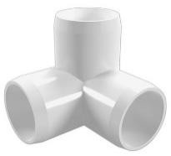
Each Cub Scout holds a tool as they speak - saw, hammer, wrench, ruler, plunger, drill, and pliers. You will need seven Cub Scouts. Maybe hang tags on the tools with their parts in LARGE print
# 1: We are the future builders of America and the world. And this is how we will shape tomorrow.
# 2: (Hammer) I will hammer out injustice.
# 3: (Saw) I will help cut out crime.
# 4: (Drill) I will drill love into every heart.
# 5: (Wrench) I will wrench out discrimination.
# 6: (Plunger) I will plunge out hatred.
# 7: (Pliers) I will pinch out poverty.

Cub Scouting is like Constructing a Tripod Equipment:
- Three straight tree branches or poles, 4' to 5' long and 3' length of heavy cord OR
- Three lengths of PVC pipe and a 3 way elbow (see picture) fitting that will accept all three pieces.

CM: (Picks up the cord or fitting) Cub Scouts and parents, this cord (fitting) represents the pack.
CM: (Picks up one branch) This pole represents you as a Cub Scout. You are all eager an anxious to be Cub Scout and do many exciting things. (Stand the branch on end and let go. (Insert PVC pipe into fitting) It will fall.):
CM: HHhhmmm, it doesn’t look like that worked. AAhh, the Cub Scout does not join the pack all alone. (He picks up second pole) They need leaders! This pole represents the Pack Leaders (He ties two branches together at the top (inserts second PVC pipe into fitting), stands them on the floor, but does not let go) Will these two branches stand up by themselves? (Cub Scouts reply that they will fall over- Cubmaster lets them fall).
CM: (Picks up the third branch.) HHhhmmmm. This third pole represents your parents. Let's attach it to the other two." (He does so forming a tripod.) Now it can stand. We can we see that it takes all of us--Cub Scouts, leaders, and parents-working together to make our pack go. Take away the parents, the leaders, or you Cub Scouts, and the pack will fall. Let's remember that and stand tall together!
Taps for Cub Scouts
Tune: "Taps"
Sun of gold, sky of blue
Both are gone from the sight, day is through.
Do your best, then to rest,
Peace to you.

A Simple Block of Wood
Characters: Each Cub Scout holds the designated prop in front
of him
# 1: A rectangular block of wood.
# 2: Roughed out pinewood derby racer right from the box
# 3: A partially completed racer with a little paint.
# 4: A finished Pinewood Derby Racer
# 5: A finished Pinewood Derby Racer
Setting: Each Cub Scout walks on to the stage to read their part- The last Cub Scout runs onto the stage shouting their line.
# 1: I’m only a simple block of wood,
Cut from a tree so tall.
Unlike the tree that thundered down,
No noise would I make should I fall.
# 2: But in the hands of a wide-eyed Cub Scout,
Armed with a knife and a saw.
There are many shapes that I can take,
Some wide, some short, some tall.
# 3: A little paint, a line or two,
Nothing fancy, but not too plain.
No two alike, made with loving hands,
We are all of the tree that remains.
# 4: Like each little Cub Scout’s life, starting with form.
Like a block of wood cut from a tree,
The loving hands of leaders like you,
Help us each to be what we shall be.
# 5: And I’m gonna be a racer!

CUBMASTER MINUTES

Cubstruction Cubmaster’s Minute
This month’s theme of Cubstruction is about building things. Anything worthwhile building takes some thoughtful planning, so that we know what materials we need, what rules we have to follow and when we need to get it done.
While you’re building something useful, you are also building your skills. So, what you had a tough time doing this time won’t be as hard the next time.
You’re not only building cool stuff, but you’re building your own personal toolbox of skills that you will carry with you for the rest of your life.

Block of Wood I
Props: Nice wooden object
Show the Cub Scouts something made of wood. Point out its beauty and fine points.
The wood carver did not learn to do this overnight. It takes patience and hard work to learn how to carve well and make
something beautiful. In the same way, you cannot learn to be adults over night. You are learning a little more each day to make you better Cub Scouts, Scouts and adults.

Block of Wood II
Hold up a nicely finished wooden item.
As the wood is shaped, assembled, sanded, finished, and adorned with the final details of a fine finished piece of furniture, so our Cub Scouts grow through experiencing the many trails Cub Scouting has to offer. And soon, almost before we know it, the Cub Scout has grown and developed until they are ready to advance into the Cub Scout Scouting program. Before our eyes, a Cub Scout has turned into a well-adjusted young adult.
But a Cub Scout doesn’t become a finished product all by himself. They need challenge and direction. Our den leaders, assistants, and other pack leaders provide this help for our Cub Scouts. They help to carve and shape the future of young men.
Parents provide vital support to help put the finishing touches on their children.
Thanks so much to all of you who have reached out to help the Cub Scouts in our pack along the way to become all they can be.

Builders
Isn't it strange that princes and kings, and clowns that caper in sawdust rings, and common people like you and me, are all of us builders of eternity.
To each is given a bag of tools,
a shapeless mass and a book of rules,
and each must make, ere this life is flown, a stumbling block or a stepping stone.

Closing Ceremony
Props: Nice wooden object
Show the Cub Scouts something made of wood. Point out its beauty and fine points.
The wood carver did not learn to do this overnight It takes patience and hard work to learn how to carve well and make something beautiful. In the same way, you cannot learn to be adults over night You are learning a little more each day to make you better Cub Scouts, Scouts and adults.

Cubstruction (Engineering) Cubmaster’s Minute
When you were Bear Scouts, you learned about tools and how to use and take care of them. Then you learned how to build models and boats, go carts and a waterwheel. The Webelos Scouts can work on four different technology activity badges, one of which is the “engineer”. Why should you learn how to do these things at your age?
As you grow older, and join Scouts BSA, you may work on the Engineering merit badge.
Engineering is the profession that puts scientific knowledge to practical use. Engineers have a direct role in creating modern technology—the tools, materials, techniques, and power sources that make our lives easier.
Take for instance the building of Hoover Dam. It not only brought about flood control of the Colorado River, but supplies domestic and irrigation water down stream. The Dam also provides hydroelectric power to the Pacific Southwest and created a reservoir, which is one of the world’s largest artificial lakes--Lake Mead.
There are many branches of engineering. So, study hard, do your science and math homework and you will prepare yourselves for a great future.

Pocketknife Closing
Cub Scouts, I hold in my hand a pocketknife. This is a valuable tool because it can be used for many useful things. It is a dependable tool as long as the blade is kept sharp and free from rust and the working parts are in good condition.
But, if it is neglected and becomes dull and rusty, it can be a dangerous tool.
when kept in good condition, will serve us well. But if we fail to take care of ourselves, we can become rusty and dull like a neglected pocketknife, do your best to keep fit.

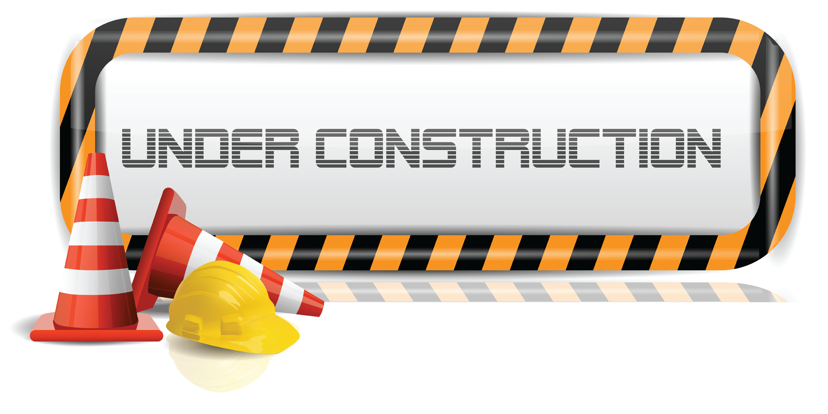

DEN and PACK ACTIVITIES

Bamboo Wind Chimes
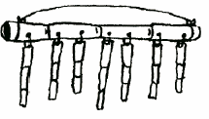
Supplies: 1 piece bamboo 8” long, 7 pieces bamboo different lengths, nylon thread , drill
Directions: Drill holes in 8” bamboo at 1” intervals . Drill hole through one end of remaining bamboo pieces. Tie the 7 pieces of bamboo to the 8” piece. Tie a thread from one end to the other for hanging.

Blue Bird Box
Construct boxes using untreated wood. Ideally, boards used in nest box construction should be ¾ inch thick. If smooth lumber is used in nest box construction, roughen the wood on the interior of the box just below the entrance hole; this makes it easier for young birds to climb out of the nesting box. Assemble boxes using screws, aluminum nails or galvanized nails. Entrance holes should be cut precisely 1 ½ inch in diameter. Larger holes permit European starlings to enter the box. All boxes should be provided with drainage and vent spaces.
The outside of bluebird boxes should be painted a light color. Boxes painted light colors stay cooler than those painted dark colors.
Do not equip a bluebird nesting box with a perch. Bluebirds do not need perches; however, nest competitors such as house wrens and house sparrows will use perches to gain access to a box.
beneath the boxes. An alternative method is to place a sheet metal cone (36 inches in diameter) around the pole beneath the box.
If you have a problem with flying squirrels increasing the size of the entrance holes to your boxes, install metal entrance hole shields around the entrance holes of all of your bluebird boxes. These shields can be obtained from stores specializing in bird-related items.
Remove sparrow nests as soon as they are discovered. While this procedure may have to be repeated several times, eventually the sparrows will nest elsewhere.
Erect boxes 5-6 feet above the ground. Whenever possible, mount bluebird nesting boxes on poles made of metal or sunlight-resistant PVC pipes. Boxes placed on such structures are easier to protect from rat snakes, raccoons and other nest predators. A piece of ¾ inch electrical conduit makes an ideal nesting pole.
If you must mount boxes on trees, leave at least a one- inch space between the nail or lag bolt and the box. This will allow the tree on which the box is mounted to grow without forcing the box off its trunk.
Boxes should be placed in open habitats with sparse trees and low vegetation. Many bluebirds' nest box efforts fail because boxes are erected directly in shrubby and forest conditions.
Position boxes so that they face a tree or shrub located within 100 feet of the box. These woody plants provide safe landing areas for fledglings on their first flight. A young bluebird landing on the ground is vulnerable to cats, dogs and other predators. Bluebirds do not seem to prefer boxes facing in a particular direction.
Boxes should be erected 100 yards or more apart. Nesting bluebirds will often fight with one another when boxes are placed close together.
Monitor boxes once a week during the nesting season. Once hatchlings appear, do not check boxes after the young are 12-14 days old as the young might try to leave their nesting box before they are ready to fly.
Do not take nesting boxes down in the winter season. Boxes make ideal roosting sites for bluebirds on cold winter nights.
Blue Bird Box Plans
Adapted from Georgia Department of Natural Resources website, http://www.gadnr.org/

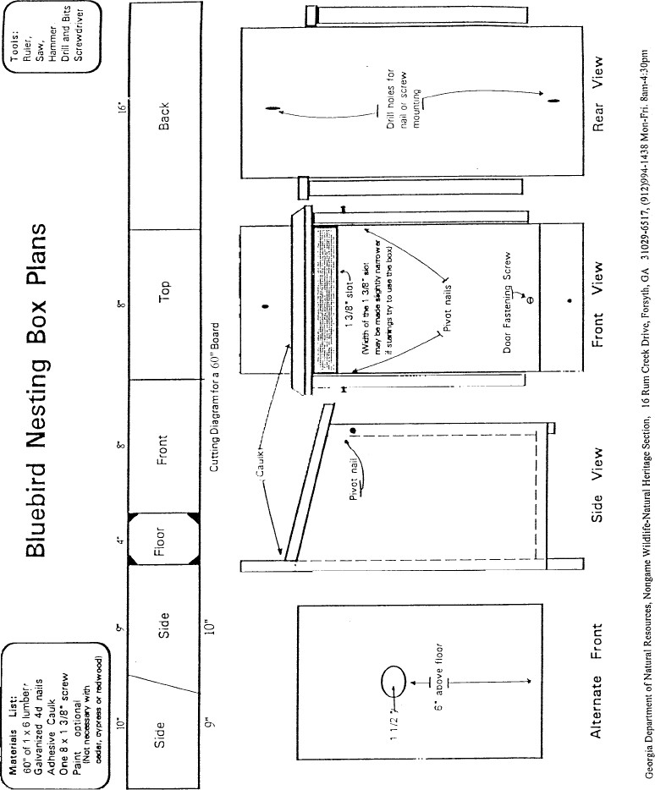
Clothespin Airplane:
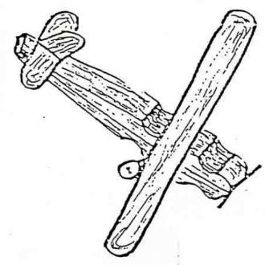
Materials:
Spring type clothespin
Ice cream sticks
Toothpicks
Buttons
Paints
Pipe cleaners (optional)
Tools:
Brushes
White glue
Electrical wire cutters
Markers
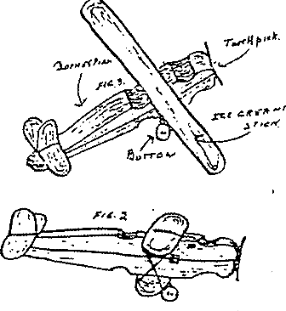
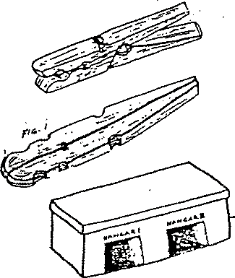
- Remove the spring from a spring clothespin.
- Lay the two sticks back to back and glue them together. (Fig. 1).
- Glue on one ice cream stick for the wings as shown below, (or 2 ice cream sticks to make a biplane)
- A short piece of toothpick can be glued into place for the propeller.
- The tail and rudder are made of pieces of ice cream sticks cut to size with a pocketknife or a pair of wire cutters then glued into place.
- Wheels are buttons mounted on toothpicks that have been bent to shape but not broken. You may use pipe cleaners instead. (Soak toothpicks in warm water for a few minutes so they bend easily.)
- Finish by painting with markers.

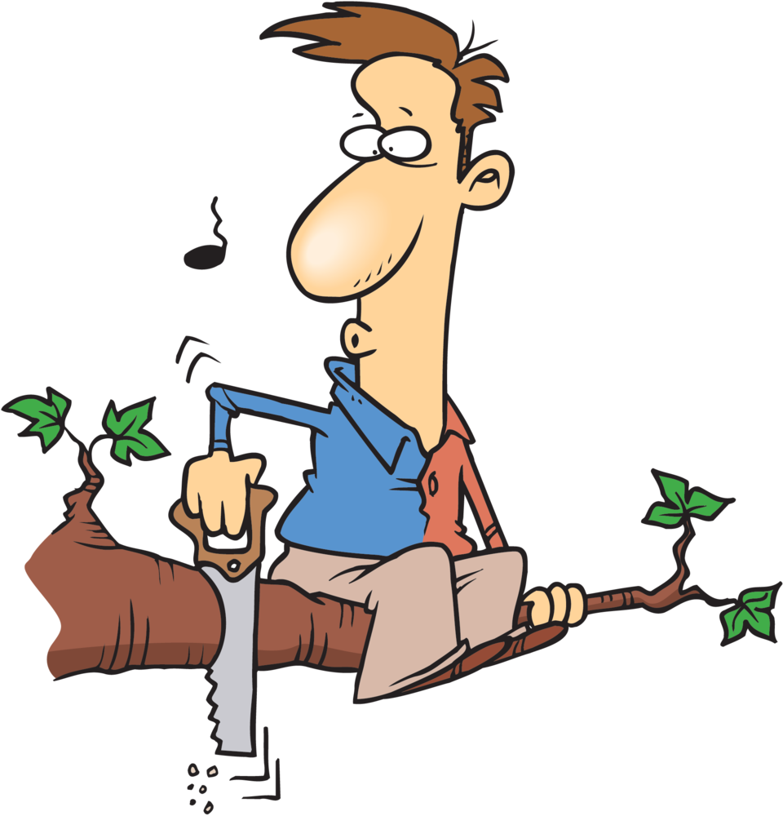

Constructing Bluebird Boxes
www.gadnr.org/
Construct boxes using untreated wood. Ideally, boards used in nest box construction should be ¾ inch thick. If smooth lumber is used in nest box construction, roughen the wood on the interior of the box just below the entrance hole; this makes it easier for young birds to climb out of the nesting box. Assemble boxes using screws, aluminum nails or galvanized nails.
Entrance holes should be cut precisely 1 ½ inch in diameter. Larger holes permit European starlings to enter the box. All boxes should be provided with drainage and vent spaces.
The outside of bluebird boxes should be painted a light color. Boxes painted light colors stay cooler than those painted dark colors.
Do not equip a bluebird nesting box with a perch. Bluebirds do not need perches; however, nest competitors such as house wrens and house sparrows will use perches to gain access to a box.
Boxes should be equipped with predator guards. One of the simplest ways to thwart predators from entering boxes is to smear automotive grease on the pole beneath the boxes. An alternative method is to place a sheet metal cone (36 inches in diameter) around the pole beneath the box.
If you have a problem with flying squirrels increasing the size of the entrance holes to your boxes, install metal entrance hole shields around the entrance holes of all of your bluebird boxes. These shields can be obtained from stores specializing in bird-related items.
Remove sparrow nests as soon as they are discovered. While this procedure may have to be repeated several times, eventually the sparrows will nest elsewhere.
Erect boxes 5-6 feet above the ground. Whenever possible, mount bluebird nesting boxes on poles made of metal or sunlight-resistant PVC pipes. Boxes placed on such structures are easier to protect from rat snakes, raccoons and other nest predators. A piece of ¾ inch electrical conduit makes an ideal nesting pole.
If you must mount boxes on trees, leave at least a one- inch space between the nail or lag bolt and the box.
This will allow the tree on which the box is mounted to grow without forcing the box off its trunk.
Boxes should be placed in open habitats with sparse trees and low vegetation. Many bluebirds' nest box efforts fail because boxes are erected directly in shrubby and forest conditions.
Position boxes so that they face a tree or shrub located within 100 feet of the box. These woody plants provide safe landing areas for fledglings on their first flight. A young bluebird landing on the ground is vulnerable to cats, dogs and other predators. Bluebirds do not seem to prefer boxes facing in a particular direction.
Boxes should be erected 100 yards or more apart. Nesting bluebirds will often fight with one another when boxes are placed close together.
Monitor boxes once a week during the nesting season. Once hatchlings appear, do not check boxes after the young are 12-14 days old as the young might try to leave their nesting box before they are ready to fly.
Do not take nesting boxes down in the winter season. Boxes make ideal roosting sites for bluebirds on cold winter nights.

Genius Kits
I can’t imagine that anyone hasn’t at least heard of the Genius Kit activity, but for those that haven’t heard of or seen this activity, here is my description. And if you have never done a Genius Kit activity, you have missed out on one of the most incredible activities you could imagine. We run these activities every few years because they are always fun and the results are never the same.
What is a Genius Kit?
Well it’s a group of 20 or more odds and ends thrown together into a container and given to a Cub Scout to turn into something. (Variations include letting the Cub Scouts pick their own items from a large open container, but again, the items are odds and ends.)
What is the purpose of the Genius Kit activity?
The object is to let the kids use their imaginations to come up with the most unbelievable creations from the junk they have. You will be amazed at the results!
How do you run a Genius Kit activity?
I have seen them run two different ways. First, as said above, is to give the kids a chance to pick their own items from a general junk bin and then let them work on making their creations. The other way is to give each Cub Scout an identical Genius Kit and have each come up with their own creation.
We also apply rules depending on how we are running the event. For example, when we’ve given the Cub Scouts all the same items, we’ve said no painting and only the materials supplied and clear glue can be used. This keeps them from adding to their creations beyond the “level playing field.”
Finally, this activity doesn’t lend itself to a large group setting. The hot glue and white glue can end up everywhere and might hurt someone. To incorporate it into a Pack Meeting, have the Cub Scouts work on them at home and bring them in for display and judging. (This is just my opinion.)
How do you judge the Genius Kits?
We try to have enough categories that virtually all of the creations get ribbons. It isn’t easy for the judges, let me tell you. Your best bet is to make sure you have ribbons or certificates for all participants and then you can come up with some Top Prizes.

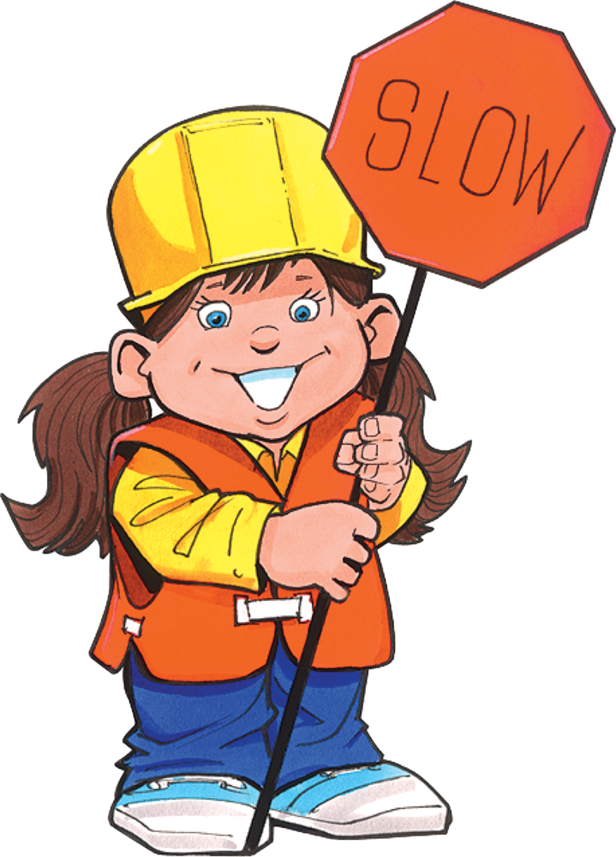

Genius Kit I
Genius kits are fun for the Cub Scouts and their families to do together. You will need a paper sack for each Cub Scout (or team). Place several different items in the sack. Make sure that you give each Cub Scout the same identical items.
The more items in the bag the more creative they can be.
Each Cub Scout is given their sack and they and their families have a specified time to make something out of the items in the bag. They can only use the items in the bag and the bag itself. Only the tools they think they might need to make something such as: Scissors, screwdriver, glue gun, hammer, etc., may be brought from home. Keep your pieces ‘Cub Scout things.” Enable them to build something solid. Don’t make it a paper craft. Possible items to use in a kit:
Different size wood pieces Styrofoam peanuts
Garbage bag ties Nails
Toilet paper rolls 2 liter bottles Cotton balls
Nuts Washers
Bolts String, rope or yarn
Paper plates Small individual cereal boxes
Tacks Beans’
Macaroni Dried Peas Fishing line
Colored paper Feather
Pinecones Paper Clips
Six-pack pop can holders Juice can lids
Rubber bands Plaster spoons Used spark plugs
Canning lids Egg cartons
Paper towel rolls Paper cups
Beans Small cans (e.g. tuna)
Beans Aluminum foil
Pop bottle lids Popsicle sticks

Genius Kit Ii
A genius kit is simply a bag full of odds and ends, scrap materials available in your neighborhood. The contents of each bag should be identical. Include a copy of the rules in each bag. Ideas:
2 scrap wood blocks 1 jar lid 12 beads
8 peanuts 1 egg carton 2 spools
1 tin can 1 cardboard tube 6 nails
1 wood clothespin 4 straws 6 pipe cleaners
1 coat hanger 4 buttons 1 foot of rope
6 assorted corks 12 tacks 3 leather scraps
3 bottle caps 3 pieces of sponge 4 feet of string
3 pieces of cloth 2 screws 1 board, 1x 6x 10
4 pieces of dowel 3 nuts 1 small tube of glue
Rules for parent/child genius kit project:
  - Use only the material supplied;
  - You do not have to use all of it.
  - Cut them up any way you wish.
  - Us any tools you wish.
  - Use your imagination and have fun!
  - Bring your genius creation to the pack meeting.
Judging prizes could be given for:
Best workmanship Funniest Most ingenious
Most Useful Best invention Most decorative
Best animal Most unusual Best contraption
Smallest Largest Best “what in the world?”
Be creative – invent your own categories!!\

Cornstarch Clay Recipe:
Materials:
- 1 cup salt
- water
- 1/2 cup cornstarch
- Food coloring (optional)

Directions:
Combine salt and 1/3rd cup water. Stir and heat the water until the salt is thoroughly dissolved. Take off the stove and add the cornstarch and ¼ cup cold water. Stir until it thickens and has a consistent texture. After it cools, knead it a bit. Add food coloring while kneading, if desired.

Mini-Shadow Box
- 1 wooden yardstick
- ¼” plywood 10” x 1¾”
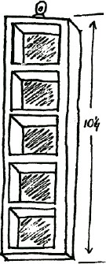
- Decorative Hanger
- glue

Directions:
- Cut stick as follows:
• 2 - 10” pieces for sides
• 2 - 2” pieces for top and bottom
• 3 - 1¾” pieces split lengthwise, to make recessed shelves.
- Glue sides to outside of plywood back,
- Glue on top and bottom pieces.
- Glue 2 of the narrow pieces to top and bottom, inside of box for added support
- Glue in 4 shelves.
- Let dry and sand rough edges.
- After glue has dried, paint or varnish
- Add ring to top back for hanging.
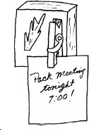

Note Holder I
Varnish or paint wood scrap. Add ring to back for hanging, Glue on clothespin and add a twig for decoration.

Note Holder II
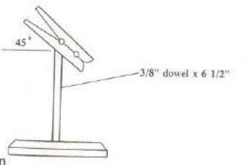
- 1 – 3/8” dowel, 6½ ” long
- 1 – wood plaque 2¾” x 1¾” x 1” thick
- spring clothes pin
- stain or paint
- drill

Instructions: Drill holes ¼” deep for dowel. Insert dowels. Glue on clothespin. Stain or paint.

Play Dough:
Materials:
1 cup flour 1 tsp vegetable oil
1 cup water ½ tsp cream of tartar
½ cup salt Food coloring (optional)

Directions: In a saucepan cook the mixture over medium heat, stir constantly, until the mixture holds together. Take off the stove and turn mixture onto a floured board. When the clay is cool enough to touch, knead it and add food coloring.

Single Chamber Bat House (Wall Mounted)
Many people have discovered the benefits and wonder of attracting backyard bats. www.batcon.org
Materials (makes 1)
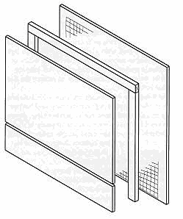
- 1/4 sheet (2' x 4') 1/2" ACX, BCX, or T1-11 (outdoor grade) plywood. DO NOT use pressure treated wood.
- One 1" x 2" (3/4" x 1 1/2" finished) x 8' pine furring strip
- 20-30 exterior grade screws, 1"
- One pint dark, water-based stain, exterior grade
- One pint water-based primer, exterior grade
- One quart flat water-based paint or stain, exterior- grade
- One tube paintable latex caulk
- 1" x 4" x 28" board for roof (optional, highly recommended)
- Black asphalt shingles or galvanized metal (optional)
- 6-10 roofing nails, 7/8" (optional)
Construction Procedure
1. Measure and cut plywood into three pieces: 26 1/2" x 24”;
16 1/2" x 24"; 5" x 24"
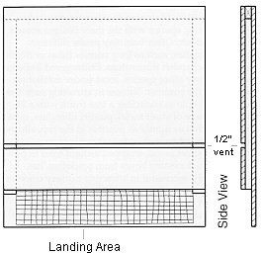
2. Roughen inside of backboard and landing area by cutting horizontal grooves with sharp object or saw. Space grooves about 1/2" apart, cutting 1/16" to 1/32" deep.
3. Apply two coats of dark, water-based stain to interior surfaces. Do not use paint, as it will fill grooves, making them unusable.
4. Measure and cut furring into one 24" and two 20 1/2" pieces.
5. Attach furring strips to back, caulking first. Start with 24" piece at top. Roosting chamber will be 3/4" wide (front to back).
6. Attach front to furring strips, top piece first (don't forget to caulk). Leave 1/2" vent space between top and bottom front pieces.
7. Caulk around all outside joints to further seal roosting chamber.
8. Attach a 1" x 3" x 28" board to the top as a roof, if desired (optional, but highly recommended).
9. Paint or stain exterior three times (use primer for first coat).
10. Cover roof with shingles or galvanized metal (optional).
11. Mount on building (south or east sides usually best).
Durable plastic mesh can be substituted for roughening to provide footholds for bats. Attach one 20" x 24 1/2" piece to backboard after staining interior, but prior to assembly.

Games

Annie-Annie Over
It is played over a building that you can throw a bouncy ball over and be able to run all the way around it quickly. You call out “Annie-Annie Over” and throw the ball over the building to the kids on the other side. If they catch the ball without it touching the ground, they can sneak around the building and throw the ball at you or catch you and tag you. You have to keep an eye open for them coming and beat them to the other side of the building. If you make it then that is your side but if you are tagged then you are on their side.

If the ball is not caught then they can wait a moment to try and fool you and then holler out “Annie-Annie Over” and throw the ball back. If the ball doesn't go over the building, the throwers can yell “Pigtail!”, and then try to throw it again. The ball must be caught in order to run around the building after you. When the last kid on a team is tagged then that team wins.

Blindfold the Cook
Equipment: Blindfold, wooden spoon, 2 bowls –one full of marshmallows, timer (or watch)
To Play: Blindfold the first player, set the bowls and spoon in front of him. Time the player for one minute while they try to scoop as many marshmallows as possible into the empty bowl. At the end of the minute, count how many marshmallows were successfully transferred. Reset for each player. The player with the most is the Champion Scooper! (But everyone gets to eat the marshmallows!)

Bricklayer's Relay
Equipment: Per team: 1 hard hat; 1 dustpan; 1 flag; 3 or more 'bricks' - stones, pieces of Styrofoam, or blocks of wood.
Directions: Divide the group into teams. Have them stand in parallel straight lines at one end of the playing area. The leader shouts 'BUILD'. The first member of each team dons the hard hat, places a brick in the dustpan and runs down to the other end of the playing area. They place the brick on the ground and runs back to the starting line. Each team member in turn, races down to build up the wall. The race continues until all the bricks on each team are
used up.

Crazy Drawing
Equipment: Paper and pencil for each player
To Play: Each player begins by drawing a single line on their paper. It can be any kind of line - straight, jagged, curvy. The papers are passed to the person to the left. Each player adds a line to the paper that is now in front of him. Continue to pass and add lines until the papers have gone around the circle. The object is to create something recognizable. Once the drawing starts to take shape, each player should continue to develop the picture, one line at a time.

Dice Count
Equipment: 1 die, pair of oven mitts, a chocolate bar or other wrapped treat, a hat
To Play: Before the game, wrap the chocolate bar in 5-6 layers of paper. Have the players sit in a circle and place the bar, the hat, and the mitts in front of one of the players. The player directly to the left of the person with the chocolate bar is given the die. On a signal, the person with the die starts rolling for a 6, while the other person puts on the oven mitts, then the hat, and then starts to unwrap the chocolate bar. Once a 6 is rolled, everything is passed to the left and a new person rolls the die, and the previous roller tries to put on the mitts and hat and unwrap the chocolate. The player who completely unwraps the candy gets to eat it.

Gates, Bridges & Tunnels
Equipment: Rubber chicken
To Play: Divide players into groups of three. One player in each group is the gate person, One is the bridge person, and one is the tunnel person. All players then form a large circle. The players in a group of 3 stand next to each other the leader stands in the middle of the circle holding the rubber chicken. When “Gates” is called, the gate people leave their spot in their circle and run around the outside of the circle. The other two players form a gate by putting their arms together. When the gate person gets back to their group, they go through the gate to the center of the circle and tries to grab the chicken. If “Tunnels” is called, the others in the group form a tunnel, which the tunnel person must pass through to get to the center. If “Bridges” is called, the others must form a bridge to be crossed to reach the center of the circle. The first player to grab the chicken each time becomes the new leader, and the former leader takes the empty place in the circle.

Fumble Fingers
Divide the den into two teams. Tell players to untie their shoelaces. Then tell them to put one hand behind their back, or tie one hand to their belt. On signal, each team tries to tie their shoelaces, with each player using only one hand. The first team finished is the winner.

Human Ladder Crossing:
Played with one Den, this is a timed event. With two dens, it’s a relay. Sit the team down in a straight line, with their hips about a foot apart and feet pointing in the same direction. Have them spread their legs, so that their feet touch those of the guy next to them.
Starting at one end of the line, upon command, one Cub Scout on each team jumps up and runs to touch the wall and then runs back over the “ladder” made by the legs of their team. They may not step on the Cub Scouts’ legs and the ladder mustn’t move. After getting across the ladder, they then touch the opposing wall and runs back across the “ladder” to take their original position. Once they sit back down in their spot, the next Cub Scout in the ladder jumps up, crosses the ladder in both directions and gets back to their spot (and so on until everyone has had a turn).
This game can be made more interesting by providing simple obstacles around the two outside edges of the hall, e.g. car tires to get through, turned gym benches to walk along, or chairs to go under.

Human Pinball
All players except one stand in a circle, facing outwards. Players spread their legs as wide as is comfortable, until their feet are touching their neighbors’ on either side. Everyone bends down and swings their arms between their legs – these are the pinball “flippers.” The one non-flipper enters the circle as the moveable target. The flippers try to hit others by knocking a volleyball or playground ball back and forth in the circle. Whoever hits the target gets to be the new target. The target’s only job is to avoid the ball. The flippers can only hit the ball, not catch and throw it.

Kick the Can
Materials: One empty #10 metal can, like for coffee or restaurant-sized canned food
This great old-time game can keep Cub Scouts occupied for hours. One person is chosen to be “It”, by a fair method. “It” then has to hide their eyes and count aloud to a pre-chosen large number, while the others all find hiding places within earshot of the can. At the end of the count, “It” announces “Ready or not, here I come!” and then tries to find out where the Cub Scouts are hiding.
If “it” identifies someone hiding, “It” has to say “I see ‘Johnny’ (or whoever) behind the tree” and then they both run to the can. If “It” picks up the can first, then the Cub Scout that was hiding gets captured. If any hiding Cub Scout kicks the can before “It” picks up the can (even if “It” didn’t see him), then everyone previously captured goes free. Ideally, “It” stays “It” until they capture everybody.
Since it can be very frustrating to be “It,” be sure to put the can in a large open area, so that they have a better chance. Also, to avoid frustration, perhaps you can change who is “It” after successfully capturing a few Cub Scouts, otherwise, with a large group it’s nearly impossible to ever capture everyone.

Log Rolling Contest
Make logs from 4” cardboard cylinders. This can be a relay, with each Cub Scout rolling a log with a dowel or stick to a given point and back to the next person in line.

Long, Short, Round
Object: To run the relay keeping track of the location of three objects.
Materials: Each team requires two containers. A long common tool, e.g. a wooden mallet; a short common tool, e.g. a stubby screwdriver,
and a round object, e.g. a small disk of wood.
This is a good game to sharpen alertness if the leader keeps it moving fast.
Directions: The teams sit down in a single file line with feet extended. They count off so that each Cub Scout in the den has a number. At the start, the container with the objects is at the front and the empty container is at the back of the team line.
The leader signals with their arms long or short or round, Then calls out a number. Scouts with that number race to their can, pick out the object, take it to the other container, and put it in the other container, and return to their places. The first Cub Scout back in place wins a point for their team. Keeping track of the location of the objects soon becomes a mental challenge. If a Cub Scout heads for the incorrect can, they are bound to lose the point.

Long, Short, Round
Object: To run the relay keeping track of the location of three objects.
Materials: Each team requires two containers.
A long common tool, e.g. a wooden mallet;
a short common tool, e.g. a stubby screwdriver, and a round object, e.g. a small disk of wood.
This is a good game to sharpen alertness if the leader keeps it moving fast.
Directions: The teams sit down in a single file line with feet extended. They count off so that each Cub Scout in the den has a
number. At the start, the container with the objects is at the front and the empty container is at the back of the team line. The leader signals with their arms long or short or round, Then calls out a number. Scouts with that number race to their can, pick out the object, take it to the other container, and put it in the other container, and return to their places. The first Cub Scout back in place wins a point for his
team. Keeping track of the location of the objects soon becomes a mental challenge. If a Cub Scout heads for the incorrect can, they are bound to lose the point.

Nail Driving Contest I
Object: To be the first team to drive nail into wood.
Materials: Scrap wood and 10-penny nails.
A hammer for each team.
Directions: Divide the den into teams. In front of each Cub Scout place a hammer and a piece of scrap wood with a 10-penny nail already started a half-inch into it. Cub Scouts take turns hammering the nail until the head is flush with the wood. This is not a speed contest. Fewest strokes wins. If the nail is bent, start over with a new one.

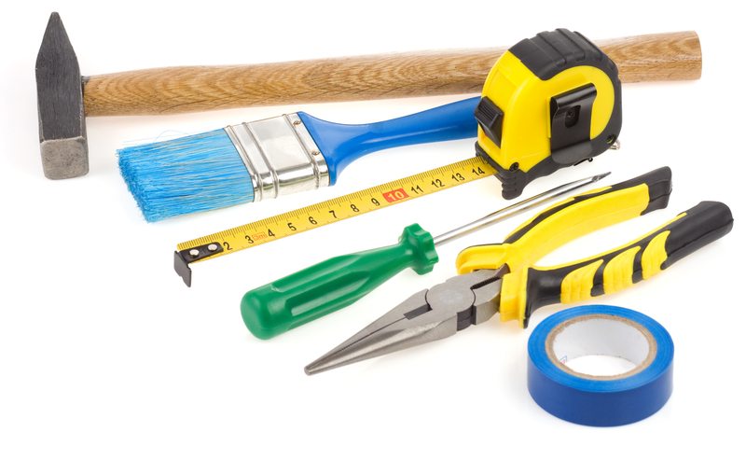

Nail Driving Contest II
Divide the den into two teams. Line up the teams for a relay race about 10 feet from the driving area. Provide each team with a piece of two by four about 1 foot long, a hammer, and nails shorter than the thickness of the wood. Each Cub Scout runs to the board, drives 2 nails, runs back, and gives the hammer to the next player. The team driving the most straight nails (not the fastest) wins. Variation: Have Cub Scouts switch hands.

Name the Tools
Cut different silhouettes of tools from construction paper, such as a hammer, plane, brace, bit, screw driver, etc. Glue these on light weight cardboard and use as flashcards.

Pipeline
This is a relay race Needed for each team –
3 pieces of PVC pipe – don’t make them too long 3 PVC pipe fittings for the pipe
1 hard hat
1 pair safety goggles 1 pair work gloves
1 small ball or marble that will fit in pipe 1 bucket for race not per team
Set up: Divide pack into teams. Place pipe, fittings, hardhat, goggles, and gloves where teams are to line up. Place bucket and ball at opposite end (or give to judge to hold.
Play: First player puts on hardhat, goggles, and gloves. Then they pick up a piece of pipe and runs down to end of course. They place pipe on floor and goes back. Second player takes hardhat, gloves, and goggles and puts them on. They take a pipe fitting and runs down to end of course. They attach fitting to pipe and returns. Thirds player takes hardhat, gloves, and goggles and puts them on. They take a piece of pipe and runs down to end of course. They attach pipe to fitting and returns. This continues until last piece is placed. Then last player calls the team. The team goes to opposite end (gets ball and bucket from staff member) rolls the ball through the pipe into bucket
(I had written this originally with pouring water but figured there were too many places where you could not use water. If you use water – add a funnel to list of stuff). First team to roll ball through pipe into bucket is winner.

Sawing Contest
Object: To be the first team to cut a 2x4 in half.
Materials: A 24-inch length of pine 2x4.
A handsaw for each team.
Directions: Divide the den into two teams. Give each team a handsaw and the 2x4. In turn, each Cub Scouts takes one stroke with the saw until the wood is cut through. This is not for speed.

Stack the Bricks
Equipment: Lots of Dixie cups (bricks)
Directions: Divide the den into 2 teams. At the other end of the hall or room is a pile of cups. In turn, each Cub Scout runs up and adds one cup to the tower started by the first Cub Scout. If it falls over, the tower has to be rebuilt. The team with the tallest, the only, the neatest (you decide – pick one of these or choose one of your own) standing tower is the winner.
Timber
The players form a circle facing inwards and are given a stave or walking stick each to hold upright in front of them on the ground. The leader will call a direction and a number (e.g. 2 to your left.) Each player must let go of their stave (he must not push it, simply let it go in an upright position) and move to grab the appropriate one (e.g. the second one on their left) before it hits the ground. If the stave hits the ground first, they are out.
The circle closes up any gaps and continues play. Play continues until only one player is left. Variations: To make a more challenging game, call directions faster and further.

Tool Box Sort Out
Use an egg carton for the toolbox. Have an assortment of nuts, bolts, screws, etc., to be sorted. The first Cub Scout to sort by size in the proper place wins.

Tower of Cups
Equipment: Lots of flat bottom plastic or foam cups Directions: Using only one hand; see how many paper or plastic foam cups you can stack top-to- top and bottom- to-bottom before they fall.
Person who stacks the most is the winner.

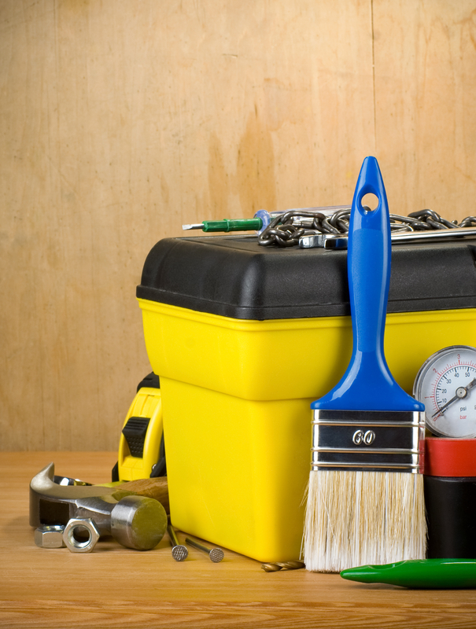

GATHERING ACTIVITIES

Gumdrop Truss Bridge
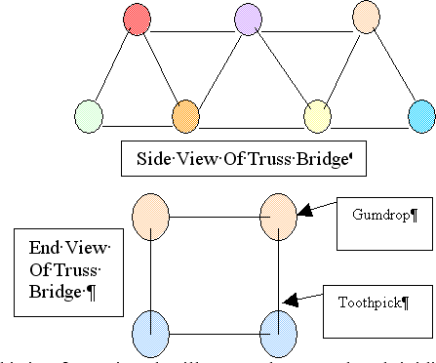
This is a fun project that illustrates the strength and rigidity of a truss bridge. You will need a box of round toothpicks and a couple of bags of inexpensive gumdrops (or spice drops). Cub Scouts can work as pairs or individuals on this project. Each Cub Scout should start by assembling a single triangular panel using 3 gumdrops and 3 toothpicks. (It is important to notice the strength of the triangular shape.) From there they can extend the side panel of the truss by adding more toothpicks and gumdrops.
Once the single truss is about 4 panels long, the Cub Scouts can begin the second side truss. The two sides are then connected by adding toothpicks between matching gumdrop node points. This short bridge span, which is about 8 inches long, will be very stiff and strong. Spanning the bridge between two stacks of books, or the like can test the strength. A cup full of pennies can be used to load the truss. After testing the strength, the Cub Scouts can extend the bridge length by adding more pieces. A second level of truss may be added for long spans (2 ft or more). The Cub Scouts will enjoy testing out various bridge configurations.
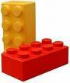
Lego Fun!
Just put out a pile of Lego blocks and see what happens as the Cub Scouts and siblings arrive at the meeting. It will be a blast. Have an adult there to watch and suggest things to build, "Let's see who can build a ____."

Paper Bag Kite
- For this kite, use a brown paper grocery bag with rectangular bottom.
- Cut a piece of cardboard the same size as the bottom.
- Cut an oval shape in the center of the cardboard.
- Using the cardboard as a pattern, cut a matching hole in the bottom of the bag.
- Punch a hole in each corner of the cardboard piece.
- Attach a long piece of string to each corner,
- Glue cardboard to bottom of bag, matching the oval openings.
- Take all free ends of the string and tie them together, so that all lengths are even. Tie them to the actual kite string, which is already wound around a piece of wood or other kite string holder. Decorate as desired. Have fun kite flying!

Pictionary
Supplies – Flip chart or large sheets of poster paper, marker
This is a simple game (a commercial version is available in stores but not needed). Cub Scouts can join in as they arrive at the den meeting.
One member from the den comes up to the den leader, who whispers a word or phrase to him. The den member then goes back to their den and attempts to draw on a sheet of paper, what the den leader said. They are not allowed to give clues by actions, speech, or writing. The first member of the den to guess correctly wins the point.
This could be played with several dens at once al working on the same word or phrase and seeing which den guesses it first. Each den should have its own paper and marker.

Match Game (or Toothpick Game)
There are many match puzzles, but this one is the best. Empty a box of ‘dead’ match sticks (or toothpicks) on to the table and invite everyone present to take eight only. With these eight, challenge them to produce two squares and four triangles. When the time limit is up, show them how easy it is:

Tools
Take several different tools and list them on a piece of paper. Then on a table have these tools set out with #’s by them. See how well they can match them up. Just for fun see if you can find a few old-time tools to identify.

Wood
Lay out a display of wood samples. You can pick these up at most places that sell wood flooring. Label the samples 1, 2, 3 and so on. On a piece of paper to be handed out list the different kinds of wood you have and a space to put the corresponding number. This will give the Cub Scouts an opportunity to check out the different types of wood, their textures and pattern designs.

Cubstruction BINGO
Prepare a BINGO card with different things relating to Cubstruction (made a Recipe Holder, used a saw, is an electrician, etc.). Each family, den or individual gets a bingo card and tries to find a person to sign each category. Each person can only sign once, so caution participants to choose carefully.

CUBSTRUCTION BINGO
The purpose of the game is to meet people and learn about them the object is to complete the bingo board.
Introduce yourself to someone you don’t know, strike up a conversation, and then ask ‘em, “say you look like someone who might have…”

A person can only sign once!!!

Built a recipe holder | Made a challenging item out of plastic | Made a door stop | Can describe how to take care of pliers | Built a birdhouse
Cut metal with a hacksaw | Made a pinewood derby car | Made a challenging item out of metal | Made a tool box | Owns/ owned a hammer
Owns a level | Owns safety goggles | Free!  Sign your name | Put pipe together | Replaced a light bulb
Has a nice smile | Can describe a wood plane | Made a display stand | Built a model | Fixed an electric plug
Made a bench fork | Has a Whittlin’ Chip card | Made a set of bookends | Made a rack for craftsman | Knows the difference between Phillips and regular screwdrivers

LEADER RECOGNITION

Cubstruction Thank You's

Think about the Cubstruction theme and identify small construction items (tools, bricks, models) that could be used as homemade recognition items and reflect the Cubstruction theme. Ideas:
- A miniature tower for the CM who is a Tower of Strength.
- A plaque with a screwdriver on it for the leader that has driven us to be the best
- A ladder (real or toy) for one who has takenus to the next level.
- A model bridge and saying for bridging us over the gap.

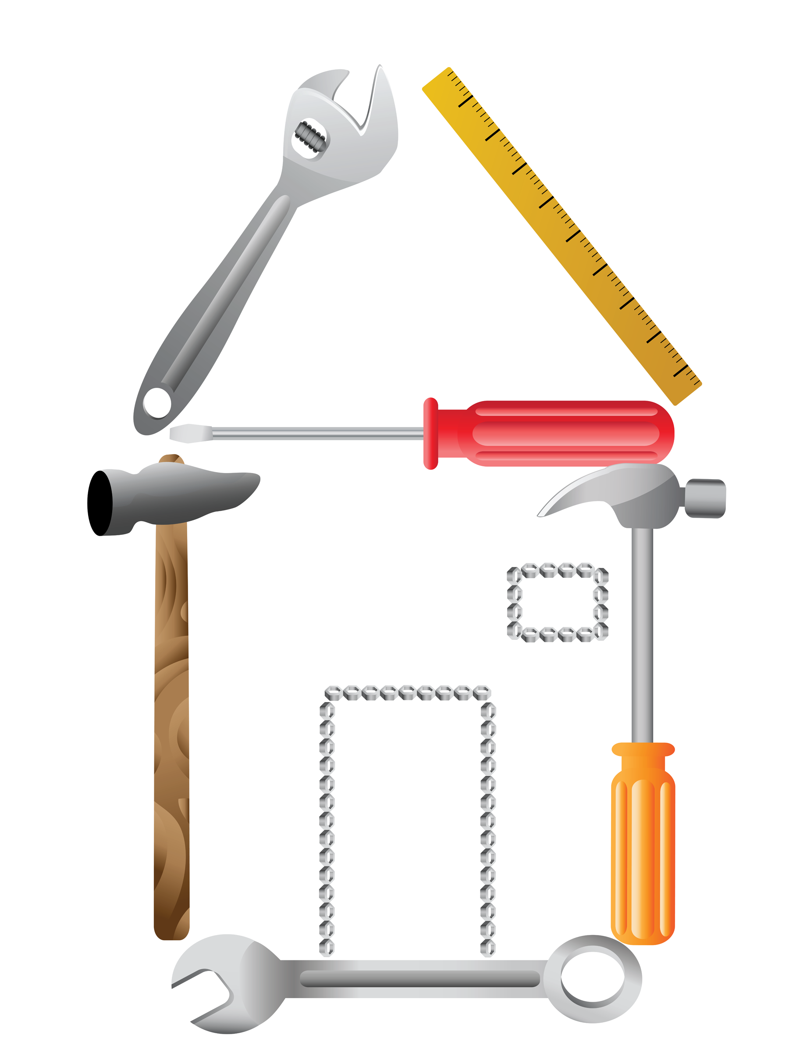

OPENING CEREMONIES

Block of Wood
Equipment: A long table with a cloth covering the top and front and side A block of wood A variety of wood working tools A piece of wood carved and finished.
CM: You see this block of wood (holds up the block of wood, uncarved) which is much like a Cub Scout as they enter the Cub Scouting program. It is just a block of wood. It is plain and does not suspect what it can become.
Now, let’s look at a piece of wood (holds up the wood that is carved) that has been lovingly shaped, sanded, stained, and finished in every way to become something useful and beautiful. What makes the difference between the uncut block of wood and this fine piece of wood?
A patient wood worker, using tools that are properly cared for, follows a pattern to shape a block of odd into something
of beauty and use. It takes time, it takes patience, it takes a plan. That’s what Cub Scouting is all about. A plan to help shape Cub Scouts into achieving their potential. And that’s what we’re here to celebrate tonight.

Building A Better World Opening or Closing
Arrangement: Twelve Cub Scouts, each holding a card with a letter on the front and their line on the back. Each speaker holds up their letter as they say their line. Last line can delivered by all a leader.
Note – Most of the lines spoken by the Cub Scouts are couplets (two line rhymes). Make sure they realize this and speak their lines properly.

# 1. Take a B for brotherhood, boosting for each other’s good.
# 2. Take an E for every land to share in earth’s riches everywhere.
# 3. Take a T for trustfulness, trusting more, and fearing less.
# 4. Take a T for teamwork, for joining hands to get things done.
# 5. Take an E for equal chance for each person to advance.
# 6. Take an R for real respect regardless of race, creed or sect.
# 7. Take a W for will to work for peace with faith and skill.
# 8. Take an O for opportunity to keep our speech and action free.
# 9. Take an R for reverence for a guiding Providence.
# 10. Take an L for love to spread around when need and bitterness are found.
# 11. Take a D for dignity of man devoted to a bigger plan.
#12: There you have it--this is how to build a better world, right now!

Constructing Greatness in America
Set Up: 7 Cub Scouts. Each has a poster with a picture of one of the 7 items listed by Cubs #4 and #5 on front and their part in LARGE letters on back. Cubs line up in order with pictures toward the audience. When #4 or #5 names the object on their poster, that Cub Scout raises it high and shows it off. (#4’s item should be the first one named by #5. 5's should be the 2nd one they call)
# 1: Cub Scouts are known for “building something”. The pages of history show how the ingenuity of ordinary men enables them to design and construct great and magnificent works.
# 2: It all starts when young Cub Scouts such as we Cubs use our imagination and start putting things together.
# 3: This nation displays that ingenuity of man. Our country provides the opportunity for man to surpass their own expectations and provides for us as citizens the enjoyment of such beauty.
# 4: Here are only a few examples of masterpieces Americans have constructed: Georgia’s Stone Mountain Park, the Kennedy Space Center, the St. Louis Gateway Arch,
# 5: The Seattle Space Needle, the Empire State Building, Hoover Dam, Mount Rushmore, and many, many more.
# 6: Please stand and give the proper salute, and together we’ll give thanks for these great constructions and for the men that built them.
# 7: Then in so doing we’ll give thanks to the country that gives us all the same opportunity. Please join with me in the pledge of allegiance.

Constructing Greatness in America
CM: Cub Scouts are known for “building something”. The pages of history show how the ingenuity of ordinary men enables them to design and construct great and magnificent works.
CA: It all starts when young Cub Scouts such as our Cubs use their imagination and start putting things together.
CM: This nation displays that ingenuity of man. Our country provides the opportunity for man to surpass their own expectations and provides for us as citizens the enjoyment of such beauty.
CA: Here are only a few examples of masterpieces Americans have constructed: Georgia’s Stone Mountain Park, the Kennedy Space Center, the St. Louis Gateway Arch, Seattle Space Needle, the Empire State Building, Hoover Dam, Mount Rushmore, and many, many more.
CM: Please stand and give the proper salute, and together we’ll give thanks for these great constructions and for the men that built them. Then in so doing we’ll give thanks to the country that gives us all the same opportunity. Please join with me in the pledge of allegiance.

Cubs Building Character
# 1: (carrying hammer) In Cub Scouts we learn to build character.
# 2: (carrying plank) It is not what the Cub Scout does to the wood, but rather what the wood does for the Cub Scout.
# 3: (carrying a plane) Through Cub Scouting we learn to remove the sharp edges off our personalities.
# 4: (carrying sand paper) As we grow in Cubbing we become more refined and smooth in our manners.
# 5: (carrying a tool chest) Our talents are gathered together and we get a chance to try them out when our den works on the themes each month.
# 6: (walking with parent) Our parents help us to learn how to use the tools of life when they help us pass our achievements.
ALL: Thank you all for helping us grow into well rounded citizens
Many Sides of a Cub Scout
Set Up: One Den Leader (DL), Six Cub Scouts with placards. Each has a picture one side appropriate for the words. Words are on the back in LARGE print.
DL: We will try to show you the many sides to little Cub Scouts we proudly call son, but remember, these are all one Cub Scout.
# 1. I'm the one who lives in dreams, always off on a cloud, at least that's how it seems!
# 2. I'm the one all full of dirt, so very sure that soap and water will hurt.
# 3. I'm the show-off and athlete; I just can't stand to get beat.
# 4. I'm the pouter, sensitive and shy, but I try to make people think I'm a real tough.
# 5. I'm the angel, neat and obedient. Mom wouldn't trade a day with me for all the money in the mint.
# 6. I'm the Cub Scout, the one we Cub Scouts like best. That's 'cause I'm different from the rest. So everyone, please join us as we say the Scout Oath and Law that we try to live by every day.
DL: They're all these Cub Scouts and even more. There are lots of surprises for you in store. So love them. Protect them, and try to understand. It's a very hard job growing up to be an adult.

Purposeful Building Opening Ceremony
Decorate ten identical boxes to look like bricks, boards or some other construction material.
Put one purpose of Cub Scouting on each box.*
Character Development
Spiritual Growth
Good Citizenship
Sportsmanship and Fitness
Family Understanding
Respectful Relationships
Personal Achievement
Friendly Service
Fun and Adventure
Preparation for Scouts BSA

Ten Cub Scouts each carry in a block and say something about the purpose listed on their block. Print script on the back of the block.
#1 and #12 do not get blocks. Leaders may perform these parts.
Have each Cub Scout place their block on the stack after reading. Start with 4 on the bottom level, three on the next row, then two and one on top.
# 1: Let us begin our meeting by thinking about the ways we help Cubstruct our Scouts.
# 2: Spiritual growth – Cub Scouting encourages spiritual growth by all members (Places block for first level of pyramid)
# 3: Character Development - Cub Scouting influences the development of positive character traits (Places block for first level of pyramid)
# 4: Good Citizenship – Cub Scouts develop habits of good citizenship (Places block for first level of pyramid)
# 5: Sportsmanship and Fitness – Cub Scouting encourages good sportsmanship and pride in growing strong in mind and body(Places block for first level of pyramid)
# 6: Family Understanding – Cub Scouting improves understanding within the family (Places block for second level of pyramid)
# 7: Respectful Relationships – Cub Scouting strengthens the ability to get along with other Cub Scouts and respect other people (Places block for second level of pyramid)
# 8: Personal Achievement – Cub Scouting fosters a sense of personal achievement by developing new skills and interests (Places block for second level of pyramid)
# 9: Friendly Service – Cub Scouts learn how to be helpful and do their best (Places block for third level of pyramid)
# 10: Fun and Adventure – Cub Scouting provides fun and exciting new things to do (Places block for third level of pyramid)
# 11: Preparation for Scouts BSA – Cub Scouting prepares us to become a Scout in a troop (Places block for top level of pyramid)
# 12: Let us now think about how our nation of fifty states was constructed from 13 original colonies as we take the Pledge of Allegiance.

Wood
Prop: a hand carved item or a block of some exotic wood. In the early days, wood was hard to cut and shape, Good tools were scarce and highly treasured. Those who had good tools and good wood used them with care. Fine wood carvings were admired and appreciated. As we gather for this pack meeting, let us remember to appreciate each other.

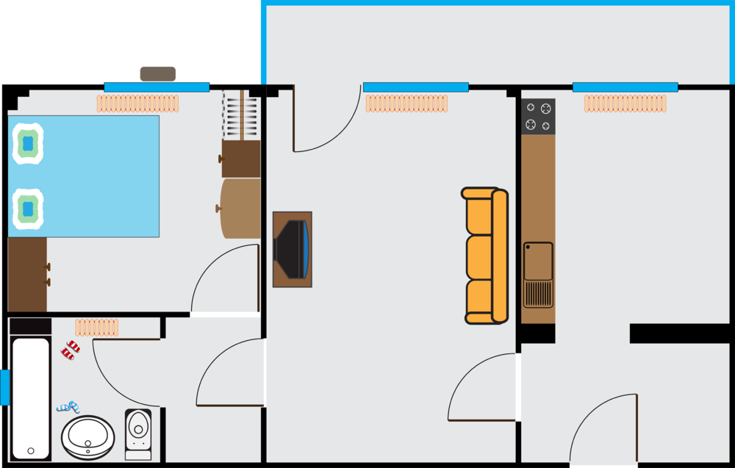

RUN-ONS

Jokes & Riddles
What nail should you never hit with a hammer? A fingernail
What are sleeping trees called? Slumber
What ten letter word starts with gas? Automobile
What do you call a tree in trouble? A birch in a lurch
What do you call a nice looking tree? Fine Pine
How would you be as a piece of wood? Bored
What is the longest furniture in the world? The Multiplication Table

Run-Ons
#1: Knock, knock.
#2: Who's there?
#1: Matthew.
#2: Matthew who?
#1: Matthew has come untied.

#1: Knock, knock.
#2: Who's there?
#1: Hannah.
#2: Hannah who?
#1: Hannah me another potato chip.

#1: Knock, knock.
#2: Who's there?
#1: Dewey.
#2: Dewey who?
#1: Dewey have to keep doing these terrible knock-knock jokes?

Baloo Goes to Court
Here are a whole series of run-ons that could be used for a pack meeting or be transformed into a skit. Baloo comes on stage carrying a briefcase
Cubmaster: What are you doing now?
Baloo: I’m taking my case to court. Baloo returns on stage later in the program. This time he’s carrying a ladder or step stool
Cubmaster: What are you doing now?
Baloo: I’m taking my case to a higher court.
Baloo returns even later with banana peels on top of their briefcase
Cubmaster: I’m afraid to ask. Where are you going now?
Baloo: I’m taking my case to a peels court. Baloo returns with a flashlight and a briefcase
Cubmaster: Baloo, where are you going?
Baloo: I’m going to night court.
Baloo returns one final time, with briefcase in hand
Cubmaster: And now where are you going, Baloo?
Baloo: To the Supremes court. (arrange for three female leaders to jump up and sing “Stop in the Name of Love. Before you break my heart, think it o-over.” (Or another Supremes song). Baloo wanders in with nothing, looks sad, and looks around for something
Cubmaster: Is something wrong?
Baloo: I lost my case.
Brain Teasers
1. Professor Mumbles Professor Mumbles held up a vial of bubbling liquid and said "Class, I have a substance in this bottle that will dissolve any solid it touches. I intend to ..." A student from the back of the room interrupted the Professor and says, "You have the wrong bottle!" How did the student know?
2. The Post Office Father asked Jason to go to the post office and buy a dozen one-cent stamps. Jason went to the post office and came home with twelve one-cent stamps. The next day Father asked Jason to go to the post office and buy a dozen two-cent stamps. How many stamps will Jason need to buy this time?
3. Good Ewes If you were walking down a country road and there was a sheep in front of two sheep, and a sheep behind two sheep and a sheep between two sheep, how many sheep would you see?
4. Mother's in a Jam Mother was making her favorite recipe for peach jam. Just as she was about to put the pot of jam on the stove, she noticed that the recipe called for one lemon for every dozen peaches. The recipe would be ruined if she didn't add lemons, but the peaches were already pureed into a jam mixture. How can Mother find out how many lemons to put into the jam?
5. Smoke Screen An electric train is moving at the speed of 60 miles per hour against a very strong head wind of 57 miles per hour. Which direction will the smoke blow, backwards or forwards?
6. The Broken Window Becky and Michael were playing in the house and accidentally smashed the picture window. "Oh, Mother will be so angry when she finds out," said Becky. "I know what to do," said Michael. They went outside and found a large rock and put it in the middle of the room. When Mother came home from shopping the children told her that someone threw a rock from outside and smashed the window. Mother was very angry, not because the window was broken, but because the children lied. How did Mother know the children were not telling the truth?
7. Leftovers Mother made twenty-four sandwiches for a picnic. All but seven were eaten. How many were left?
8. The Farmer and the Squirrel Farmer Brown had nine ears of corn in his barn. A squirrel went into the farmer's barn and walked out with three ears each day. It took the squirrel nine days to take all the corn from the farmer's barn. Why?
9. Mr. Hornbeeper's Dilemma Mr. Hornbeeper was driving in his car and heading west on a straight road. After driving for a mile, Mr. Hornbeeper found himself one mile east of his starting point! How can this be?
10. All Wet Ronald and Donald were at the swimming pool. "I can hold my breath for a whole minute," said Ronald. "Watch me." They dove into the pool and sure enough stayed under water for a whole minute. "That's nothing," said Donald. "I can stay under water for five minutes." "That's impossible!" said Ronald. "No one can do that!" "Let's make a bet," said Donald. "I bet I can stay under water for five minutes." "It's a bet," said Ronald. Donald won the bet. How?
Solutions:
1. A substance that melts anything it comes in contact with would have melted the bottle.
2. Twelve - because a dozen is always a dozen.
3. Three sheep.
4. Count the peach pits.
5. Electric trains don't have any smoke.
6. If the window had been broken from the outside, there would have been glass all over the floor.
7. If all but seven were eaten, then there were seven left.
8. Two of the three ears were on the squirrel's head.
9. Mr. Hornbeeper drove in reverse.
10. Donald held a glass of water over his head for five minutes

SKITS

Cubstructing a Cub Scout
- Hammer with "Do My Best” sign on it
- Screwdriver with "Do My Duty” sign on it"
- Pliers with "to God and Country” sign on it"
- Saw with "Help Other People at all times” sign on it.
- Block plane with "Scout Law " sign on it
Setting: Cub Scout is on stage. They are about as scruffy as one can imagine (shirttails are out, face is grungy, hair is a mess, slouching, forlorn frown on face). Other Cub Scouts enter and proceed with the repairs…
# 1. Wow! This Cub Scout’s in pretty bad shape. We’d better fix this Cub Scout up. I’ll use my "Do My Best" hammer. [#1 “hammers” on the Cub Scout. Scruffy Cub Scout tucks in shirt.]
# 2. Well, that’s a start! Let me use this "Do My Duty" screwdriver. [#2 pretends to make adjustments. Scruffy Cub Scout combs hair.]
# 3. Now we are getting somewhere! Here, I’ll give these "to God and Country" pliers a try. [#3 pretends to use pliers. Scruffy Cub Scout stands up straight.]
# 4. Hey, just about there! Let me work with this "Help Other People at all times" saw. [#4 pretends to saw. Don’t really use it! Scruffy Cub Scout wipes off face with a wash towel.]
# 5. By golly! I think we’re about done! Just let me give a little touchup with this "Scout Law" plane. [#5 pretends to shave a little here and a little shave there. Scruffy Cub Scout responds by changing the frown into a great big smile.]
Former Scruffy Cub Scout: Gee, thanks, guys! I guess I just needed to get with the program—the Cub Scout program, that is.

Dad's Tools
Props – tools mentioned throughout the skit
Characters: Narrator, Dad, Mom, Cub Scout
Narrator: As our skit begins, Dad is looking for his hammer...
Dad: Has anyone seen my hammer?
Mom: No dear, did you look in your toolbox?
Dad: It's not there. No one ever puts anything back where it belongs around here.
Cub Scout: Look, Dad. I found it. It's over here behind the door where you used it to fix the loose door hinges.
Dad: Now, where is my saw?
Mom: It should be on your workbench.
Dad: Well, it's not there. No one ever puts my tools away.
Cub Scout: Dad, don't you remember? You left it out by the garage when you were sawing those boards to build my clubhouse.
Dad: Good grief! Now where is my file?
Cub Scout: Oh, that's out in the yard where you used it to sharpen the lawn mower blade.
Dad: I can't find my screwdriver now, and I just had it! Did you use it, son?
Cub Scout: Yes, Dad. And here it is in the toolbox-right where I put it when I finished with it.
Dad: Oh! I never thought of looking for it there!

Cub Scout Cookout
Characters: Several Cub Scouts around fake campfire pretending to cook hot dogs on sticks. Two Cub Scouts dressed as mosquitoes--antennae, wings etc.
Setting: Cub Scouts around fire keep slapping as if they are being attacked by mosquitoes throughout the skit. As the scene opens, the two mosquitoes enter the stage and continue walking randomly around the Cub Scouts as they deliver their lines.
Mosquito #1: Hey, I got a good one! Which sport do we mosquitoes like best?
Mosquito #2: Easy! Skin diving. Say, did you hear what the Cub Scout said to the mosquito.
Mosquito #1: No, what?
Mosquito #2: Don't bug me!
Mosquito #1: Are you related to any of the bugs around here?
Mosquito #2: Sure. My ant.
Mosquito #1: Did you hear what the mother grasshopper said to her children?
Mosquito #2: No -- tell me.
Mosquito #1: Hop to it!
Cub Scout #1: These mosquitoes are awful! Lucky I brought the insect repellent. (Pretends to spray air.) (Mosquitoes exit quickly -- choking and gagging.)
Cub Scout #2: (To #1) Say, what has 18 feet, red eyes, and long claws.
Cub Scout #1: I don't know.
Cub Scout #2: Neither do I, but it's crawling up your neck. (All Cub Scouts run screaming from stage.)

The Invisible Bench
Need: 4 (or more) Cub Scouts and a leader. Have two Cub Scouts building an invisible bench using invisible tools. They can pretend to hammer and saw, lift pieces and carry the completed bench to a spot on stage. Make sure they make it look heavy!
# 1: Cub Scout am I glad we are done building this invisible bench for that Adventure in our Book
# 2: Yes, let’s go get Mr./Miss (name of leader) and show him/her. Two other Cub Scouts now enter and move the invisible bench to the other side of the stage and leave. #1 returns and squats as though sitting on the invisible bench where it was originally placed
# 1: I’ll just sit here on the bench until (Cub #2’s name) returns with the (leader’s name) to check our work.
# 2: (enters with leader) Here it is (Leader’s name) Come try out our bench Cub Scout #2 and leader sit in bench. All three discuss how comfortable and well made the bench is. If you have more den members, have them come in one at a time and ask
Cub X: What are you doing?
# 1: I’m sitting on the invisible bench..
# X: Can I join you?
# 2: Sure, there’s plenty of room. Each additional Cub Scout pretends to sit on the bench. Go on for as many Cub Scouts as you want. After the last Cub Scout is sitting, the two Cubs who moved the bench return.
# 3 What are you guys doing?
All: We’re sitting on the invisible bench..
# 4: (points) But we moved it over there this morning!”
All: :AAAAHHHHHH!!!! All seated Cub Scouts fall down.
New Saw
Announcer This scene takes place in a hardware store in a small north woods lumber town.
Lumberjack (Enters) My old crosscut saw is worn out, and I need something that will let me cut more wood or I’m going to go broke!
Owner: Yes, sir! For only one hundred bucks you can be the proud owner of this chain saw. I guarantee that it will cut twice as much wood in a day as your old crosscut.
Lumberjack: (Handing over money) O.K. great!
(Exits)
Announcer: The next day.
Lumberjack: (Enters tiredly) There’s something wrong with this saw. I worked very hard yesterday but only cut half as much wood.
Owner: Well, sir, I have a lot of faith in this product. Here, I’ll put a new chain on it and you give it another try.
Lumberjack: O.K., but if it doesn’t do any better, I’ll be back! (Exits)
Announcer: The next day.
Lumberjack: (Enters exhausted) This darned saw is no good. I worked even harder and still it won’t cut half the wood of my old saw! I want my money back!
Owner: Yes, sir! Just let me check it out here.
(Pulls starter rope)
Announcer (Makes sound effects of saw running.)
Lumberjack: Oh, My Gosh! What on earth is all that noise?

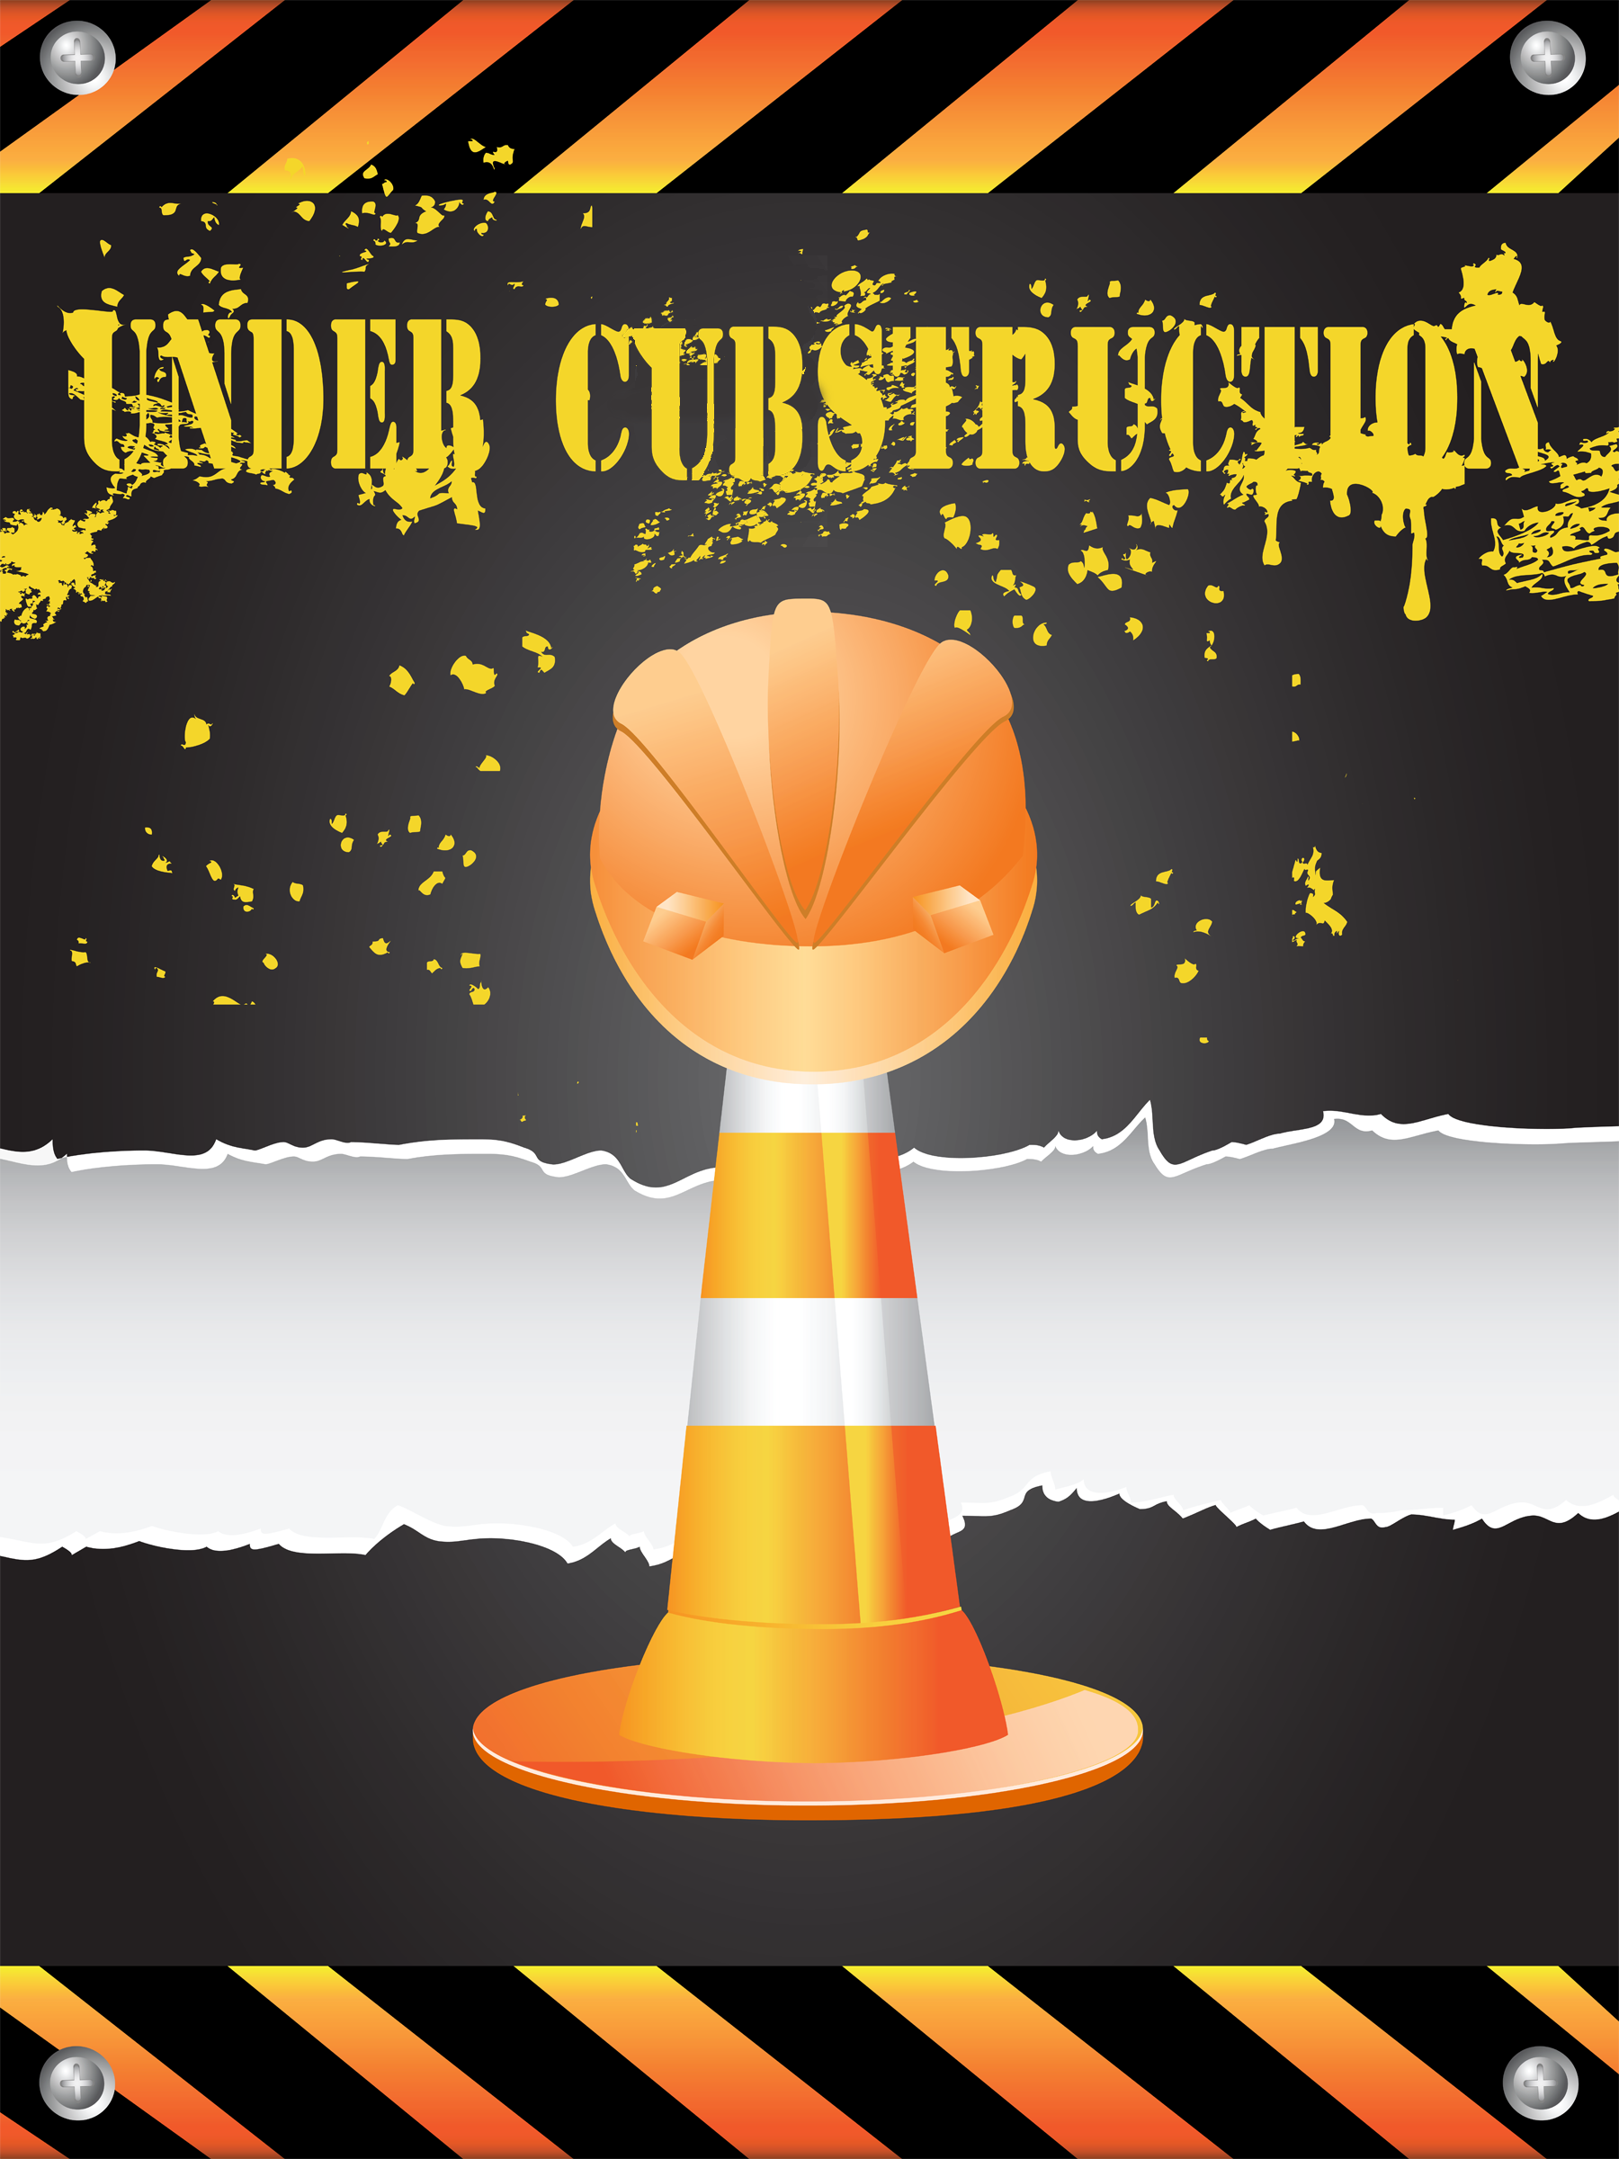

Measurement Problem Skit
Cast: Two Webelos Scouts and one Cub Scout
Set Up: Two Webelos Scouts come on stage carrying a long pole. They prop it up, then stand back and look at it.
Scout 1: Now, there are several ways we can figure out the height of this pole. How do you want to start?
The Scouts unsuccessfully try various methods of estimation to calculate the height of the pole. The conversation goes something like...
Webelos Scout # 1: According to my calculations, that pole is about 2 meters high.
Webelos Scout # 2: There's no way. It has got to be shorter than that. Just look at it. This kind of exchange repeats several times as the Scouts obviously become more and more exasperated. A Cub Scout strolls onto the stage.
Cub Scout: Hi! (He watches a bit). What are you guys trying to do?
Webelos Scout # 2: We are trying to measure the exact height of this pole.
Webelos Scout # 1: We haven't had too much luck yet, but we will get it.
Cub Scout: Why don't you just lay the pole on the ground and measure its length?
Webelos Scout # 2: (To the Cub Scout) Didn't you hear right? We want to know how tall the pole is—not how long it is.

Wood Project
Cast: 1 Den Leader (DL) or other adult, 3 Cub Scouts
Den Leader: Wow, Cub Scouts, we've been working on this wood project for an hour now. I'm really tired!
# 1: I've almost finished mine, but my feet are tired.
# 2: I've stood here so long I think my feet are stuck to the floor.
# 3: Yeah, I agree. Let’s stretch and take off our shoes for a while.
All: Wow, what smells so bad? Is it the wood? Is it a stink bug?
Den Leader: Cub Scouts, I hate to tell you this, but I think it's your feet! (All Cub Scouts pass out)

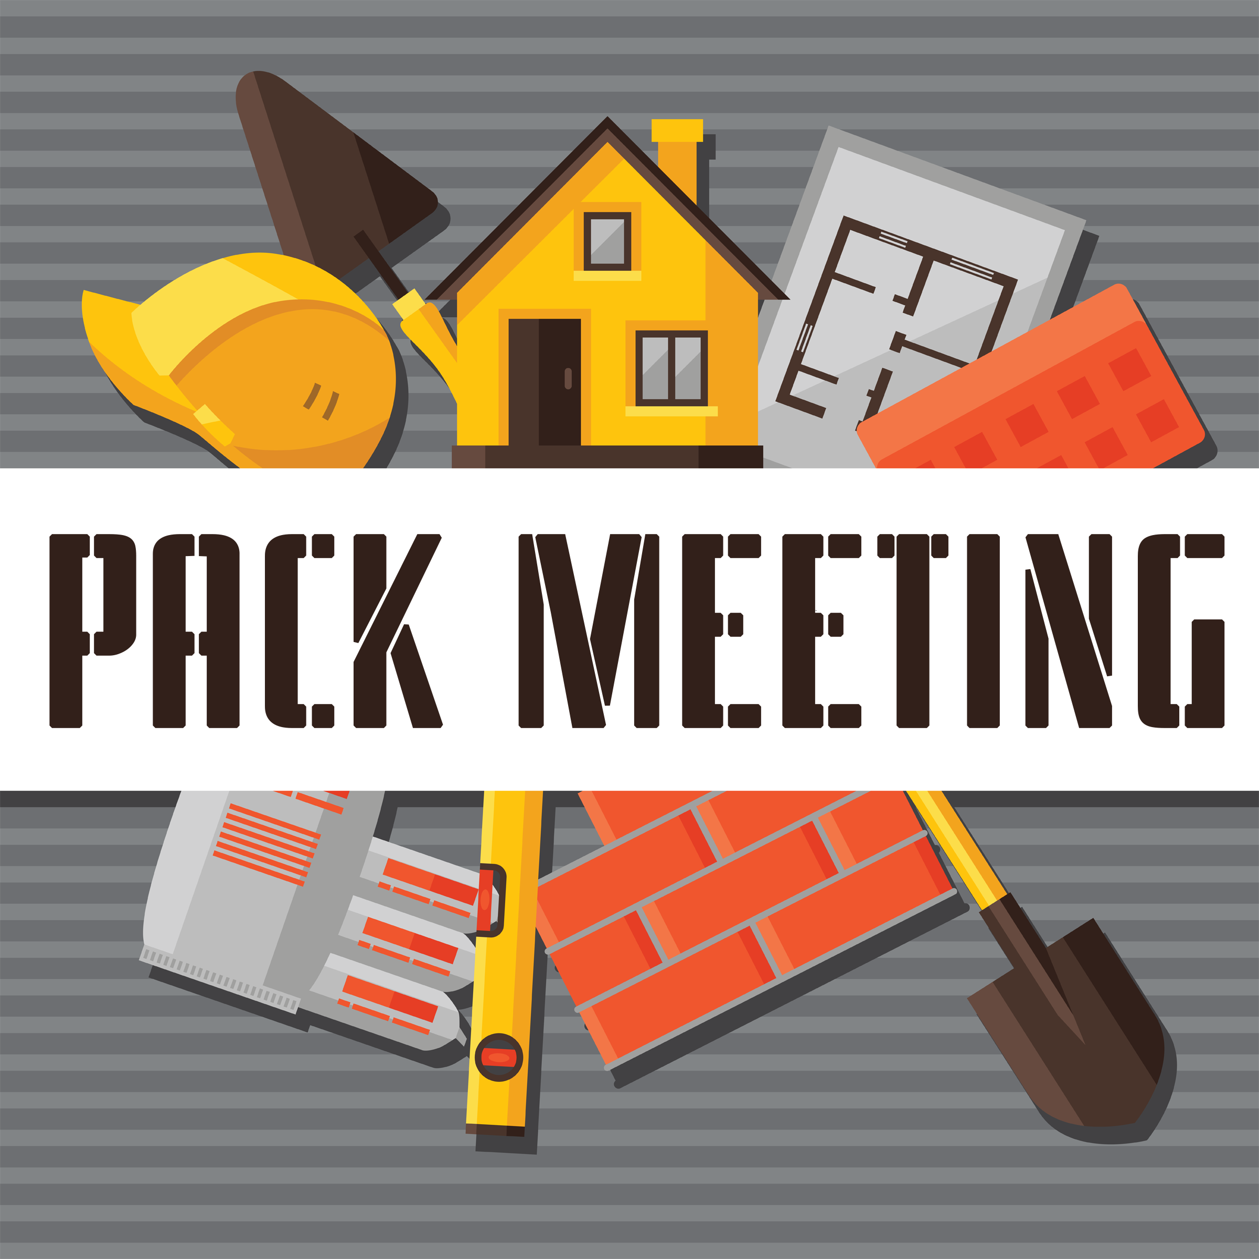

SONGS

Cubstruction
Tune – Alouette
Use these or make up other motions for the actions:
- Block of wood – draw a square in the air
- Down to size - Saw
- Right size nail – position fingers to show size
- Hammer carefully – swing arm as if hammering
- Big Paintbrush – position hand as if holding brush
- Paint it very nice – pretend to paint with brush
- Name on it – Pretend to sign your name in mid air
- We are done -Pretend to sign your name in mid air
Chorus
Cubstruction, we build with Cubstruction
Cubstruction, it’s how we build our world

First you take a block of wood
Then you cut it down to size
Block of wood – Down to size OOOooohhh
Chorus
Next you take the right size nail
Then you hammer carefully
Right size nail –carefully
Block of wood – Cut to size OOOooohhh
Chorus
Now you take a big paintbrush
Then you paint it very nice
Big paintbrush – Very nice
Right size nail –carefully
Block of wood – Cut to size OOOooohhh

Last we put our name on it
Then we know that we are done
Name on it – WE ARE DONE!

Don’t You Like to Saw
Tune: I’ve been working on the railroad

I’ve been sawing on this piece of wood.
All the live long day,
I’ve been sawing on this piece of wood,
Just to pass the time away.
Can’t you see the saw dust flying?
Rise up so early in the ‘mom.
Can’t you see our leader shouting,
Not on my wood floor!

Don’t you like to saw,
Don’t you like to saw,
Don’t you like to saw,
More, more, more, more!
Don’t you like to saw,
Don’t you like to saw,
Even if it’s on the floor!

My Cub Scoutmobile
Tune: On Top of Old Smokey
One Saturday morning,
My granddad and I,
Went down to the woodpile,
To get some supplies.

Some long boards, some short boards,
A few thin ones too,
Four wheels and a gear shift,
We’re practically through.

Some paint and a good seat,
Completes our fine car,
Now on to the race track,
Where the Cub Scouts compete.

Zoom! Down the roped off street,
Cub Scouts dressed in blue,
All had a real great time,
We hope you did too!

Pound the Nail
Tune: Row, Row, Row Your Boat

Pound, pound, pound the nail,
Pound it right on through!
If you miss and pound your thumb,
Then it will turn true blue!

Toolbox Song
Tune: I’m a Little Teapot

I’m a pair of pliers just because,
Here is my handle here are my jaws
Chorus: Keep me in your toolbox bright and new
Take me out and I’ll work for you.

I’m a coping saw that’s strung too tight
Pull me then, push me to use me right.
Chorus

I’m a big strong hammer, a mighty tool
Hit the nails only, that’s the rule.
Chorus

I’m a happy C-clamp, tell you what I do
I eat board sandwiches filled with glue.
Chorus

I’m a handy wood plane, give me a try
I can help you out if your door’s too high.
Chorus

Whacked My Thumb
Tune: Jimmy Crack corn or The Blue Tailed Fly
When I was young I went to play
In father's workshop one fine day
I took a hammer, some wood and nails
And tried to make some kitchen scales.
Chorus : Whacked my thumb and I don't care
Hurt real bad, but I don't care
Whacked it good, but I don't care
The feelings gone away

I tried to hang a picture frame
Sent to me by Aunt Jane
To hang the picture, I was dumb
I swung the hammer, and smashed my thumb
Chorus
One day I tried to make a boat
Worked real hard so it would float
I nailed my fingers to the bow
I'm bandaged to my elbows now
Chorus
I joined the local Cub Scout pack
I learned to make a neat tie rack
A little skill was all it took
They had instructions in the book
New Chorus :
I missed my thumb, I learned to care
I missed my thumb, I wouldn't dare
I missed my thumb, my thumbnail's bare
The feelings here to stay

Wood Working Is Fun
Tune: Jingle Bells
Saw on wood, Hammer nails,
Wood working is fun!
We’ll get this project done on time
With the setting sun!
Stain the wood, Putty the nails,
Let’s give a big hooray!
Now this project is done on time,
Let’s go out and play!

